Cover Art | Title/Release Info/Streaming M3U playlist with 4min Samples
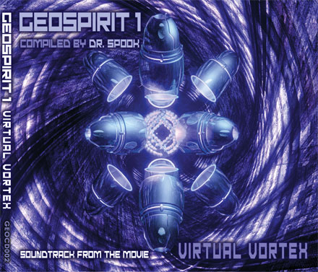 | geocd002 Geospirit 1: Virtual Vortex  geomagnetic.tv/releases/geospirit1cd.htm geomagnetic.tv/releases/geo1/infosheetGEOCD002.pdf  geomagnetic.tv/releases/geo1/geoSpirit1/4minMp3/PlayAll.m3u
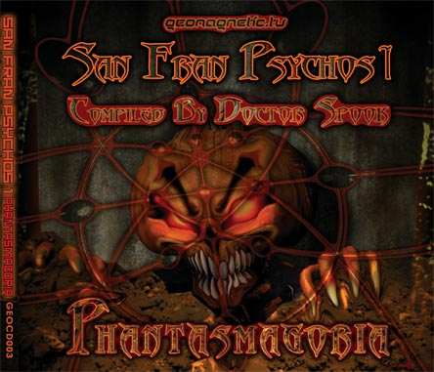   | geocd003 San Fran Psychos 1: Phantasmagoria v/a  geomagnetic.tv/releases/SanFranPsychos.htm geomagnetic.tv/releases/SanFranPsychos1/infosheetGEOCD003.pdf  geomagnetic.tv/releases/SanFranPsychos1/4minPreviews_mp3/PlayAll.m3u
geocd004 Random: Implicate Order – Artists Album
geomagnetic.tv/releases/Random_ImplicateOrder.htm geomagnetic.tv/releases/Random_ImplicateOrder/infosheetGEOCD004.pdf
geomagnetic.tv/releases/Random_ImplicateOrder/mp3/PlayAll.m3u
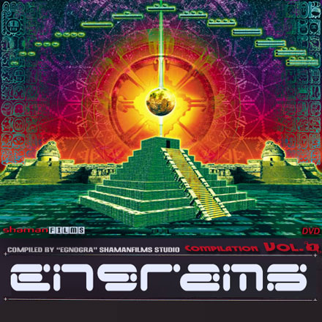 | geocd005 Engrams1: Luminaria 2012 – v/a  geomagnetic.tv/releases/engrams1.htm http://geomagnetic.tv/releases/Engrams1/infosheetGEOCD005.doc  geomagnetic.tv/releases/Engrams1/4min_mp3/PlayAll.m3u
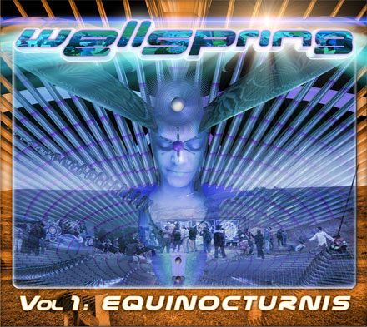 | geocd006 Wellspring1: Equinocturnis – v/a  geomagnetic.tv/releases/wellspring1.htm geomagnetic.tv/releases/Wellspring/infosheetGEOCD006.doc  geomagnetic.tv/releases/Wellspring/4min_mp3/PlayAll.m3u
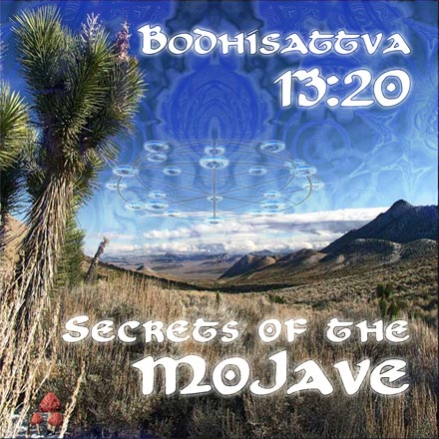 | geocd007 Bodhisattva 1320: Secrets of the Mojave – Artist Album  geomagnetic.tv/releases/Bodhisattva_SecretsOfTheMojave.htm geomagnetic.tv/releases/Bodhisattva/infosheetGEOCD007.doc  geomagnetic.tv/releases/Bodhisattva/mp3/PlayAll.m3u
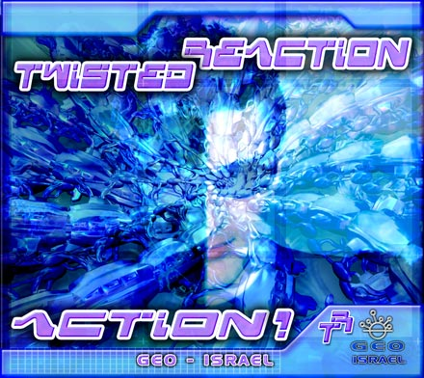 | geocd008 Twisted Reaction: Action! – Artists Album  geomagnetic.tv/releases/TwistedReAction_Action.htm http://geomagnetic.tv/releases/TwistedReAction_ACTION/infosheetGEOCD008.doc  geomagnetic.tv/releases/TwistedReAction_ACTION/4minMp3/PlayAll.m3u
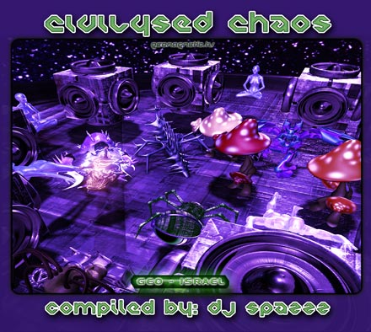 | geocd009 Civilysed Chaos –v/a  geomagnetic.tv/releases/CivilysedChaos.htm http://geomagnetic.tv/releases/CivilysedChaos/infosheetGEOCD009.doc  geomagnetic.tv/releases/CivilysedChaos/4minPreviews/PlayAll.m3u
  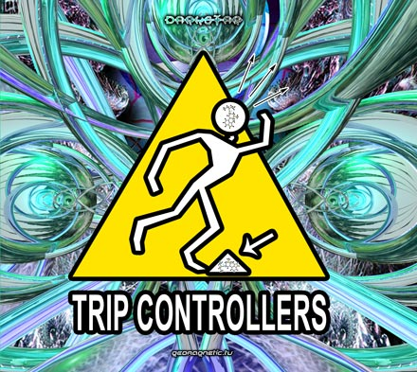   | geocd010 HIGH Way 420 – v/a geomagnetic.tv/releases/Highway420.htm http://geomagnetic.tv/releases/420/infosheetGEOCD010.docgeomagnetic.tv/releases/420/4minmp3/PlayAll.m3u
geocd012 Trip Controllers – V/a
http://geomagnetic.tv/releases/TripControllers.htm http://geomagnetic.tv/releases/TripControllers/infosheetGEOCD012.doc
geomagnetic.tv/releases/TripControllers/4minpreviews/PlayAll.m3u
geocd013 Grateful Dance – V/a
http://geomagnetic.tv/releases/GratefulDance.htm
http://geomagnetic.tv/releases/GratefulDance/infosheetGEOCD013.doc
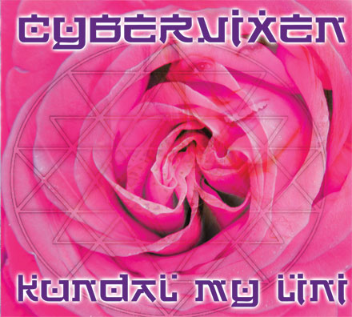  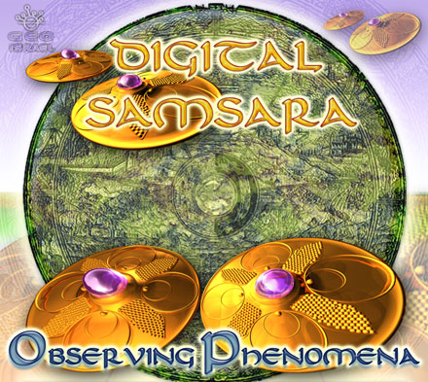   | geocd011 Cybervixen – Kundal My Lini  http://geomagnetic.tv/releases/Cybervixen-KundalMyLini.htm  http://geomagnetic.tv/releases/Cybervixen-KundalMyLini/infosheetGEOCD011.doc  geomagnetic.tv/releases/Cybervixen-KundalMyLini/PlayAll.m3u
geocd014 Digital Samsara – Observing Phenomena
http://geomagnetic.tv/releases/DigitalSamsara_ObservingPhenomena.htm
http://geomagnetic.tv/releases/DigitalSamsara/infosheetGEOCD014.doc
geomagnetic.tv/releases/DigitalSamsara/4minMP3/PlayAll.m3u
geocd015 v/a PSYCHIC CHAKRA 2CD v/a
http://geomagnetic.tv/releases/psychicchakra.htm
http://geomagnetic.tv/releases/PsychicChakra/infosheetGEOCD015.doc
geomagnetic.tv/releases/PsychicChakra/4minMP3/PlayAll.m3u
 | geocd016 DIGITAL DRUGS 2CD v/a  http://geomagnetic.tv/releases/DigitalDrugs.htm  http://geomagnetic.tv/releases/DigitalDrugs/infosheetGEOCD016.doc  geomagnetic.tv/releases/DigitalDrugs/4minMP3/PlayAll.m3u
 | geocd017 ATMA – Beyond Good and Evil  geomagnetic.tv/releases/ATMA-BeyondGoodAndEvil.htm  geomagnetic.tv/releases/ATMA-BeyondGoodAndEvil/infosheetGEOCD017.doc  geomagnetic.tv/releases/DigitalDrugs/4minMP3/PlayAll.m3u
  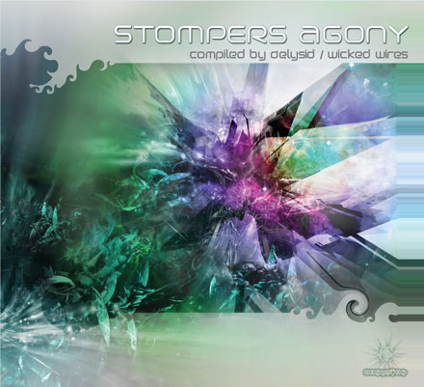 |     geocd018/acidcd018 -STOMPERS AGONY v/a by Delysid/Wicked Wires) http://geomagnetic.tv/releases/StompersAgony.htp  http://geomagnetic.tv/releases/stompers_agony/info-ACIDCD018-GEOCD018.doc  http://geomagnetic.tv/releases/stompers_agony/4minMp3/PlayAll.m3u
Label: Psybertribe Records
ptr001 Digital Shaman -- NOW IN STOCK – v/a
geomagnetic.tv/distro/DigitalShaman.htm geomagnetic.tv/distro/DigitalShamen/infosheetPTRCD001.pdf
 | Label: Vaporvent Records  vv004 Chromatone - ChromaConnections –Album-- NOW IN STOCK  http://geomagnetic.tv/distro/Chromatone-Chromaconnection.htm  http://geomagnetic.tv/distro/vaporvent/infosheetVVCD004.doc  http://geomagnetic.tv/distro/vaporvent/vv005_m3u/PlayAll.m3u
 | Label: Divine Balance Records  dbr001 Return of the Boom Shanti – v/a NOW IN STOCK  http://geomagnetic.tv/distro/ReturnOfTheBoomShanti.htm  http://geomagnetic.tv/distro/divinebalance/infosheetDBRCD001.doc  http://geomagnetic.tv/distro/divinebalance/m3u/PlayAll.m3u
 | Label: Mind Funk Music  mfm002 Complex Cosmic Creation – v/a NOW IN STOCK  http://geomagnetic.tv/distro/ComplexCosmicCreation.htm  http://geomagnetic.tv/distro/MindFunk/MFR002-ComplexCosmicCreation.doc
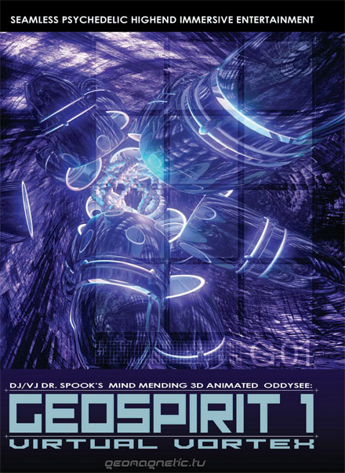 | DVD ← Label: Geomagnetic.tv Cat: geodvd002  Title: Geospirit1: Virtual Vortex v/a: Animation by Dr. Spook  http://geomagnetic.tv/releases/geospirit1dvd.htm  http://geomagnetic.tv/releases/geo1/infosheetGEODVD002.pdf  http://geomagnetic.tv/releases/geo1/geo1_trailer.html
 | DVD ← Label: Geomagnetic.tv Cat: geodvd001Title: MAGNUS: Geomagnetic Sampler v1 v/ahttp://geomagnetic.tv/releases/Magnus.htmhttp://geomagnetic.tv/releases/magnus/infosheetGEODVD001.pdfhttp://geomagnetic.tv/releases/magnus/magnus_trailer.html

