V/A SanTRANCEcisco CD – KEYFRAME ENTERTAINMENT

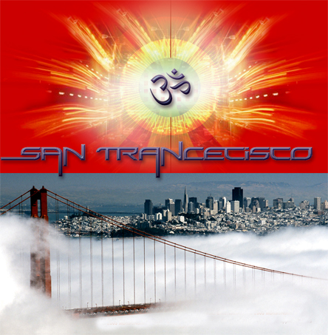 |  | RELEASE NOTES  The San TRANCEcisco compilation fuses producers from the Bay Area to create an  immersive sound outside of today's musical climate. This underground perspective  travels through all the senses and offers melodic soundscapes, brute force, spatial  beauty and above all psychedelia.  Label Profile:  Keyframe is a San Francisco Based Dance Music Label, on a mission is to unite the Trance community and expose Bay Area underground music to the masses. Committed to exploration, creating unique compilations and inventing new sonic formats.  Artist Profile:  http://www.santrancecisco.com  http://santrancecisco.com/producers.html  Nine producers from the Bay Area, showcasing different perspectives of Trance.  DirtyHertz's tracks and remixes are being supported by some of the top DJs in the world like: Sasha, Paul Van Dyk and Dave Seaman.  The Loomii and Sanyama will open new doors of perception whether you hear them for the 1st time or the 50th time... It's music that has to be heard!  Sea Creatures are an integral part of the amazing Collective Aranji.com - "Hell Bent On Making You Think!"  The duo Enigma Machine and producers Random & Helios are deeply rooted in the Psychedelic Underground and their command of music and emotion is undeniable.  Vaporware's melodic Trance/Breaks "Callisto" is mellow while EKKO's mind blowing PsychedelicTechno track "The Wizard" will challenge any genre classification.  San TRANCEcisco is dedicated to all of those creative souls who devote their time and energy to love, art, music and dance.
Title: | San TRANCEcisco
Artist: | Various Artists 2006
Label: | Keyframe Entertainment
Catalogue: | KFECD001
Format: | Jewel Case Audio CD
Barcode: | 634479107276
Release: | July 2006 World Wide
TRACK LIST
- DirtyHertz - Suicide
- The Loomii - Scarab
- Sea Creatures - Bumper Boats
- Random - Design Possabilities
- Helios - Transient Node
- EKKO - The Wizard
- Enigma Machine - Alien Antics
- Sanyama - After Party
- Vaporware - Callisto
- Doramey Fossillotti -Beyondananna
- Etienne - We Come in Peace
CREDITS
Mastered by: TWERK
Artwork by: Keyframe
Distribution by Geomagnetic Distro
(p) and © Keyframe Entertainment
http://geomagnetic.tv/distro/Santrancecisco.htm
info@geomagnetic.tv


