
turbo trance records
catalogue

COMPILATIONS

TTrCD002 - Fire - VA
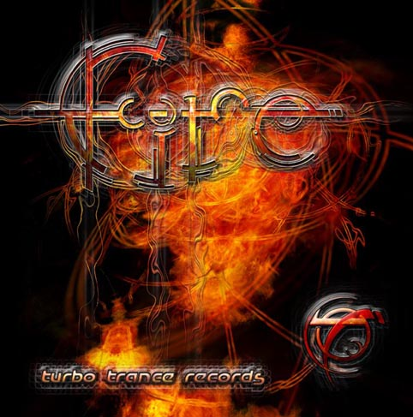
Mumbo Jumbo Pornogram
Triptych Funky Wah
Biodegradable Homo Digitalus
Hyper Frequencies a.k.a. Gill Cosmo Box
Growling Mad Scientists Zak & Kracht
Neuromotor Speed Racer
Hyper Frequencies Signs of Dance
T. I. T. Can you Believe ...
Nuclear Ramjet Delta 1

TTrCD004 - Amazon - VA

Cameleon Cear Vision
Quixotic Evngelica
Aphid Moon Funck
Triptych Cranky Stevie (Tribal remix)
Tortured Brain vs. Sterilizer Totally Fucked
Hyper Frequencies Robotomix
Etnica Liquid Forms (live remix)
Tristan vs. Jon Om Futur Fizz
Ticon Obi not the one Kenobi
TURBO TRANCE RECORDS

3 rue Saint Exupery
13580, La Fare les oliviers France

Tel : 0033.04.90.42.50.19
Mobile : 0033.06.03.56.19.65

e.mail : lelf@turbotrance.com

website:
www.turbotrance.com

TTrCD006 - Unbreakable - VA
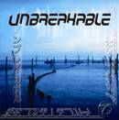
Mekkanikka Outside World
Triptych Platypus
Psypilot Train to Nowhere
Mumbo Jumbo Snared
Ninja Brazalien
Triptych Accelerator
Wizzy Noise Aqua Blue
Bus & Super Cozi Stray Light
T.I.T. Reality (Soft Drink remix)

TTrCD009 – Accelerator 1.0 - VA
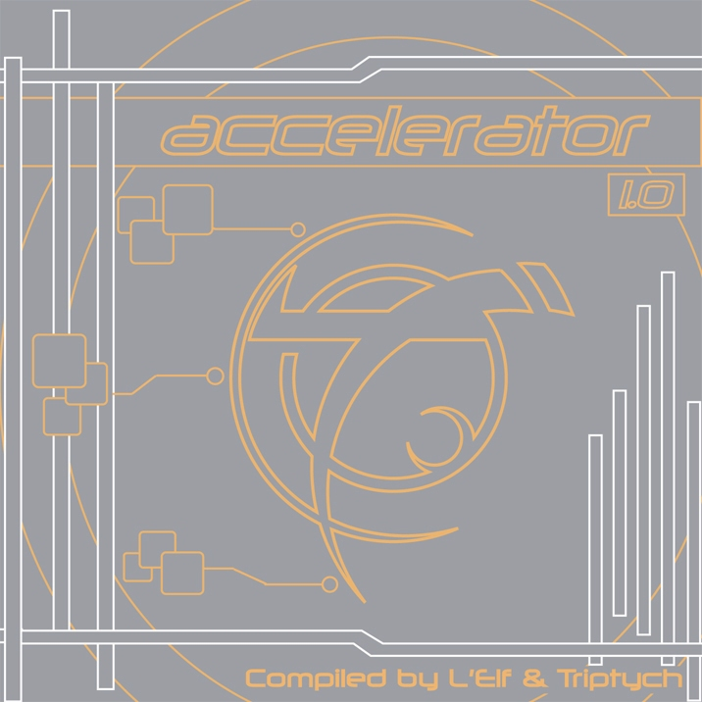
Tikal vs. Ninja Flowing High
Talamasca Future Shock
Psypilot Organic Synthesis
Protoculture Universo paralello
Triptych Access All Areas
Skulptor Searching for answers
Vibe Tribe Ectasy of revelation
Elec3 XXI Century
Psypilot Feel zero five (Triptych rmx)

TTrCD010 – Trance Scandinavian Express - VA

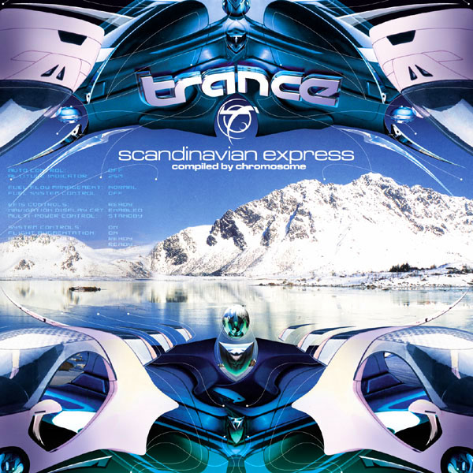
Alternate Vision vs Z Man Back to reality
Andromeda Hypnotic Meeting rmx
Artax Mysterious Virus
Son Kite On Air (Deedrah rmx)
Tranan vs Z man Who’s Who
Chromosome Big Fat Giant phantom
S Range Hypermental
Logic Bomb Tales from Basement
S Range Testtones rmx

TTrCD012 – Accelrator 2.0 - VA
Triptych Here I am
Polaris Unity
Overlap When dreams come true
Alternative Control hijacka
Interactive Psycho Entertainment
Aphid Moon Do what you want
Mekkanikka Booyakasha
Point vs Quantum I’m so…
Intelabeam Power Puff
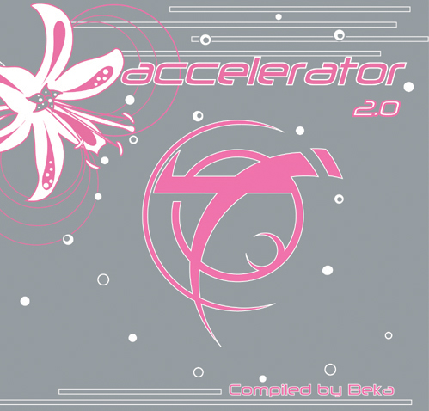

TTrCD015 – Pygmees Groove volume 1 – VA MARCH 27th

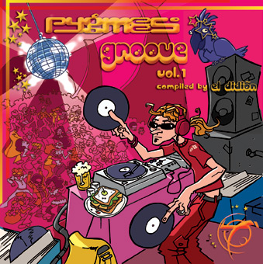
Talamasca Groovy Pygmee part 1
Inessence Treasure
Manmademan And all that (Alternative control remix)
Triptych Meegos
Tikal Flow
Intelabeam Free action
Elec3 Plugged (Wizzy Noise remix)
Prosper Electro grooves
Logic Bomb Shadow of the beast (Psypilot remix)

ALBUMS

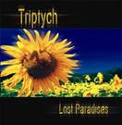
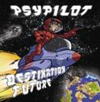
TTrCD003 - Walhalla - Menu Mental TTrCD005 - Mumbo Jumbo - Speaking in .
Thought Transfer
Contact
Nitrogen & Oxygen
Synflowers
The Path
Recording the Report
Accelerator (Paradise Remix)
Pegasus
One Shot
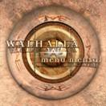
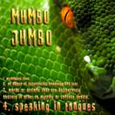
Breath in
Harvester
Earthworm
Triviality
Purple Shrimp
Unfulfilled Prophecy
Hippocampe
Museau Vinaigrette
Breath out
Turtlehead
Brad
Techno Boom Boom remix
Jax Bac
Dumb Ass Groovers
Mysteronz (live remix)
The Bongolians
Fishbone remix
Speaking in Tongues

TTrCD007 - Triptych - Lost paradises TTrCD008 - Psypilot - Destination future
Gaia
Breathing Spirals
Full OM
Destination Future
I Like it in Here
Morning Star
Tiyoweh & Grumble-Barry
Levitation
Feel Zero Five
=

TTrCD011 - Triptych – Electrology
Access
Question & Answer
Stop the press
Bokoboko
Fifty
Electrology
State of confusion
Own Desire
Wicked Jimmy

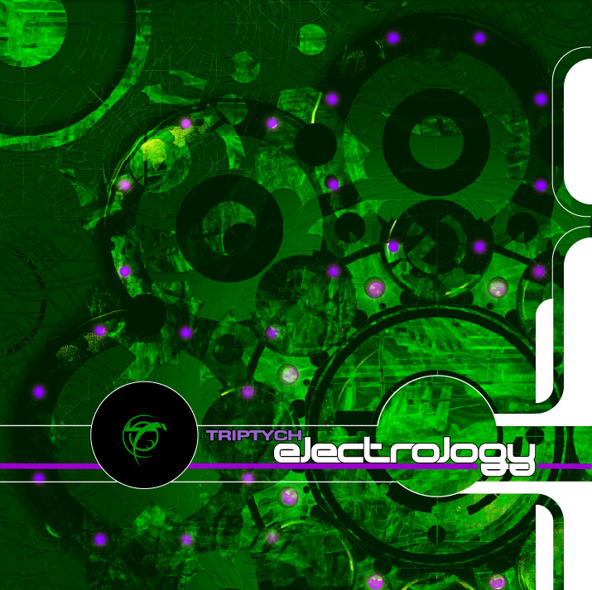

TTrCD013 – Manmademan –The legend remixes
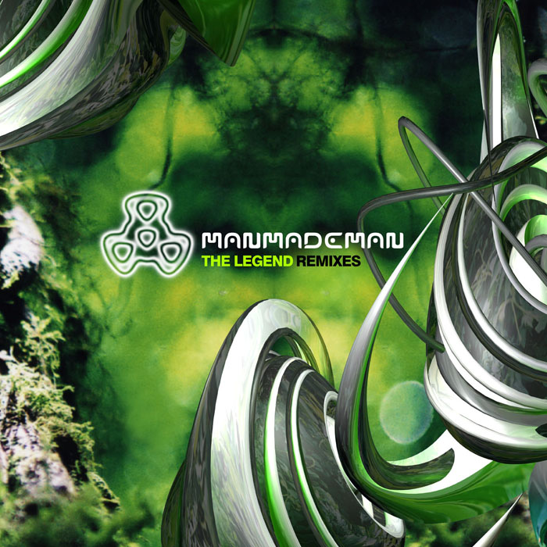
Triptych Desire remix
Polaris Down on earth remix
Hallucinogen Karahana remix
Eat Static Motion detector remix
Silicon Sound Halt Prod remix
Tristan Creation Myth remix
Manmademan William remix
System 7 Feeler remix
Tranan Arabian Daze remix

TTrCD014 – Elec3 – Plug & Play FEBRUARY 27th

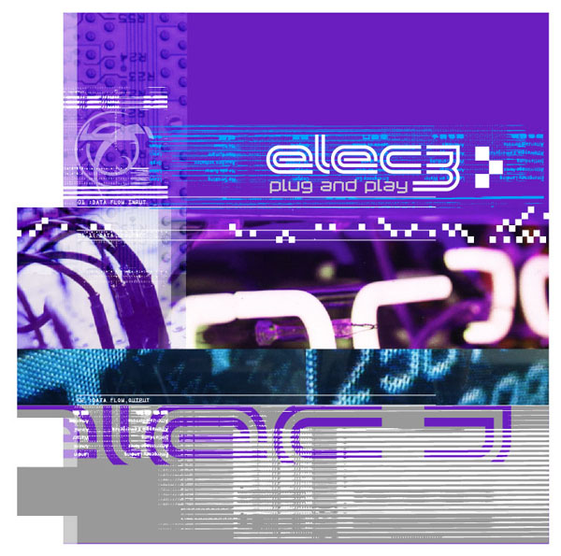
Plugged
Open doors
Nubus
Realizm
Pnp
Noisy therapy
Chaplog
Orchid extract
Unplugged

COMING SOON

TTrCD016 – Accelerator 3.0 – VA MAY 1st

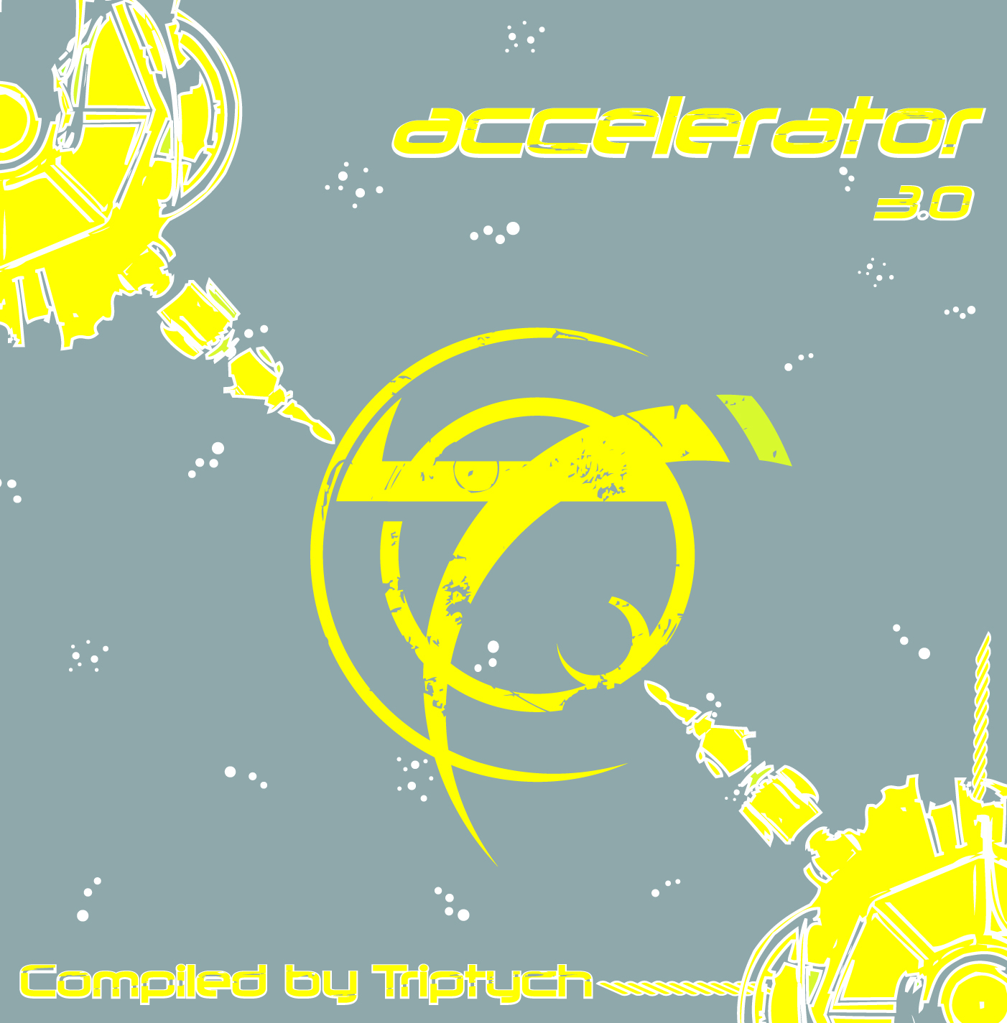
Ecliptic Unbelieving
Manmademan Strut
Tranan Mental expedition
Manmademan Karahana (Altom remix)
Triptych Numbers
Elec3 Think Pink
Mumbo Jumbo Mirage
Narcophone Vampire’s funk
Pop Stream & Triptych Beef

TTrCD017 – Triptych – The remixes JUNE 5th

Featuring Protoculture, Pop stream, Tranan, Manmademan, Elec3, Eat Static…

TTrCD018 – Pygmees Groove Volume 2 - VA OCTOBER 9th

TTrCD019 – Accelerator 4.0 - VA DECEMBER 4th

TTrCD020 – Tranan album January 22nd 2007

TTrCD021 – Pygmees Groove volume 3 - VA March 26th 2007

TTrCD022 – Accelerator 5.0 - VA May 1st 2007

