RETURN OF THE BOOM SHANTI–TRINITY SERIES 1
Compiled by Divinebalancedevi & Dbsonic collective
Divine Balance Records

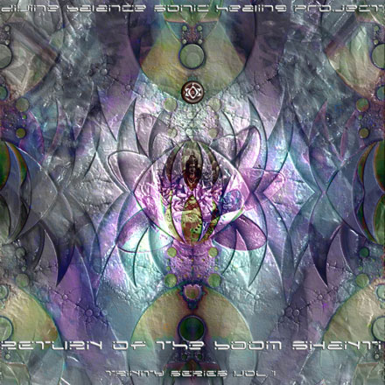 |  | RELEASE NOTES  Divine Balance Records is proud to present it’s first release, Return of the Boom Shanti- Trinity Series 1. Featuring 11 fresh and delicious unreleased tunes specially created for the DIVINE BALANCE SONIC HEALING PROJECT by inspiring and talented artists globally, in all genres of psychedelic soundz. This compilation was a collective effort of many artists, labels and families joining in celebrating the healing benefits of sound. All the tracks have been generously donated to promote and raise proceeds for research of SST(Sonic Sound Technology) Compiled by Chicago Label owner, Dj and Dr: Shai aka Divine Balance Devi and the rest of the DBSONIC collective. Return of the Boom Shanti is about the return to healing elements of sound. The human species suffers from a pervading imbalance because the eye dominates the ear. Many of our problems, ranging from unrest in our relationships to international conflicts, can be minimized through re-evaluating the way we view, utilize, and relate to sound. The Yoga of Sound can help us find balance for ourselves, our communities, and our world.  Enjoy this colourful concept of 24 hour full power in one hour… from the sunset to the sunrise…in one cd. Also be on the look out for Trinity 2 and 3, due to be released shortly after Trinity 1, with similar concepts and different genres of Dark Psy, Mornin Psy and Downtempo Psy  Label Profile:  Divine Balance Records(DBR) is a non-profit label subsidiary of the parent non-for-profit organization, Divine Balance Sonic Healing Research Institute(DBSHRI). This special worldwide Sound Healing Initiative is spearheaded by Dr. Shai (Sharmilla Patil, M. D.), founder of DBR/DBSHRI and one of the Primary partners of the DBSONIC Healing Project. The project partnership collective Board include Geomagnetic.tv(SF), RealityEngine(NYC), DataGrama(PT). In addition, many other International Labels, Artists, and Communities have signed on to support this project and we are excited about the current rapid rate of growth, success and progress that is manifesting it self. The revenue generated from all releases by DBR will be donated to the DBSONIC global research project. In addition, once this Sonic Sound Technology is developed, the proprietary knowledge and theories will be shared with the artists, so that they may implement this special sound healing technology into their music to create homeostasis and balance in the mind, body and soul of their listeners.
Title: | RETURN OF THE BOOM SHANTI- TRINITY SERIES 1
Artist: | dbsonic collective– v/a
Label: | DIVINE BALANCE RECORDS
Catalogue: | DBRCD001
Format: | 4-Panel Digipak
Barcode: | 9366977745254
Release: | JUNE 2006
TRACK LIST
01 Loud- Small Talk
02 Chromatone- Evolvelectro
03 Toxical-Chilli Pups
04 BioGenesis- Atomic tendencies
05 Delysid vs Wicked Wires- Illicit patterns
06 Jetlux-Tikpa
07 DivinebalanceDevi vs Jeto-Indalien temple
08 Digicult-The Zen Mind
09 Ananda Shake- Shy Eye
10 Tegma Feat. Path of Paradise-Path 1
11 Lauge-Winter Look

CREDITS
Mastered by Chromatone Waveworks
Engineering by Random
Distribution by Geomagnetic.tv
3D Art and effects by Underfoot, Yidam(Varun) and Psycosmo(James)
Conceptual Design by Shai Patil
(p) and © Divine Balance Records
http:/www.divinebalance.com
http:/www.dbsonic.org
info@divinebalance.com

