CHROMATONE - CHROMACONNECTION
Chromatone and Friends
VaporVent Records Cat.#: VV005

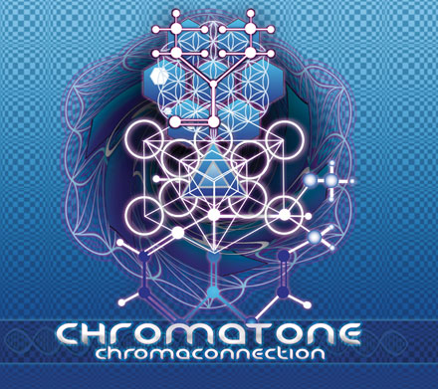 |  | RELEASE NOTES  Chromatone: "Chroma" meaning color in full spectrum and then divined into "Tone" or sound. Instead of sitting alone in a studio trying to make the same "Track" 9 times for an album, Chromatone teams up with his friends and favorite producers in order to create the ultimate collection of high level "Songs" with psychedelic story. Through the vision of trance that is heavy and driving while, uplifting and musical, Chromatone defines his powerful sound as "Maximalist". Using many layers to satisfy a great range of taste with every element from grinding snarly leads to beautiful majestic atmospheres that fly above the enormous bouncing bass lines and intricate percussion. Each track is a polished gem that stands on its own, and have been proven across the globe to propel dance-floors to the height of ecstatic exuberance. This truly one of a kind and timeless sonic experience is a must have CD that will be enjoyed over and over for years to come.  Label Profile:  Vaporvent is a creative entity that does not fall into one catagory. We are a collective of people that produce, create and reflect on the world around us.  We are musicians, designers, clothing-makers, software desigeners, travellers and life livers... Started in 1999 as a way to get our music out to the world and bypass the somewhat hostile avenues of media release, we formed our own label. Though the growth has been organic, we have created a network around the world through our creations and energy.In the spirit of the co-op, we love to meet new like-minded creators and see vaporvent as an evolving entity reflecting back on the great creation of life itself!  Artist Profile:  Chromatone is Lawrence Hoffman, a San Francisco native who has been producing electronic music for over a decade. Working as a professional audio consultant, producer, engineer, he is also doing mastering for many labels: Vapor Vent, Peak Rec, Geomagnetic.tv, Mind Funk, Noise Poison, Drop Out, plus a growing list of clients. After training in visual arts with the legendary Doctor Spook they produced the Video: “Chromatone - Mightochondria” released on the successful Geomagnetic “Magnus” and "Virtual Vortex" DVDs. As VJ Dr. Hoffman he has now projected visuals at several events.  After releasing four trax on King Records Japan, Lawrence compiled the CD “Vaporize” for his own label Vapor Vent. Then working in France with Mechanik records to produce, mix, and master the double comp, “Mechanik Castle”. Back in San Francisco, many collaborations with his studio partner Random produced releases including trax on Spun, Acidance, and Time Code records.
Title: | CHROMACONNECTION
Artist: | CHROMATONE
Label: | VAPORVENT RECORDS
Catalogue: | VV004
Format: | 4-Panel Digipak
Barcode: | 9366977745247
Release: | JULY 2006
TRACK LIST
1. Merciful Error
(+ Random + Helios) 145 F
2. Existentialist Detectives
(+ *Christine* ) 145 F
3. Biiiig Sticky (+ Earthling + Random) 145 E
4. Strengthen the Strange
(+ CPU + Random) 147 E
5. Spiritual Reality
(+ Digital Talk + Random) 147 G
6. Glow-stick Armageddon
(+ Freaks of Nature) 149 G
7. Laser Wax
(+ Hyper Frequencies + Random) 147 G
8. Electryk ChroMama
(+ Neuromotor/ ESXS) 144 G#
9. Green Power House
(+ Rob-ot + Psytony) 135 E

CREDITS
Mastered by Chromatone Waveworks
Engineering by Chromatone
Distribution by Geomagnetic Distro and Acidance Distro. File (Japan)
(p) and © Vaporvent Records
www.vaporvent.com
www.geomagnetic.tv
info@geomagnetic.tv

