Cosmo Sounds Volume 01 – Compiled by Tripy and Mindstorm – (Cosmo Sounds)

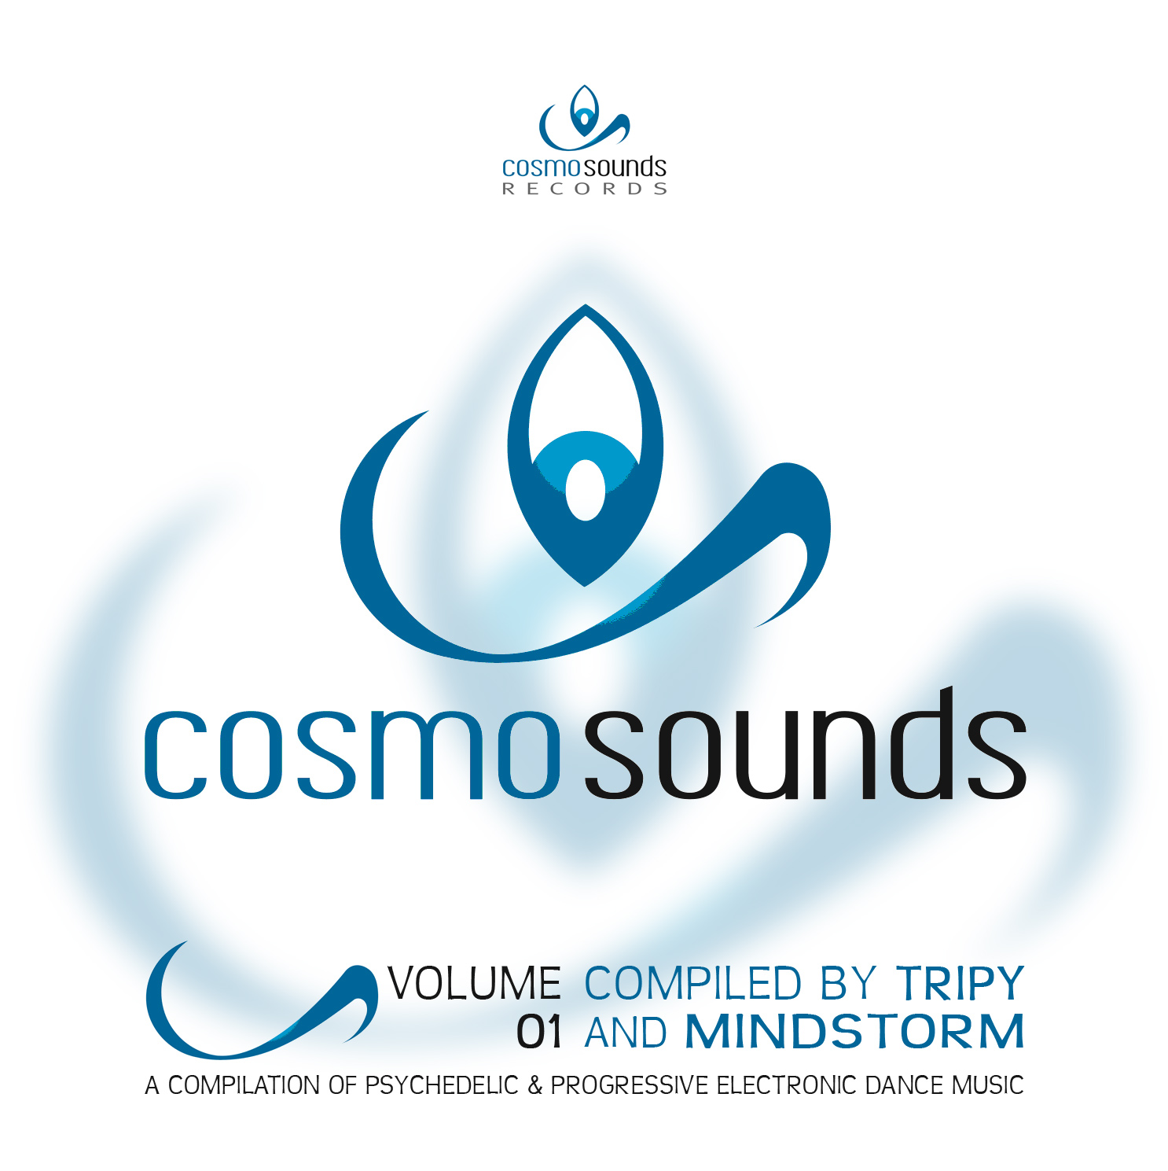 |  | RELEASE NOTES  Tripy and Mindstorm combine forces to deliver a unique and well balanced perfect selection for the summer season. 11 Strong tracks from the leaders of the underground sound will keep you dancing from sunset to sunrise. Enjoy this pure pleasure collection chosen by two dedicated party specialists. Tripy A.k.a Charlie Xuereb was born in Malta in 1977. Early in his youth Charlie felt a strong connection with music which became his life long focus. He experimented with different rhythms like break dance and hip hop. During his path to becoming a musician he met the sounds of electronic music like house, hard house, and experimental minimal techno until finally he was sucked into the Trance Sounds. In 2000 Tripy finds himself in Goa India and at the point it all changes. Since then he has dedicated his life and artistic energy into creating psytrance and dance gatherings. After all this he decided to move to Australia where he is now performing live and mainly focusing on more music productions in morning melodic music. He met with Doctor Spook and found a home for his unique uplifting sound with the Digital Drugs Coalition / Geomagnetic Morning star label family and is lined up to introduce his brand new fresh Album. Tripy has released some singles and as well the Shamanik Concept EP and expect many more to come rocking hits coming soon to the dance floors around the world. MINDSTORM (aka Nathan Vogel aka Doctor Spook) has morphed into an amazing LIVE VISUALS AND MUSIC project that Doctor Spook has been realizing from the SAN FRANCISCO based GEOMAGNETIC World Headquarters. Musically Spook is collaborating with a stream of the worlds leading musical masterminds inlcuding Tamir Ozana from Atomic Pulse, Chromatone and Random, Altom, Earthling, Central Processing Unit & Twisted Reaction Mindstorm has a strong concept with each track, a detail lacking in much of todays dance music. COSMO SOUNDS RECORDS is an electronic dance music label from Australia focused on psychedelic trance, progressive and psychill artists from around the globe who are creating the sound that the dance floors of the world crave!  Artist Profile: www.myspace.com/tripy3p| www.myspace.com/mindstorm1  Tripy A.k.a Charlie Xuereb was born in Malta in 1977. Early in his youth Charlie felt a strong connection with music which became his life long focus. He experimented with different rhythms like break dance and hip hop. During his path to becoming a musician he met the sounds of electronic music like house, hard house, and experimental minimal techno until finally he was sucked into the Trance Sounds. In 2000 Tripy finds himself in Goa India and at the point it all changes. Since then he has dedicated his life and artistic energy into creating psytrance and dance gatherings. After all this he decided to move to Australia where he is now performing live and mainly focusing on more music productions in morning melodic music. He met with Doctor Spook and found a home for his unique uplifting sound with the Digital Drugs Coalition / Geomagnetic Morning star label family and is lined up to introduce his brand new fresh Album. Tripy has released some singles and as well the Shamanik Concept EP and expect many more to come rocking hits coming soon to the dance floors around the world.  MINDSTORM (aka Nathan Vogel aka Doctor Spook) has morphed into an amazing LIVE VISUALS AND MUSIC project that Doctor Spook has been realizing from the SAN FRANCISCO based GEOMAGNETIC World Headquarters. Musically Spook is collaborating with a stream of the worlds leading musical masterminds inlcuding Tamir Ozana from Atomic Pulse, Chromatone and Random, Altom, Earthling, Central Processing Unit & Twisted Reaction Mindstorm has a strong concept with each track, a detail lacking in most dance music.  Label Profile: www.myspace.com/geomagnetic | www.geomagnetic.tv  COSMO SOUNDS RECORDS is an electronic dance music label from Australia focused on psychedelic trance, progressive and psychill artists from around the globe who are creating the sound that the dance floors of the world crave! www.myspace.com/cosmosoundsrecords  Morningstar, division of Geomagnetic Records. Uplifting, melodic, full-on, progressive and perfect for those ecstatic moments of sunshine and awakening, we know you want to be carried on a cloud of feel-good grooviness as you welcome the morning light!  Geomagnetic.tv was established in the summer of 2001 by Dr. Spook one of the founders of the prominent San Francisco 3D FX and Multimedia boutique known as Minds Eye Media (est.1995). www.mindseyemedia.com  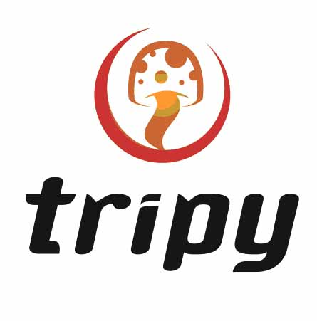
Title: | Cosmo Sounds Volume 01
Artist: | v/a by Tripy & Mindstorm
Label: | Cosmo Sounds Records
Catalogue: | Cosm01
Format: | 4-Panel JewelCase Audio CD
Barcode: | 881034378248
Release: | July 2009 World Wide
TRACK LIST

01 - Crying Freemen - Odyssey 2009 (Polypheme rmx)
02 - AtomicPulse vs Mindstorm - Psybernetic (TripyRmx)
03 - Electrypnose - Ornic (Random RMX)
04 - Imix - Alien Chakra
05 - Aya - Drugs Open Your Eyes (3mix)
06 - Goe - Carminaburana
07 - FrostRAVEN - The Time Traveler
08 - Hypohektika - Chicken Teriyaki
09 - TeTuna - Crop Circles
10 - Bratex - Take Your Time
11 - Chang - On The Run

CREDITS
Mastered by Sergio @ Meteor Burn Lab (Portugal)
Artwork: Tripy and Dr. Spook
Distribution: SaikoSounds.com / Geomagnetic
(p) and © Geomagnetic.tv / Morningstar Rec
http://geomagnetic.tv/news/cosm01
info@geomagnetic.tv mp3 Samples online.

