Album: Music from the New Edge – Vol:01

Artist: Various Artists
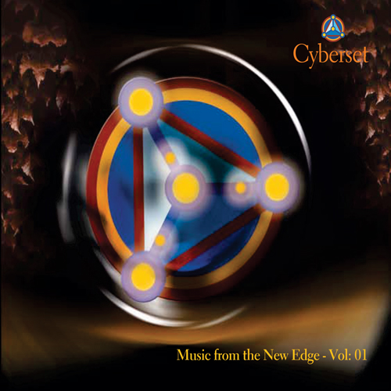
UPC #: 876585003282
Catalog: Cyber1025
Contact: info@cyberset.cc

Tracklisting:

01 Begin - Divasonic 2:58
02 Heaven - Electric Skychurch 5:46
03 Sufi Swirl - B.Smiley 5:33
04 Before They Came - David Satori 5:30
05 Purple & Orange - Welder 7:27
06 Effigy - hands upon black earth 7:22
07 Febru-wary - Single Cell Orchestra 6:14
08 Fountain of Life - Artemis 3:23
09 Leaf on a Wind - Irina Mikhailova 4:37
10 Dreamcycle - Foxgluv 5:46
11 Slowly - Aphrodesia 6:42
12 Sulvation Dub - LunaGroove 4:24
13 Weightless - The Wolfman 4:31
14 The River - Ayman 5:08

Brief Description: The styles range from Downtempo Electronica to Trip-Hop to New Age to World Beat, offering the listener a relaxing journey into the world of cutting-edge sounds. It is beautiful music for any occasion.

About the Artists: Cyberset’s growing family of artists blend musical elements of world, ambient, dance, vocal, and urban genres into fresh sounds that share the positive intentions and global reach of modern New Edge culture. Music from the New Edge – Vol:01 embodies this emerging culture with music and artists that promotes community, personal growth, social conscience, and ecological awareness. Cyberset music is available in digital format from all the major download sites and services as well from our own online catalog. CD’s are availale at select sites around the world.


CYBERSET MUSIC 861 40th Avenue, San Francisco, CA 94121 : 415-750-0971 : www.cyberset.cc

