Faxi Nadu – Modern Knight – DIGICD005, Digital Drugs Coalition / Faxi Island Rec.

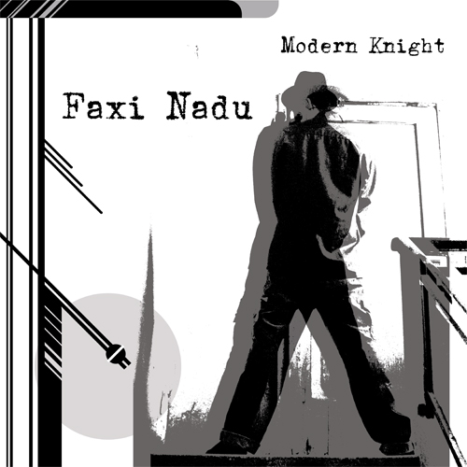 |  | RELEASE NOTES:  Faxi Nadu – Modern Knight – DIGICD005  Modern Knight is a real psytrance album - a true blend of psy without feeding off hype or fashion. True ghetto home cooked sound and sounds, packed with over seventy minutes of Faxi Nadu adventures. Ever since the 2003 net album Platinum Membership, Yaron has not released a full length album as Faxi Nadu, this Modern Knight has been waiting to emerge into our world. Enjoy!  Download FREE album promo zip (full tracks) in 160kbps mp3:  www.postunder.net/knight/faxi_nadu_-_modern_knight_160.zip  Artist Profile: myspace.com/elmooht  Faxi Nadu aka Yaron Eshkar is a highly accomplished electronic music producer from Israel. He produces music under the aliases: Faxi Nadu / Elmooht / Cider Groove / D-Fault. He also runs Postunder Records, where many of his releases can be found for free mp3 download. www.faxinadu.net  Label Profile: myspace.com/geomagnetic  Digital Drugs Coalition is a union of psychedelic trance artists from around the globe who believe that digital art + music are the purest form of getting high. Expect unique, fresh + truly out of this world productions from this hot posse!!  GEO-ISRAEL is a subdivision of Geomagnetic Records, offering the most cutting edge sounds from the hottest new artists of the Israeli psychedelic underground. With no distinguishing night and day, day and night, GEO-Israel offers a thick, light, full-on and dark aural journeys to enhance your trance dancing experience!  Geomagnetic.tv was established in the summer of 2001 by Dr. Spook one of the founders of the prominent San Francisco 3D FX and Multimedia boutique known as Minds Eye Media (est.1995). www.mindseyemedia.com  Faxi Island / Postunder Records are the personal labels of Yaron Eshkar. www.faxinadu.net | www.postunder.net  
Title: | Modern Knight
Artist: | Faxi Nadu
Label: | Digital Drugs Coalition / Faxi Island
Catalogue: | DIGICD005
Format: | 4 Panel Insert Jewel CD / DDL
Barcode: | 881034184696
Release: | July 2008
TRACK LIST

01 I Am The Night
02 Take Cover
03 Issue At Stake
04 Pace Of The Space Race
05 Remember The Alamo
06 Crazy People Attacking
07 Escalating Fetishist
08 Crisis
09 Heart Of Glory
10 Sweep Dreams
----------------------------------------------------------
CREDITS:
Produced by: Yaron Eshkar www.faxinadu.net
Mastering: Xenomorph www.xeno-morph.net
Album graphics: Hadar Lubaton
Distribution: Psyshop.com, Saikosounds.com, Goa-Records.com
(p) and © www.Geomagnetic.tv
info@geomagnetic.tv
More info online.
geomagnetic.tv/labels/DigitalDrugs/DIGICD005-FaxiNadu-ModernKnight



