Digital Drugs 4 Robot Revolution v/a Prescribed by Dr Spook (Mindstorm)
[ DIGICD004 ] Digital Drugs Coalition / DARKSTAR / Geomagnetic.tv

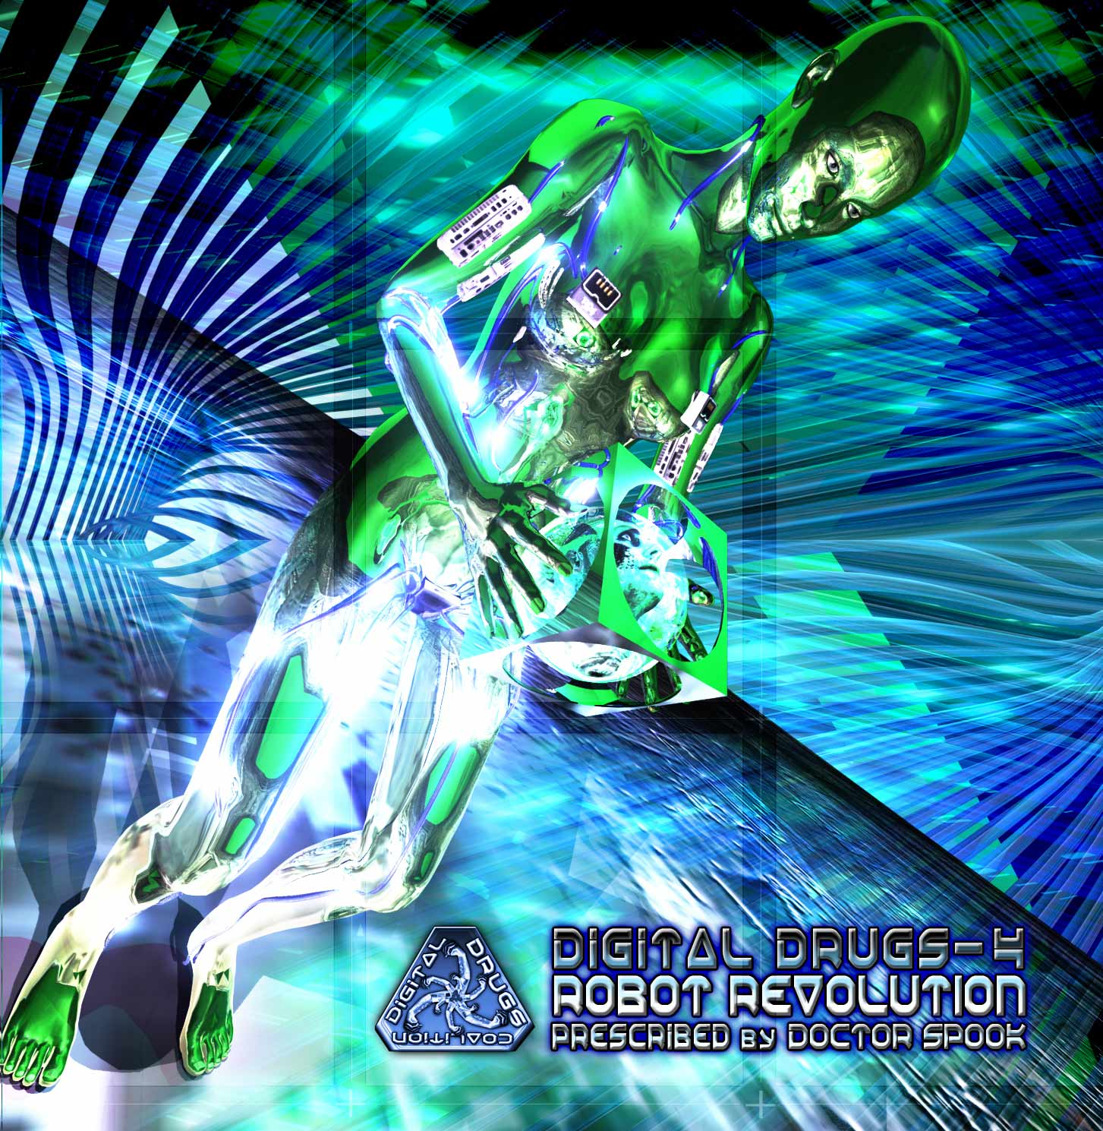 |  | RELEASE NOTES  Digital Drugs is a coalition of psychedelic trance artists from around the globe who believe that digital art + music are the purest form of getting high. expect unique, fresh + truly out of this world productions from this hot posse !! This wild new cd showcases the most respected dark psy producers together next to a crew of talented artists that are less well known but also quite talented! The disc opens with a melodic and uplifting corker by Dr.Hoffman vs. MindController a dynamic duo from Guadalajara Mexico. Its followed by a reserved yet full on blaster by Psyshark vs Kalilaskov AS both from Israel with what is deep and haunting ballad fittingly titled Butterfly. Virtual Light from Canada and Wizack Twizack from Sweden transcend all boundaries and deliver up the revolutionary title track. Overhuman from Columbia gives us a mental excursion we wont forget. Paraforce from India steps things up a notch to rattle our screws loose with a full throttle mind slammer. Next up K Lapso from Portugal remixes an ultra classic by none other than Iron Madness! From there Darkforce from Israel slips on the psy helmet with this burst of dark comedy. Next are two fanatical artists from the USA West Coast. Facehead ensures that escape in not wanted while Frost Raven makes us beg to know more this mysterious wizard of wump. Tricossoma from Portugal points out that those with Fear seldom attain their goals. From here legendary and most versatile psy trance artist on the planet maestro Random from psychedelic capital, San Francisco doses us with a memorable closer of titanic dimensions. From start to what no doubt is a finish you wont ever want to end this full spectrum romp from a truly international team delivers the goods to places you didn’t know that sorely needed a solid dose.  Artist Profile:  By Doctor Spook (Mindstorm) MINDSTORM (aka Nathan Vogel aka Doctor Spook) has morphed into an amazing LIVE VISUALS AND MUSIC project that Doctor Spook has been realizing from the SAN FRANCISCO based GEOMAGNETIC World Headquarters. Musically Spook is collaborating with a stream of the worlds leading musical masterminds inlcuding Tamir Ozana from Atomic Pulse, Chromatone and Random, Altom, Earthling, Central Processing Unit & Twisted Reaction Mindstorm has a strong concept with each track, a detail lacking in much of todays dance music.  Label Profile:  Digital Drugs Coalition is a union of psychedelic trance artists from around the globe who believe that digital art + music are the purest form of getting high. Expect unique, fresh + truly out of this world productions from this hot posse!!  Darkstar is the sub-label of Geomagnetic that focuses on Dark, Night time music, with hard and experimental styles.  Geomagnetic.tv was established in the summer of 2001 by Dr. Spook one of the founders of the prominent San Francisco 3D FX and Multimedia boutique known as Minds Eye Media (est.1995). www.mindseyemedia.com
Title: | Digital Drugs4 – Robot Revolution
Artist: | v/a Prescribed by Dr. Spook
Label: | Digital Drugs Coalition
Catalogue: | DIGICD008
Format: | 6-Panel Booklet Jewel CD
Barcode: | 881034279095
Release: | November 2008 World Wide
TRACK LIST

01.Dr.Hoffman_vs._MindController-Daydreaming
02.Psyshark_vs_KalilaskovAS-Butterfly
03.Virtual Light vs Wizack Twizack-Robot_Revolution
04.Overhuman_Project_Senti-Mental
05.Paraforce-Psychedelic_Virus
06.Iron_Madness-Psycho_Piano_(K_Lapso_RMX)
07.Darkforce-HeadGear
08.FaceHead-NooScape
09.FrostRaven-Merlin_The_Wise
10.Tricossoma-Those_With_Fear
11.Random-The_System_Is_Down

CREDITS
Mastered by Random @ Geomagnetic Studios
Artwork by Nathan Vogel aka Dr. Spook
Distribution by Saiko Sounds & Psyshop
(p) and © www.Geomagnetic.tv
http://www.geomagnetic.tv/labels/DigitalDrugs/DIGICD008-RobotRevolution info@geomagnetic.tv
