Paraforce – Assassins – DIGICD010 –Digital Drugs Coalition / Darkstar

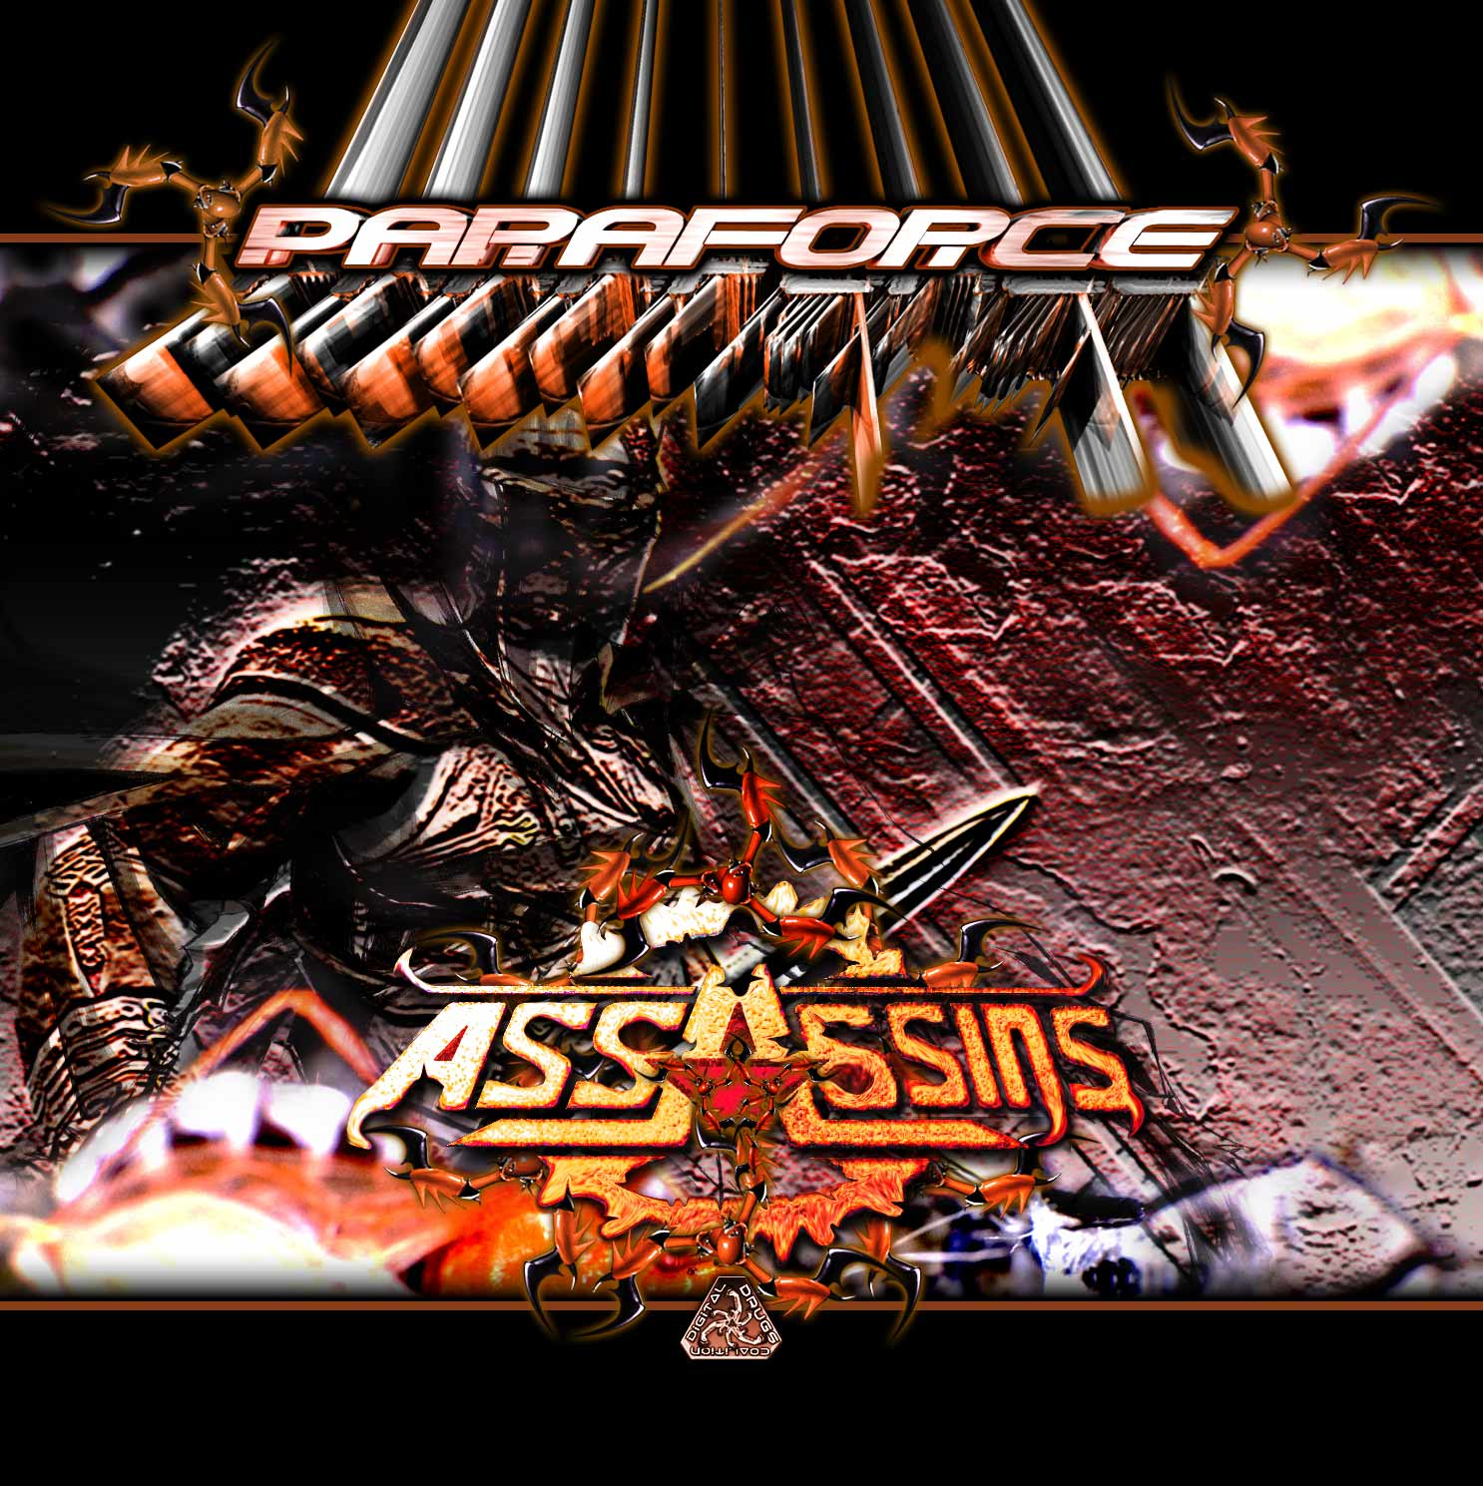 |  | RELEASE NOTES:  Paraforce – Assassins – DIGICD010  “Assassins” is the latest full power offering from Indian native Varun Anand aka Paraforce (New Delhi). His style is a ferocious blend of mind warping dark psytrance and brain boggling industrial techno with an average of 150 bpm. The title “Assassins” has the root in the name of a long ago people who were reputed to have the greatest “killers” in the land. The word Assassin goes farther back than being mere “killers” for this people were actually called Hashishins and because things are how they are folks got lazy and simple called them Ashishins and then Assassins. This people were said to have even better hashish (it was killer) and was actually used as part of the ritual of creating and training specially selected people that if proven worthy would become a “lone gunman” style assassin. These initiates after passing all the martial tests given copious amounts of the best Hashish to the point of feeling like they died. When they awoke they find them selves transported to a “magical place” where “all there wishes and fantasies were granted but with message being that they had died and gone to heaven but they would be given one chance to return to the real world to perform a special duty and if completed could return to “Paradise” forever. This 2nd full length album takes you through the training procedures and rigorous processes entailing becoming a master assassin. Prepare for an excruciating yet ultimately rewarding ordeal to attain a new level of awareness!  Artist Profile: myspace.com/paraforceproject  Paraforce is the solo trance music project of Varun Anand, based in New Delhi, India. He started going to psy trance parties at the age of 17 and after 4 yrs of understanding the music he started playing at parties in the hills and later decided to make his own music with a feeling of gothic and darkness to take u all on a trip, a trip to self awareness and eternity. Varun prefers to create tracks with hard and driving bass lines, twisted leads and heavy atmospheric sounds. He aims to give the listener’s a gothic and psychedelic experience. geomagnetic.tv/artists/paraforce.htm  Label Profile: myspace.com/geomagnetic  Digital Drugs Coalition is a union of psychedelic trance artists from around the globe who believe that digital art + music are the purest form of getting high. Expect unique, fresh + truly out of this world productions from this hot posse!!  Darkstar is the sub-label of Geomagnetic that focuses on Dark, Night time music, with hard and experimental styles.  Geomagnetic.tv was established in the summer of 2001 by Dr. Spook one of the founders of the prominent San Francisco 3D FX and Multimedia boutique known as Minds Eye Media (est.1995). www.mindseyemedia.com  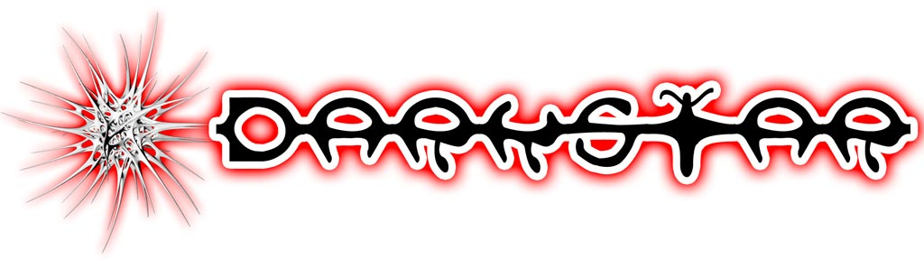
Title: | Assassins
Artist: | Paraforce
Label: | Digital Drugs / Darkstar
Catalogue: | DIGICD010
Format: | 4 Panel Insert Jewel CD / DDL
Barcode: | 881034279040
Release: | Expected December 2008
TRACK LIST

1.Master Of Torture (148)
2.Cutting The Cheese (152)
3.Divine Moment Of Truth (150)
4.Agressively Sequenced (152)
5.Pleasures And Treasures (150)
6.Wilderness (150)
7.The Dark Tunnel (RMX) (150)
8.Insanity (148)
9.Sixth Sense (150)
10.Travelling With Time (150)
----------------------------------------------------------
CREDITS:

MASTERED BY: TIM SCHULTZ 4CN STUDIOS
Artwork by: Doctor Spook
Distribution by: Psyshop, Saikosounds, Crystal-Code / Goa-Records.com
(p) and © www.Geomagnetic.tv
info@geomagnetic.tv More info online.
www.geomagnetic.tv/labels/GEO-Darkstar/GEOCD029-Paraforce-DeepForest

