FrostRaven – Star Muse – DIGICD011 – Digital Drugs Coalition /Geo-Morningstar

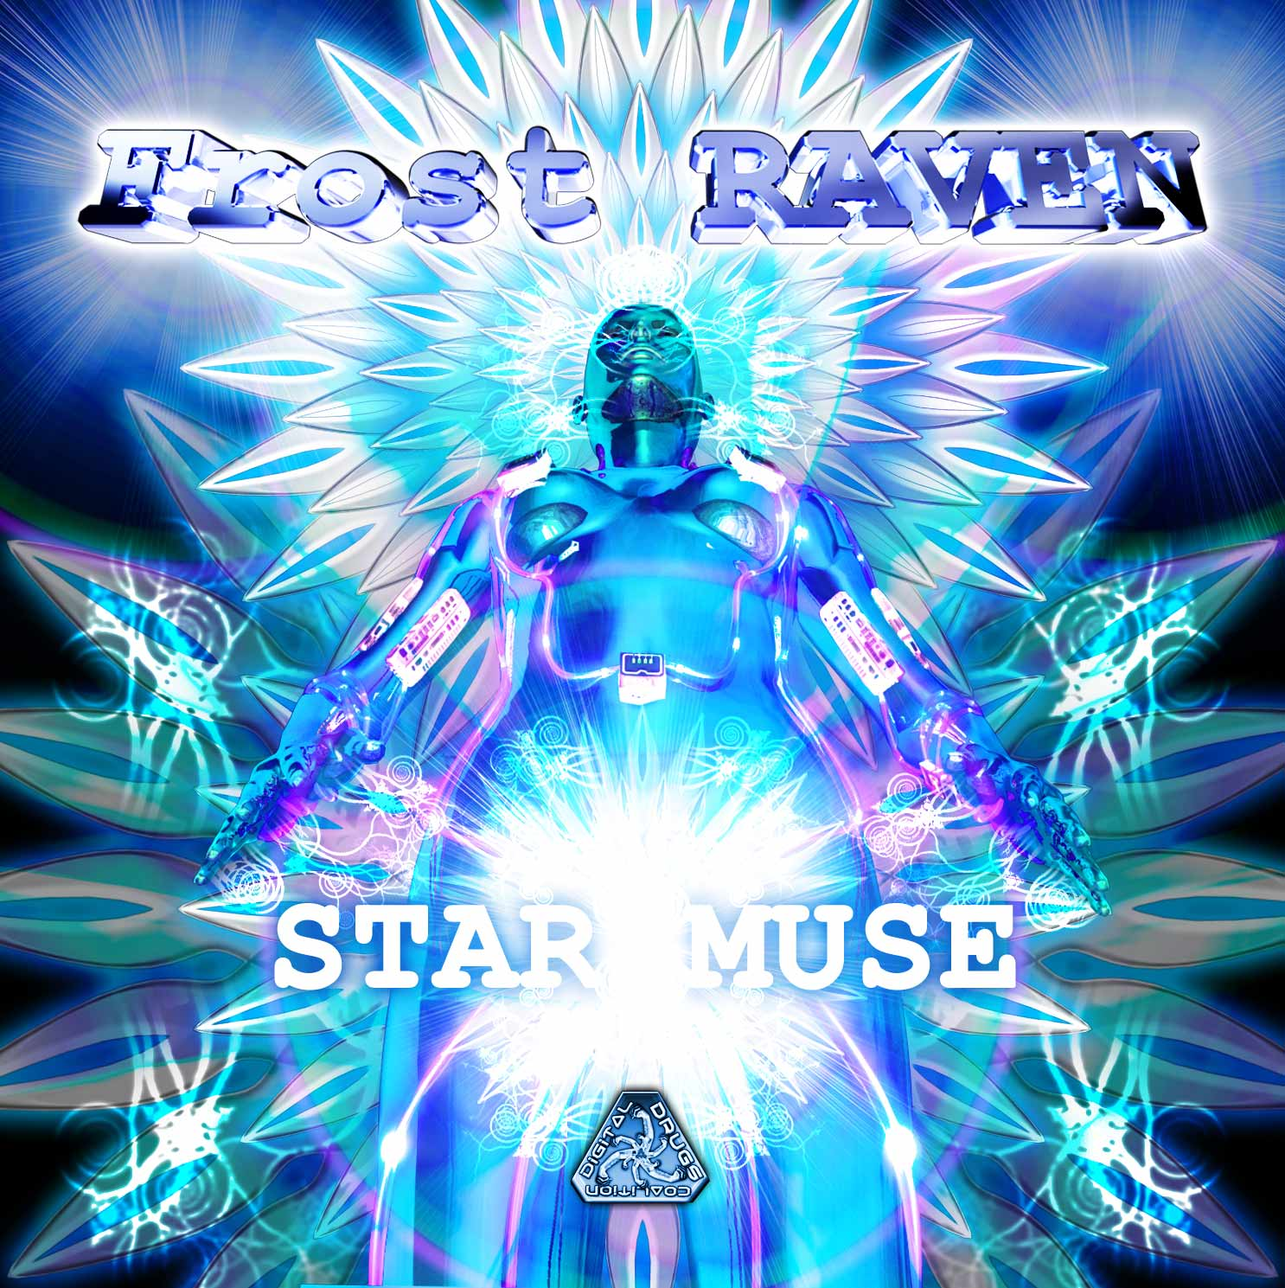 |  | RELEASE NOTES: FrostRaven – Star Muse Digicd011  Frost Raven’s debut full length CD Album entitled “Star Muse” is the latest in cutting edge full power and progressive psychedelic Goa trance music. Artists like Frost Raven from the San Francisco’s bay area underground dance scene are the creative force for this seminal sound that is dominating today’s biggest clubs, festivals and stadiums. Since the early 90s this genre has continued on to become the leading sound in the underground dance culture. This world class EP demonstrates the style, production skill, and catchy hooks that have driven this sound to the top of the charts. Frost Raven’s unmistakable melodic sound is crystal clear and full of heart. Get ready to upgrade your music collection with this top of the stack winner! With a background in film and theater soundtrack composition, Frost Raven started out with applications such as Soundforge and ACID Pro. After attending Pyramind; The Institute for Advanced Digital Audio Training, Dustin Musser (aka Frost-RAVEN) gained the skills and exposure necessary to elevate his music to a new level. While in school Dustin was offered a digital contract for his album Desert Walker, which alongside his electro-house EP Fire City, quickly began to dominate INgroove's new releases charts on Beatport.com. However Dustin Musser's true passion is psychedelic trance music. Currently Frost-RAVEN has a number of projects on tap. His new down-tempo EP Deep in Blue is set for spring release on the INgooves digital label. Also new tracks can be heard CD compilation due out February on the Geomagnetic label. Frost-RAVEN is also the co-founder of Somasoundsystem, a Bay Area collective of DJs and producers. Together they represent fresh sounds and pre-current trends:  Artist Profile: www.myspace.com/frostraven  With a background in film and theater soundtrack composition, Frost Raven started out with applications such as Soundforge and ACID Pro. After attending Pyramind; The Institute for Advanced Digital Audio Training, Dustin Musser (aka Frost-RAVEN) gained the skills and exposure necessary to elevate his music to a new level. While in school Dustin was offered a digital contract for his album Desert Walker, which alongside his electro-house EP Fire City, quickly began to dominate INgroove's new releases charts on Beatport.com. However Dustin Musser's true passion is psychedelic trance music. Currently Frost-RAVEN has a number of projects on tap. His new down-tempo EP Deep in Blue is set for spring release on the INgooves digital label. Also new tracks can be heard CD compilation due out February on the Geomagnetic label. Frost-RAVEN is also the co-founder of Somasoundsystem, a Bay Area collective of DJs and producers. Together they represent fresh sounds and pre-current trends:  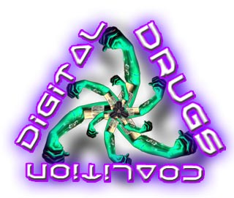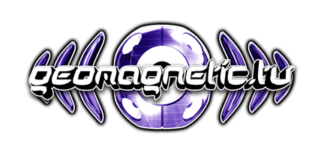  Label Profile: www.myspace.com/geomagnetic  Digital Drugs Coalition is a union of psychedelic trance artists from around the globe who believe that digital art + music are the purest form of getting high. Expect unique, fresh + truly out of this world productions from this hot posse!! www.myspace.com/digitaldrugscoalition  Morningstar, division of Geomagnetic Records. Uplifting, melodic, full-on, progressive and perfect for those ecstatic moments of sunshine and awakening, we know you want to be carried on a cloud of feel-good grooviness as you welcome the morning light!  Geomagnetic.tv was established in the summer of 2001 by Dr. Spook one of the founders of the prominent San Francisco 3D FX and Multimedia boutique known as Minds Eye Media (est.1995). www.mindseyemedia.com
Title: | Muse
Artist: | FrostRaven
Label: | Goa Records and Geo-Morningstar
Catalogue: | GOAEP005
Format: | 1 Panel Insert Audio CD & DDL
Barcode: | 881034098511
Release: | Nov 2008
TRACK LIST

01-FrostRaven - Starchaser
02-FrostRaven - The Well
03-FrostRaven - Tabula Rasa
04-FrostRaven - Night_Freak
05-FrostRaven - Muse
06-FrostRaven - Nightmares
07-FrostRaven - Lore
08-FrostRaven - Dark Wood
09-Virtual Light - Nuclear Sun(FrostRaven RMX)

CREDITS:
MASTERED BY: Tyler Straub, San Francisco
Artwork by: doctorspook@hotmail.com
Distribution by Saikosounds / Psyshop
(p) and © Geomagnetic.tv / Goa Rec. 2008
info@geomagnetic.tv More info online.
http://geomagnetic.tv/labels/DigitalDrugs/DIGICD011-FrostRaven-StarMuse/



