Virtual Light – Livewire Voodoo, [DIGICD013] Digital Drugs Coalition (Morningstar / Geomagnetic.tv)

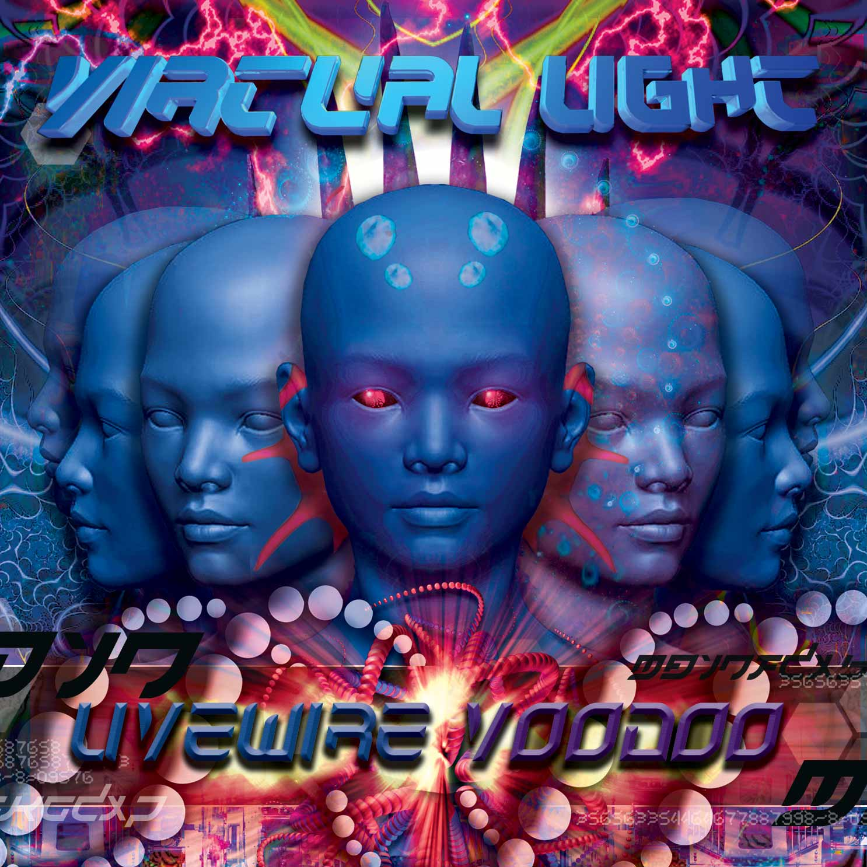 |  | RELEASE NOTES Virtual Light – Livewire Voodoo  VIRTUAL LIGHT, Canada native based in Montreal delivers the long awaited debut album comprising his most magical dance floor hits all in one mind warping package. Virtual Light’s style is an un-quantifiable hybrid of full on morning psytrance that takes up from the melodic and mental romping grounds of Logic Bomb and then is injected deep into the mainframe where your DNA is recoded into tiny digital nano-bots and you are reborn in the matrix as new form of life. Each track is a tale of adventure and survival chronicling the possible fate of humankind in a world where life is about enjoying each and every moment to the fullest and to relentlessly create a better world for humankind. As the first track starts out (an incredible odyssey co-created with Ross Dubois aka San Francisco based producer, Random) your are instantly catapulted into the matrix via a series of cell scanning holographic re-construction and INFECTED by the matrix. Your bits are transferred to the deepest dungeons of CASTLEVANIA where the mad psyentists begin their tests on you and the other prisoners in the CONCENTRATION CAMP forcing you to dance and have fun. When you wake you find your self woven into a mystic CRYSTALIS. As you shed your DEAR HUMAN body and bold arise to become a new form of life custom built to dance, the GRIM LEAPER. Now in your new digenetically designed body you can survive the expanded spectrum of our NUCLEAR SUN. Though your hybrid form is still X-PERIMENTAL you know you can save the world and tranceform humanity! It is a ROBOT REVOLUTION so don’t miss this experience. Tune in on RADEON RADIO for more details…  Back in the real world Vince aka Virtual Light is a relentless dj, party promoter, graphic/clothes designer and a world class top shelf international psy-producer as well. His Dj and Live sets have been known to send dance floors to other planets and back and his unique style of uplifting full on psychedelic trance is nothing short of amazing! His first artists release was in 2006 on legendary VA compilation "PSYCHIC CHAKRA". Since then he’s had over 20 more popular releases on some of the most well known labels in psytrance including Nano, Kagdilla, Psytropic, Goa Rec, Digital Drugs, Hearts Eye Rec and the Geomagnetic label family. Look for many more hit releases coming soon! Virtual Light has a successful side project with Random entitled “Random Light” that also has a full album coming soon.  Free Track – Nuclear Sun http://www.sendspace.com/file/zi5rqv  Artist Profile: www.myspace.com/virtuallight23  VIRTUAL LIGHT is based in Montreal, Canada. He Is a relentless dj, party promoter, graphic/clothes designer and a world class top shelf international psy-producer as well. His Dj and Live sets have been known to send dance floors to other planets and back and his unique style of uplifting full on psychedelic trance is nothing short of amazing! His first artists release was in 2006 on legendary VA compilation "PSYCHIC CHAKRA". Since then he’s had over 20 more popular releases on some of the most well known labels in psytrance including Nano, Kagdilla, Psytropic, Goa Rec, Digital Drugs, Hearts Eye Rec and the Geomagnetic label family. Look for many more hit releases coming soon! Virtual Light has a successful side project with Random entitled “Random Light” that also has a full album coming soon.  Label Profile: www.myspace.com/geomagnetic | www.geomagnetic.tv  Digital Drugs Coalition is a union of psychedelic trance artists from around the globe who believe that digital art + music are the purest form of getting high. Expect unique, fresh + truly out of this world productions from this hot posse!! www.myspace.com/digitaldrugscoalition  Morningstar, division of Geomagnetic Records. Uplifting, melodic, full-on, progressive and perfect for those ecstatic moments of sunshine and awakening, we know you want to be carried on a cloud of feel-good grooviness as you welcome the morning light!  Geomagnetic.tv was established in the summer of 2001 by Dr. Spook one of the founders of the prominent San Francisco 3D FX and Multimedia boutique known as Minds Eye Media (est.1995). www.mindseyemedia.com
Title: | Virtual Light – Livewire Voodoo
Artist: | Virtual Light
Label: | Digital Drugs Coalition
Catalogue: | DIGICD013
Format: | 4-Panel Jewel Case CD
Barcode: | 881034278999
Release: | May 2009 World Wide
TRACK LIST

01. Infected*
02. Castlevania
03. Concentration Camp
04. Crystalis
05. Dear Human
06. Grim Leaper
07. Nuclear Sun
08. X-perimental*
09. Robot Revolution*
10. Radeon Radio

* t1 – w/Random, t8-w/Intersys,
t9 w/ Wizack Twizack

-----------------------------------------------
CREDITS
Artwork by Virtual Light & Dr. Spook
Distribution by Saiko Sounds & Geomagnetic Rec
(p) and © www.Geomagnetic.tv
http://www.geomagnetic.tv/news/digicd013 info@geomagnetic.tv
