TRIPY A.k.a Charlie Xuereb - “Shamanik Concept” CD – (Digital Drugs Coalition / Cosmo Sounds)

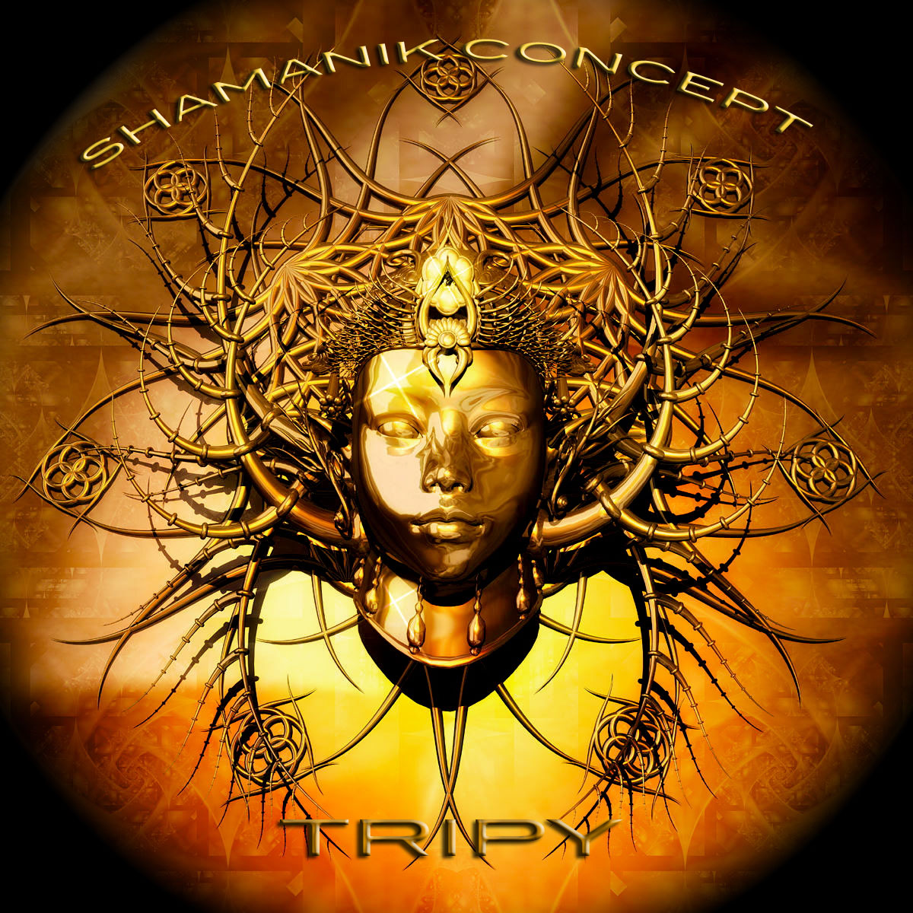 |  | RELEASE NOTES  Shamanik Concept is the eagerly expected debut album for Maltese born, Australian legend: Tripy aka Charlie Xuereb. As the first rumbling bass notes grinds your hips you know you are in for a full body treat that captivates you the moment it washes over your soul. A story in each track fulfills the needs of psy and goa freaks alike with spicy melodies, elaborate bass lines, intricate rhythms and wild psychedelic personality. Australia’s best kept secret finds a perfect niche where Mr. Peculiar and Fractal Glider have blazed trails through the outback Tripy continues to forage ahead into unknown mental-bolic escapades. Sure to make you dance and laugh at any time of the party this music is ready for the summer festivals and packed clubs as well the intimate doof in the woods. Treat your self and your tribe to the new sound from the underground and look out for more Tripy productions come to you soon from downunder… Tripy A.k.a Charlie Xuereb was born in Malta in 1977. Early in his youth Charlie felt a strong connection with music which became his life long focus. He experimented with different rhythms like break dance and hip hop. During his path to becoming a musician he met the sounds of electronic music like house, hard house, and experimental minimal techno until finally he was sucked into the Trance Sounds. In 2000 Tripy finds himself in Goa India and at the point it all changes. Since then he has dedicated his life and artistic energy into creating psytrance and dance gatherings. After all this he decided to move to Australia where he is now performing live and mainly focusing on more music productions in morning melodic music. He met with Doctor Spook and found a home for his unique uplifting sound with the Digital Drugs Coalition / Geomagnetic Morning star label family and is lined up to introduce his brand new fresh Album. Tripy has released some singles and as well the Shamanik Concept EP and expect many more to come rocking hits coming soon to the dance floors around the world.  Artist Profile: www.myspace.com/tripy3p  Tripy A.k.a Charlie Xuereb was born in Malta in 1977. Early in his youth Charlie felt a strong connection with music which became his life long focus. He experimented with different rhythms like break dance and hip hop. During his path to becoming a musician he met the sounds of electronic music like house, hard house, and experimental minimal techno until finally he was sucked into the Trance Sounds. In 2000 Tripy finds himself in Goa India and at the point it all changes. Since then he has dedicated his life and artistic energy into creating psytrance and dance gatherings. After all this he decided to move to Australia where he is now performing live and mainly focusing on more music productions in morning melodic music. He met with Doctor Spook and found a home for his unique uplifting sound with the Digital Drugs Coalition / Geomagnetic Morning star label family and is lined up to introduce his brand new fresh Album. Tripy has released some singles and as well the Shamanik Concept EP and expect many more to come rocking hits coming soon to the dance floors around the world.  Label Profile: www.myspace.com/geomagnetic | www.geomagnetic.tv  Digital Drugs Coalition is a union of psychedelic trance artists from around the globe who believe that digital art + music are the purest form of getting high. Expect unique, fresh + truly out of this world productions from this hot posse!! www.myspace.com/digitaldrugscoalition  Morningstar, division of Geomagnetic Records. Uplifting, melodic, full-on, progressive and perfect for those ecstatic moments of sunshine and awakening, we know you want to be carried on a cloud of feel-good grooviness as you welcome the morning light!  Geomagnetic.tv was established in the summer of 2001 by Dr. Spook one of the founders of the prominent San Francisco 3D FX and Multimedia boutique known as Minds Eye Media (est.1995). www.mindseyemedia.com  
Title: | TRIPY – Shamanik Concept
Artist: | TRIPY
Label: | Cosmo Sounds / Digital Drugs
Catalogue: | Digicd014
Format: | 4-Panel JewelCase Audio CD
Barcode: | 881034279149
Release: | May 2009 World Wide
TRACK LIST

01. Shiva Was Born - 145 bpm
02. Shamanik Concept - 145 bpm
03. Spiral Dream – 145 bpm
04. Cosmic Sounds - 145 bpm
05. Koma - 145 bpm
06. Light Of Wisdom – 145 bpm
07. The Force - 145 bpm
08. Alien Contact - 145 bpm
09. Trip Out – 145 bpm
10. Beta Language – 145 bpm

CREDITS
Mastered by Tripy @ Cosmo Sounds Studio
Artwork: Vj Gors /Dr spook
Distribution:SaikoSounds.com / Psyshop.com
(p) and © Geomagnetic.tv / Morningstar Rec
http://geomagnetic.tv/labels/news/digicd014
info@geomagnetic.tv mp3 Samples online.

