Digital Drugs 5 Mental Matrix v/a Prescribed by Dr Spook (Mindstorm)
[ DIGICD015 ] Digital Drugs Coalition / DARKSTAR / Geomagnetic.tv

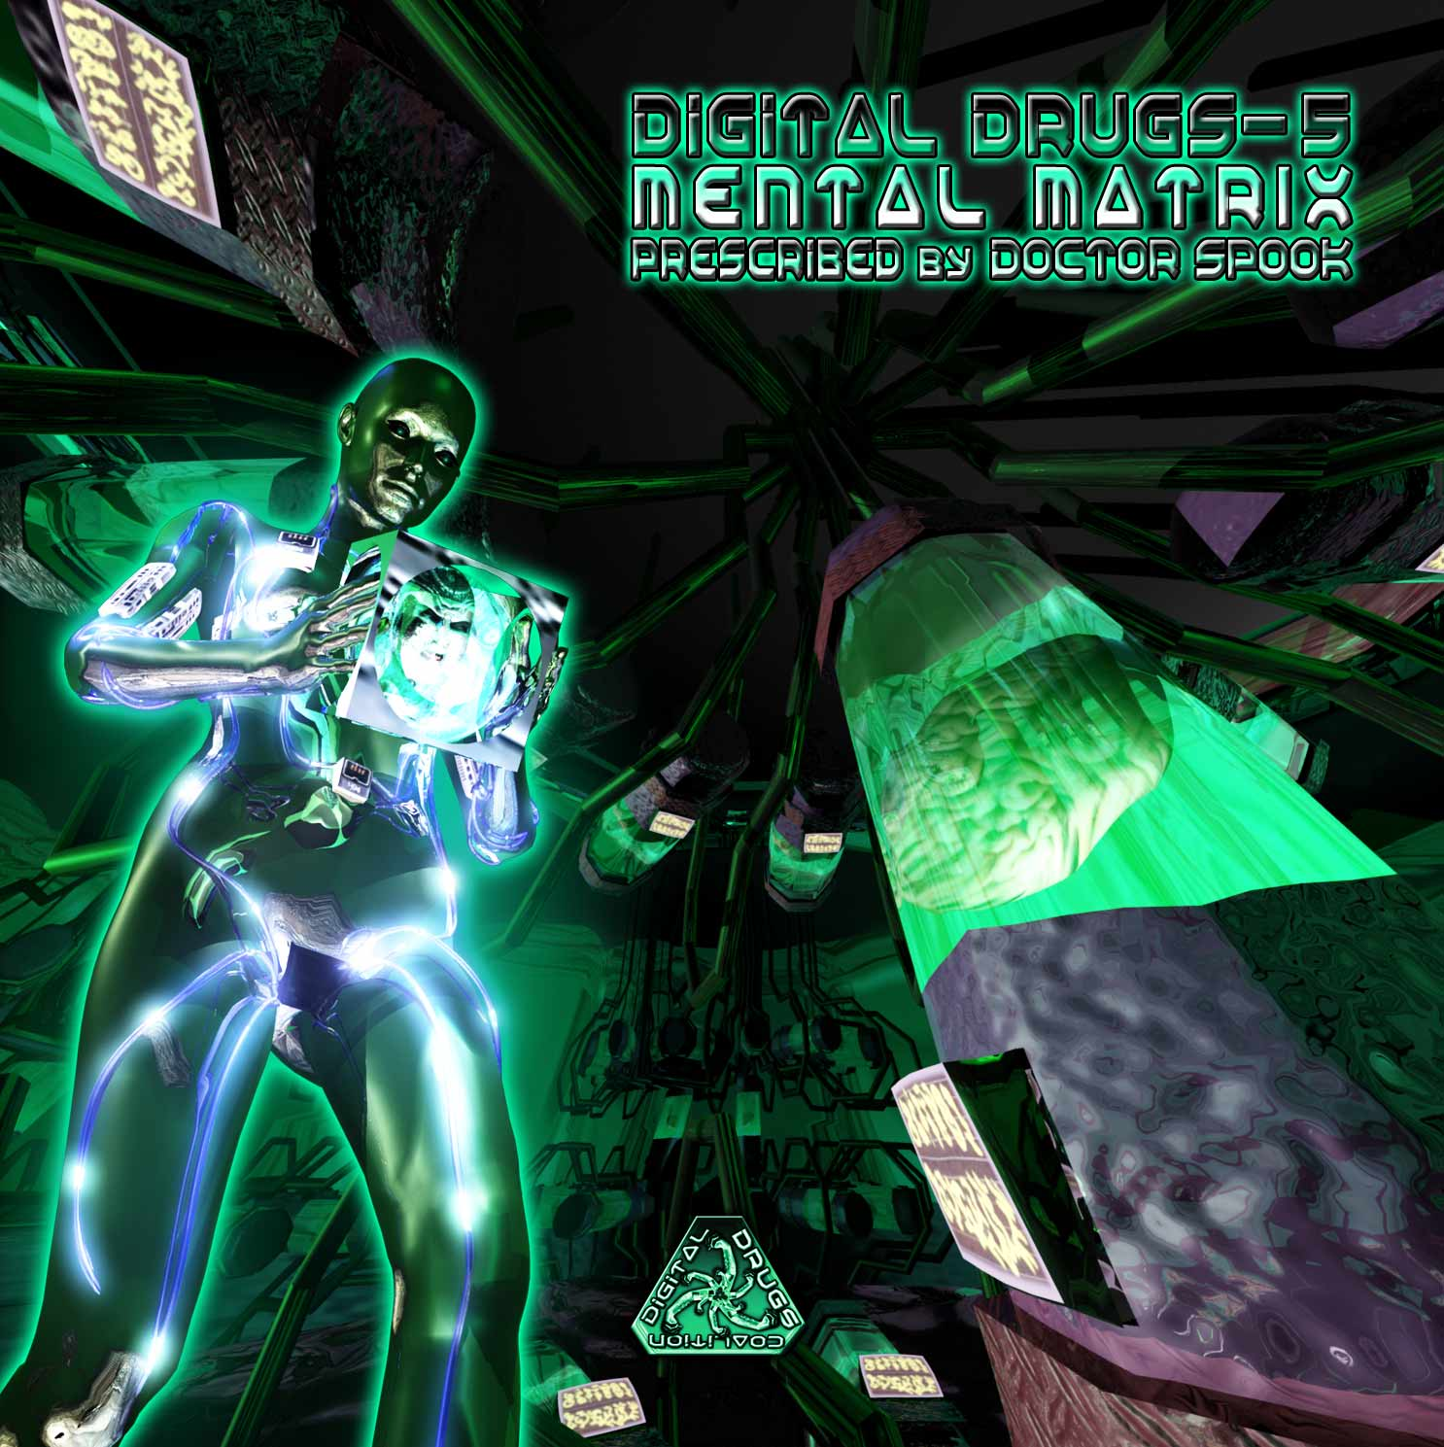 |  | RELEASE NOTES  Doctor Spook prescribes a whole new dose of epic psyber psyence fiction adventure through your psynapses with this fresh batch of ultra blasters culled from the front lines of the psychedelic underground. Our tale opens with a thick and chewy full on blaster from Dr. Hoffman (Guadalajara, Mexico) that starts us off smooth and potent with a punch line that sneaks up on you. Psyshark vs Kalilaskov (Israel) continue the mayhem with a portal opening pumper to help you see clearly. Broken Beat vs Electronic Concept opens your eyes to the reality of the situation with their debut thumper. As your consciousness jacks in and descends down the chasm of the cortex San Francisco Bay Area native Frost Raven turns up the energy to full blast! Electrypnose gets rewired by Portuguese duo Meteor Burn for a blast off into the next dimension while another duo from Portugal feels the ecstasy of full body immersion while getting a full blast to the mind. Fright Rate (South Africa) continues the full on freaky madness handing it off to Indian native Paraforce to up the ante to a new level. Digital Dimensions reminds us to run around screaming all night while Overhuman Project and Wizack Twizack only increase the bewilderment. Finally we realize this was all a test as Hyper Drive eases us down with his debut to the international circuit. From beginning to end your are treated to a perfect variety of both the leading legends from the global psychedelic dance floors and a balance of talented new comers that are exploding their local music communities with a non stop dose of Digital Drugs!  Digital Drugs is a coalition of psychedelic trance artists from around the globe who believe that digital art + music are the purest form of getting high. expect unique, fresh + truly out of this world productions from this hot posse !!  Artist Profile:  By Doctor Spook (Mindstorm) MINDSTORM (aka Nathan Vogel aka Doctor Spook) has morphed into an amazing LIVE VISUALS AND MUSIC project that Doctor Spook has been realizing from the SAN FRANCISCO based GEOMAGNETIC World Headquarters. Musically Spook is collaborating with a stream of the worlds leading musical masterminds inlcuding Tamir Ozana from Atomic Pulse, Chromatone and Random, Altom, Earthling, Central Processing Unit & Twisted Reaction Mindstorm has a strong concept with each track, a detail lacking in much of todays dance music.  Label Profile:  Digital Drugs Coalition is a union of psychedelic trance artists from around the globe who believe that digital art + music are the purest form of getting high. Expect unique, fresh + truly out of this world productions from this hot posse!!  Darkstar is the sub-label of Geomagnetic that focuses on Dark, Night time music, with hard and experimental styles.  Geomagnetic.tv was established in the summer of 2001 by Dr. Spook one of the founders of the prominent San Francisco 3D FX and Multimedia boutique known as Minds Eye Media (est.1995). www.mindseyemedia.com 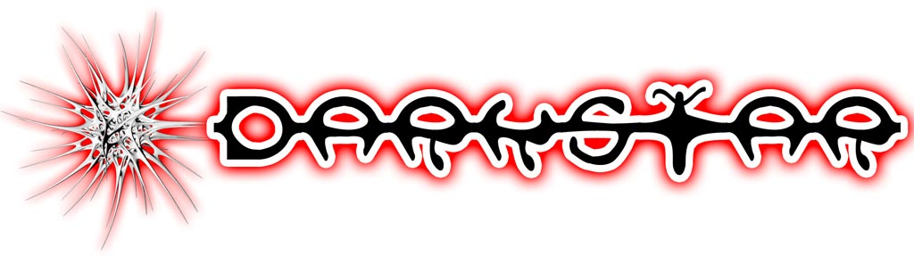
Title: | Digital Drugs5 – Mental Matrix
Artist: | v/a Prescribed by Dr. Spook
Label: | Digital Drugs Coalition
Catalogue: | DIGICD015
Format: | 4-Panel Booklet Jewel CD
Barcode: | 881034377937
Release: | May 2009 World Wide
TRACK LIST

01 - Dr.Hoffman - 10 days
02 - Psyshark vs Kalilaskov AS -Transparent Universe
03 - BrokenBeat vs Electronic Concept - Nightmare
04 - Frost Raven - The Hole
05 - Electrypnose - Ornic (MeteorBurn RMX)
06 - Tricossoma vs K-Lapso - Dark Movie
07 - Fright Rate - Scary Story
08 - Paraforce - The Giants Rule The Land
09 - Digital Dimensions - Emergency
10 - Overhuman Project - Neuro Confusion (Wizack Twizack RMX)
11 - Hyper Drive - Delay Test

CREDITS
Mastered by Random @ Geomagnetic Studios
Artwork by Nathan Vogel aka Dr. Spook
Distribution by Saiko Sounds & Psyshop
(p) and © www.Geomagnetic.tv
http://www.geomagnetic.tv/news/digicd015 info@geomagnetic.tv

