DigiDelights v.1 v/a compiled by Mindstorm & Tripy [DIGICD016] Digital Drugs Coalition / Morningstar /Geomagnetic.tv

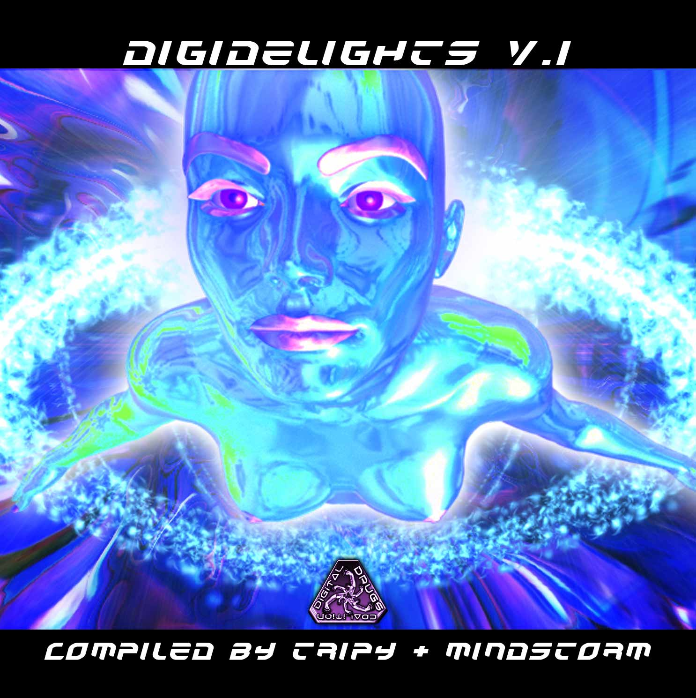 |  | RELEASE NOTES  Mindstorm (San Francisco, California) and Tripy (Sydney, Australia) serve up a bountiful selection of the highest caliber packed full of full throttle dance music with absolutely pristine production. Gigantic melodies, blistering bass lines & next dimensional kicks will give you the power and euphoric energy every dance floor needs. Expect to truly be uplifted with this compilation from the masterminds of mind expanding psychedelic trance music... Digital Drugs Coalition. From beginning to end you are treated to a perfect variety of both the leading legends from the global psychedelic dance floors and a balance of talented new comers that are exploding their local music communities with a non stop dose of DigiDelights! Polaris (France) brings us a new remix by Kinesis of one of his dance floor hits. Crying Freemen (France) offers us a track from their hot new album. Random (Usa) and Virtual Light (Canada) combine forces to create a new blazing new project Random Light. Reactive (Russia) leads the way with superior production and truly memorable hooks. Polypheme (France) and his friend Bobby Wan continue the unstoppable beats. Frost Raven (Usa) turns the bpms up a few notches with this deep hard full on goa-psy pounder. Dr. Hoffman (Mexico) reminds us what its all about with a festival favorite. Tripy (Australia) takes us on a tour down under with his own magic thunder. Virtual Light’s classic is remixed once again by Micro Scan (France) to bring us a new twist. Finally TeTuna (France) eases us down with his playful and feel good style. Digital Drugs is a coalition of psychedelic trance artists from around the globe who believe that digital art + music are the purest form of getting high. expect unique, fresh + truly out of this world productions from this hot posse!!  Artist Profile:  MINDSTORM (aka Nathan Vogel aka Doctor Spook) has morphed into an amazing LIVE VISUALS AND MUSIC project that Doctor Spook has been realizing from the SAN FRANCISCO based GEOMAGNETIC World Headquarters. Musically Spook is collaborating with a stream of the worlds leading musical masterminds inlcuding Tamir Ozana from Atomic Pulse, Chromatone and Random, Altom, Earthling, Central Processing Unit & Twisted Reaction Mindstorm has a strong concept with each track, a detail lacking in much of todays dance music. www.myspace.com/mindstorm1  Tripy A.k.a Charlie Xuereb was born in Malta in 1977. Early in his youth Charlie felt a strong connection with music which became his life long focus. He experimented with different rhythms like break dance and hip hop. During his path to becoming a musician he met the sounds of electronic music like house, hard house, and experimental minimal techno until finally he was sucked into the Trance Sounds. In 2000 Tripy finds himself in Goa India and at the point it all changes. Since then he has dedicated his life and artistic energy into creating psytrance and dance gatherings. After all this he decided to move to Australia where he is now performing live and mainly focusing on more music productions in morning melodic music. He met with Doctor Spook and found a home for his unique uplifting sound with the Digital Drugs Coalition / Geomagnetic Morning star label family and is lined up to introduce his brand new fresh Album. Tripy has released some singles and as well the Shamanik Concept EP and expect many more to come rocking hits coming soon to the dance floors around the world. www.myspace.com/tripy3p  Label Profile(s): www.myspace.com/geomagnetic  Digital Drugs Coalition is a union of psychedelic trance artists from around the globe who believe that digital art + music are the purest form of getting high. Expect unique, fresh + truly out of this world productions from this hot posse!! www.myspace.com/digitaldrugscoalition  Morningstar, division of Geomagnetic Records. Uplifting, melodic, full-on, progressive and perfect for those ecstatic moments of sunshine and awakening, we know you want to be carried on a cloud of feel-good grooviness as you welcome the morning light!  Geomagnetic.tv was established in the summer of 2001 by Dr. Spook one of the founders of the prominent San Francisco 3D FX and Multimedia boutique known as Minds Eye Media (est.1995). www.mindseyemedia.com
Title: | DigiDelights v.1
Artist: | v/a by Mindstorm & Tripy
Label: | Digital Drugs Coalition
Catalogue: | DIGICD016
Format: | 4-Panel Booklet Jewel CD
Barcode: | 881034377944
Release: | July 2009 World Wide
TRACK LIST

01 - Polaris - Tribal Quest (Kinesis Rmx)
02 - Crying Freemen - Odyssey (2010 rmx)
03 - Random Light (Random + Virtual Light) - Save The Last Human
04 - Reactive - The Invincible
05 - Polypheme feat Dj Bobby Wan - Stop Us Now
06 - FrostRaven - Molly
07 - Dr.Hoffman - Memories
08 - Tripy - The Face Of The Moon
09 - Virtual Light - Nuclear Sun (Micro Scan RMX)
10 - TeTuna - Circus Light (Live Mix)

CREDITS
Mastered by Sergio @ Meteor Burn Labs
Artwork by Nathan Vogel aka Dr. Spook
Distribution by Saiko Sounds & GeoMagnetic Distro
(p) and © www.Geomagnetic.tv
http://www.geomagnetic.tv/news/digicd016 info@geomagnetic.tv

