Meteor Swarm v/a compiled by Meteor Burn (Portugal)
[ DIGICD017 ] Digital Drugs Coalition / DARKSTAR / Geomagnetic.tv

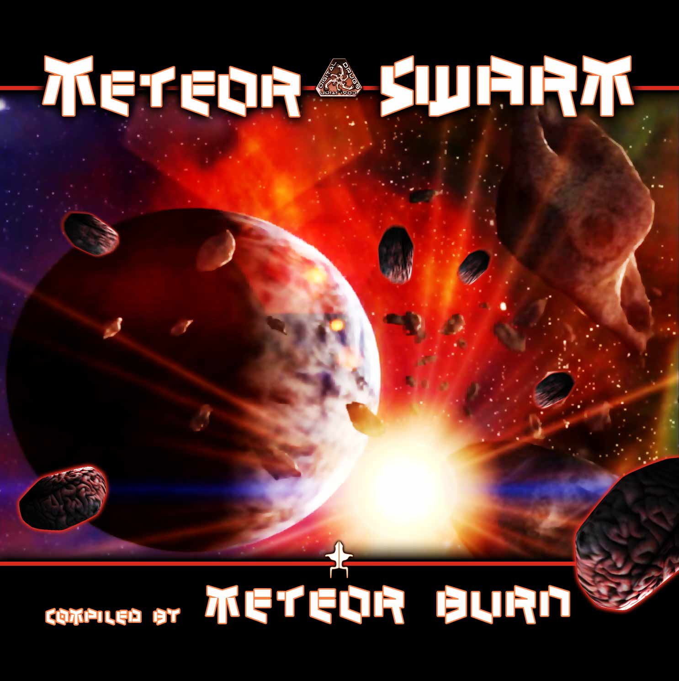 |  | RELEASE NOTES  Meteorburn, Portuguese duo, Sérgio aka Meteor & Xano aka Burn who are burning a hole in the dance floor with their non stop mega masher bass lines and full throttle mentalities coming deep from psy-space with a mission to deliver the hardest rocking chunky space debris right to your brain. Meteor Swarm is just what you need to keep your local scene up to date on the latest psyentific discoveries. Stereographic balances our freak-quencies with a broadcast received from Out of This World. Electrypnose remixes his collaboration project Cerebral Factory (vs Karash) to deliver a new form of pleasure. Hallucypnotic trips us out even more with a Mekanofobic report. Antagon ricochets off of nearby asteroids while Tricossoma delivers a startling revelation. TerraTech and Paraforce combine powers to create a mystical new energy. Meteor Burn joins the ranks of the starship troopers whose job it falls upon to navigate the treacherous swarm. ZenMind brings absolution to those who must face a dark fate while Psychoz discovers a new friend he found living in the bottom of a deep crater. Kasatka screams to an explosive finish with his own brand of howling insanity. After hurtling through space with this swarm of blazing dark-psy talent you will never come back to earth (if you ever truly were there to begin with =). Digital Drugs is a coalition of psychedelic trance artists from around the globe who believe that digital art + music are the purest form of getting high. expect unique, fresh + truly out of this world productions from this hot posse !!  Artist Profile:  Meteorburn is a 2 member project, Sérgio aka Meteor & Xano aka Burn. In the year 2000 they went to a lot parties and they won a lot of contacts, which who taken a union of creativity to launch the project Meteorburn,so they started to make dark style in influences of : Ocelot, Electrypnose, Kasakta, Digital Talk, Irgum Burum, Parasense, Psychotic Micro, Ram , highko and others. Together they show to you a live set with many strong atmospheres, giving in that way a beautiful travel, with a sound really original. In Studio they have a Sony Vaio, an Asus, an Interface audio Terratec Phase 26, RME Multiface II, M-audio oxygen 8 and CME UF midi keyboard, Samson Resolv 80a and Alesis One Mk2 Active Monitors, TC PowerCore FireWire, Virus PowerCore, Clavia Nord Lead Rack 2x and Steinberg Cubase 5.  Label Profile:  Digital Drugs Coalition is a union of psychedelic trance artists from around the globe who believe that digital art + music are the purest form of getting high. Expect unique, fresh + truly out of this world productions from this hot posse!!  Darkstar is the sub-label of Geomagnetic that focuses on Dark, Night time music, with hard and experimental styles.  Geomagnetic.tv was established in the summer of 2001 by Dr. Spook one of the founders of the prominent San Francisco 3D FX and Multimedia boutique known as Minds Eye Media (est.1995). www.mindseyemedia.com
Title: | Meteor Swarm by Meteor Burn
Artist: | v/a compiled by Meteor Burn
Label: | Digital Drugs Coalition
Catalogue: | DIGICD017
Format: | 4-Panel Booklet Jewel CD
Barcode: | 881034377951
Release: | May 2009 World Wide
TRACK LIST

01 - Stereographic - Out Of This World 146
02 - Cerebral Factory - Disturbed (Electrypnose rmx) 150
03 - Hallucypnotic - Mekanofobia 152
04 - Antagon - Echoes 153
05 - Tricossoma - Satanic Culture 154
06 - TerraTech Vs. Paraforce - Mystical Powers 154
07 - Meteorburn - Space Soldier 154
08 - ZenMind - Absolution 154
09 - Psychoz - Black Snake 155
10 - Kasatka - Howlup 158

CREDITS
Mastered by Random @ Geomagnetic Studios
Artwork by Nathan Vogel aka Dr. Spook
Distribution by Saiko Sounds & Geomagnetic Distro
(p) and © www.Geomagnetic.tv
http://www.geomagnetic.tv/news/digicd015 info@geomagnetic.tv


