V/A “BAD 01” - Bay Area Dub Step 01 CD – Full Melt Records

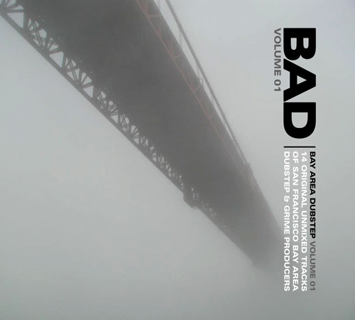 |  | RELEASE NOTES  Bay Area Dubstep volume 01 contains 14 unmixed, dj friendly tracks by San Francisco bay area dubstep and grime artists. From the deep ethnic stylings of Djunya, JuJu and D Program, to the twisted tech-dub of Eskmo and The Antiserum, from the grimey orchestrations of MBZ and the live hardware sounds of Albert Joseph, Atomikdog and Zapper, to the rootical stylings of Matty G and Roomate, each and every track is a chronicle to this contemporary musical artform called "Dubstep".  Artist Profile:  DJ Ripple is the owner of Full Melt recordings, a San Francisco, California based Dubstep label. One of the stateside originators of the sound, he can be found spreading the dubstep vibes most weekends throughout the bay area. Djunya is a fixture of the San Francisco scene. Ethnic stylings and heady atmospherics create the soundtrack to your mind. He has numerous vinyl releases, including recent tracks on JuJu's NarcoHz label. JuJu is a veteran of bass-oriented music. Following huge success in the drum and bass arena, he now directs his energy to creating dark, bouncy bassline dubstep. Owner of NarcoHz, another San Francisco dubstep label, he is the official granddaddy of S.F. Dubstep. Albert Joseph arose out of the east bay (Oakland) scene, with a history that includes stints in live electronic bands to underground hip-hop production.D-Program is another veteran of the San Francisco D&B scene, having released a CD of original material under the name True Force. MBZ is an east bay grime producer that works almost exclusively with his own production / dj crew. Roommate has releases on Breakbeat Science, Steps In Time, and 6Six6 recordings. Two of his tracks are presented here, showing his range of production skills. Eskmo has had major success with releases in the Nu-Skool breaks genre, with releases on Cyberfunk, Vertical Sound and Downbeat recordings. This is his first official dubstep track, included is a collaboration with The Antiserum. The Antiserum is a bay area wonderkid, with vinyl releases on BreaksFM records and Steps in Time. Matty G is a Santa Cruz native that creates dubstep inna-roots reggae-stylee. With many releases on Argon records, and many more planned, Matty G is the sound of future dub. Zapper mashes together punk aesthetics with raw synth power to create bass music with new-wave attitude. Atomikdog is known around the bay as a live electronica maestro that blurs the lines between live improvisation and electronic music production.  Label Profile:  Full Melt Recordings is a San Francisco, California based label specializing in Dubstep music. Next level production and cutting edge basslines are combined to create serious dancefloor energy.This is music designed for soundsystems, this is the future of music.
Title: | Bay Area Dub Step volume 01
Artist: | V/A by DJ Ripple
Label: | Full Melt Records
Catalogue: | FMRCD001
Format: | 4-Panel Digipak Audio CD
Barcode: | 881034098467
Release: | Oct 2007 World Wide
TRACK LIST
1. DJunya – Along The Path
2. Juju - Creation
3. Eskmo - Amphibian
4. Albert Joseph – Lucent Bass
5. D Program – The Traveler
6. MBZ – Darko Dub
7. Roommate – Sensimillia (Gimme Ganja Rmx)
8. Eskmo vs The Antiserum - Monstahs
9. The Antiserum – Top shottas
10. Ripple vs The Antiserum – Blaze It
11. Matty G - Amen
12. Zapper – Gutty Works
13. Atomik Dog - Selecta
14. Roommate – Last Breath

CREDITS
Compiled by DJ Ripple
Mastered by Random
Artwork by Ripple
Distribution by: www.Saikosounds.com www.crystal-code.com Arabesque



