V/A “BAD 02” - Bay Area Dub Step 02 CD – Full Melt Records

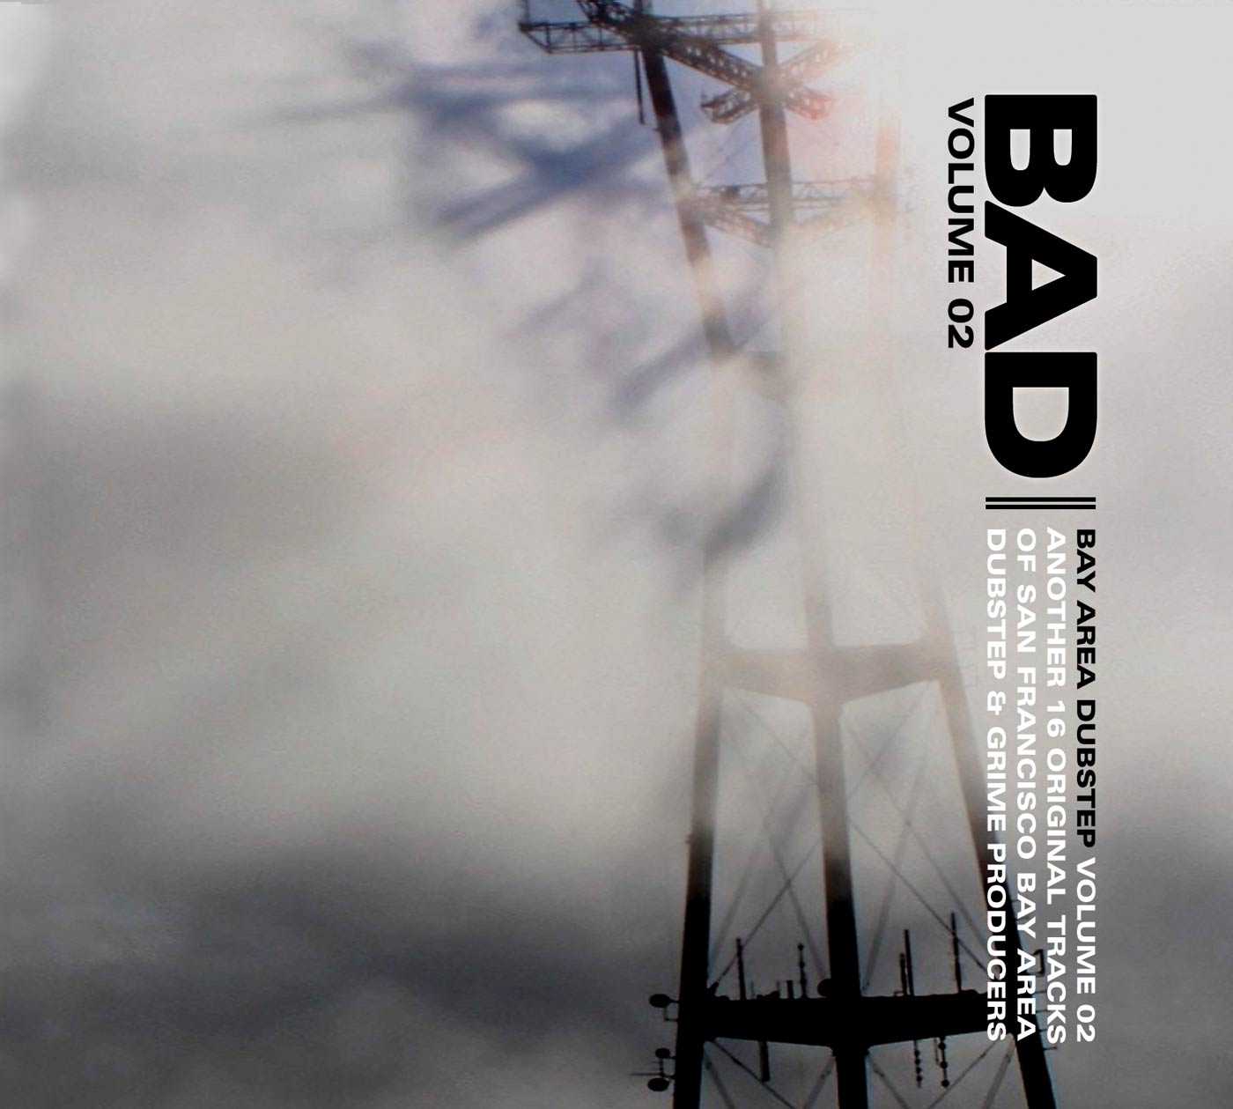 |  | RELEASE NOTES  Bay Area Dubstep volume 02 contains 16 unmixed, dj friendly tracks by San Francisco bay area dubstep and grime artists that have each been thoroughly tested to extreme effect on the dance floors and dub pits of the west coast and usa. From the deep ethnic stylings of Djunya, to the twisted tech-dub of Eskmo and The Antiserum, with tons of the grimiest orchestrations and the live hardware sounds, to the rootical stylings of Matty G and Roomate, each and every track is a chronicle to this contemporary musical art form called "Dubstep". DJ Ripple is the owner of Full Melt recordings, a San Francisco, California based Dubstep label. One of the stateside originators of the sound, he can be found spreading the dubstep vibes most weekends throughout the bay area. Djunya is a fixture of the San Francisco scene. Ethnic stylings and heady atmospherics create the soundtrack to your mind. He has numerous vinyl releases, including recent tracks on JuJu's NarcoHz label. Roommate has releases on Breakbeat Science, Steps In Time, and 6Six6 recordings. Two of his tracks are presented here, showing his range of production skills. Eskmo has had major success with releases in the Nu-Skool breaks genre, with releases on Cyberfunk, Vertical Sound and Downbeat recordings. This is his first official dubstep track, included is a collaboration with The Antiserum. The Antiserum is a bay area wonderkid, with vinyl releases on BreaksFM records and Steps in Time. Matty G is a Santa Cruz native that creates dubstep inna-roots reggae-stylee. With many releases on Argon records, and many more planned, Matty G is the sound of future dub.  The first volume BAD 01 CD was featured by DJ " Mary Ann Hobbs" on Radio One on her now infamous "Essential Mix" electronic music show being broadcast weekly out of London. On the show she played track 6 aka Monstahs by Eskmo vs The Antiserum and gave a big shout out to all the artists and labels involved. This hit CD was also featured on N-Types RinseFM Mix both broadcast in the UK and via podcast.  Label Profile:  Full Melt Recordings is a San Francisco, California based label specializing in Dubstep music. Next level production and cutting edge bass lines are combined to create serious dancefloor energy.This is music designed for sound systems, this is the future of music.
Title: | Bay Area Dub Step volume 02
Artist: | V/A by DJ Ripple
Label: | Full Melt Records
Catalogue: | FMRCD002
Format: | 4-Panel Digipak Audio CD
Barcode: | 881034278982
Release: | Feb 2009 World Wide
TRACK LIST
1. DJunya – Tip Tap Toes
2. OSC - Evolution
3. Roommate & Moksha – One Direction
4. The Spit Brothers – Oh Contrarians
5. Roommate – Revolution Time
6. Dubsworth – Busted Brain
7. Matty G – Strollin’
8. OSC & DJG – One Mile High
9. Babylon System – Big Up
10. DJG – Screwball
11. Antiserum – Rambo Style
12. Antiserum & Ripple – Sound Biz
13. Roommate – Rock Steady
14. Blackheart – Airbag
15. DJ Quest & Eskmo – Speakers Corner
16. Ripple – Sunday Morning Dub

CREDITS
Compiled by DJ Ripple
Mastered by Random
Artwork by Ripple
Distribution by: www.Saikosounds.com www.geomagnetic.tv www.psyshop.com

