SAN FRAN PSYCHOS 1: Phantasmagoria CD – Geomagnetic.tv

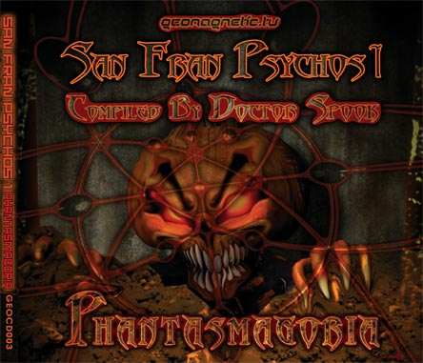 |  | RELEASE NOTES  Presenting SAN FRAN PSYCHOS 1: Phantasmagoria. Featuring 10 Dark and Driving new psy-trance gems by international Psy-masters coming out of SAN FRANCISCO Bay Area USA, compiled by DJ/VJ Dr. Spook. These tracks are suitable for arousing massive dance floor frenzies. This Halloween themed compilation blends dark, funky, atmospheres with deep groovy and spooky melodies. Each track fits together with the next to create a mood and feeling of ominous depth. All of the tracks have been tested on the dance floors to combine the essence of ferocity with the spice of danceability to produce a soul clenching trip that you will never forget! Veteran Psy-trance wizards combine with some fresh new talent to keep you on the edge of your sanity until the sun finally rises once more! This comp firmly announces the power and style of SF!  Label Profile:  Geomagnetic.tv was established in the summer of 2001.  Their first major international release is the legendary DVD  project “MAGNUS” geodvd001. Based in San Francisco  and focusing mostly on visual and music related projects,  you can expect to see lots more cutting edge releases on the way from this award winning crew! Geomagnetic.tv was started by Spook one of the founders of the prominent San Francisco 3D FX and Multimedia boutique known as Minds Eye Media (est.1995). www.mindseyemedia.com  Artist Profile:  DJ/VJ Doctor Spook (San Francisco, USA)  Also known as Nathan Vogel, Spook is an award winning  3D animator and music video director. He began creating  psychedelic visuals in 1992, receiving critical acclaim for  all of his projects. Nathan has worked with major music labels such as Arista, Geffen/Universal, Sony, Om and now with all of the most prominent Psy-trance labels with ground breaking new releases. Spooks passion for electronic music drove him to start making music in 1990. He began DJing Psy-trance at the Burning Man festival in 1998.  Audio CD Format 10 Previously Unreleased Psy-trance Dark Epics by the best of the SF Bay Area Psy-Trance Producers:  Penta, Chromatone & Random, Ocelot vs. Vector Selector, Mubali, Deeper in Zen. Look for Random’s stunning Album “IMPLICATE ORDER” coming out on GEOMAGNETIC.TV Spring 2006. Geomagnetic.tv is proud to debut some of the hottest new projects coming from San Francisco:  AEON – Look for his incredible new artist album coming out on Geomagnetic.tv Spring of 2006!  MEGADROP – Collaborative Project between two veteran masters, RANDOM and HELIOS.  MINDSTORM – The most eagerly anticipated new producer coming from SF is Dr. Spook’s new project.
Title: | SANFRANPSYCHOS1: Phantasmagoria
Artist: | Dr. Spook - Various Artist
Label: | Geomagnetic.tv
Catalogue: | GEOCD003
Format: | 4-Panel Digipak Audio CD
Barcode: | 9366977745032
Release: | Feb 27th World Wide
TRACK LIST
01. Deeper in Zen
X-IDER
02. Aeon
AMORPHOUS
03. Chromatone & Random
EMPTY OATHS
04. Mubali
STANDARD DEVIATION
05. Quasar
LUM BOUGHT A ME
06. Ocelot vs Vector Selector
THE BRIDGE
07. Random vs Viral
DIGITAL DOWNGRADE
08. Megadrop (Random & Helios)
FRANK–N-STUFF
09. Mindstorm (Dr. Spook)
EVIL JACK (IS BACK)
10. Penta
FRANKENSTEIN 2001

CREDITS
Mastered by Chromatone
Artwork by Doctor Spook
Distribution by Saiko Sounds
(p) and © Geomagnetic.tv
http://www.geomagnetic.tv/releases/SanFranPsychos.htm
info@geomagnetic.tv

