Paraforce – Deep Forest – GEOCD029 –Geomagnetic / Darkstar

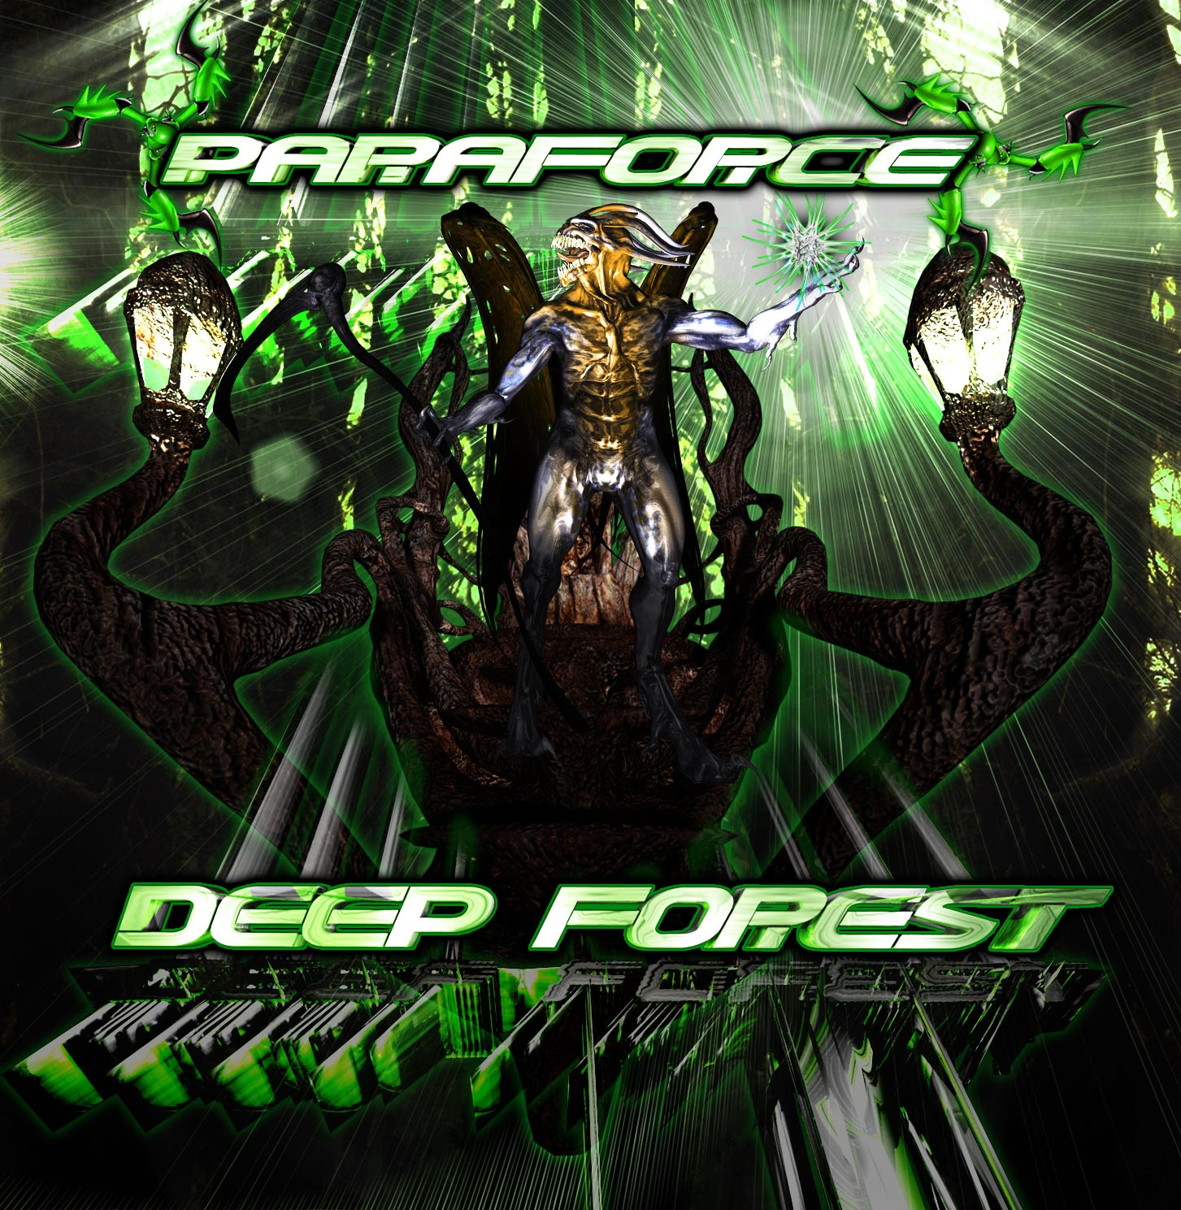 |  | RELEASE NOTES:  Paraforce – Deep Forest – GEOCD029  Deep Forest is the latest full power offering from Indian native Varun Anand aka Paraforce (New Delhi). His style is a ferocious blend of mind warping dark psytrance and brain boggling industrial techno with an average of 150 bpm. The Psytrance global community has been in a transition process for quite some time, growing and changing as an evolving family should. This full length album represents the completion of this transition from experimental to a full fledged sub-genre taking bloom. Now Dark industrial trance has a new hero to breath life and energy into this vast untouched territory of the mind. Prepare to define new limits the term Psychedelic as you break down the edge not only your own mental barriers but to those of the whole planetary community as well. Please welcome your latest savior... PARAFORCE!  Artist Profile: myspace.com/paraforceproject  Paraforce is the solo trance music project of Varun Anand, based in New Delhi, India. He started going to psy trance parties at the age of 17 and after 4 yrs of understanding the music he started playing at parties in the hills and later decided to make his own music with a feeling of gothic and darkness to take u all on a trip, a trip to self awareness and eternity. Varun prefers to create tracks with hard and driving bass lines, twisted leads and heavy atmospheric sounds. He aims to give the listener’s a gothic and psychedelic experience. geomagnetic.tv/artists/paraforce.htm  Label Profile: myspace.com/geomagnetic  Geo - Darkstar is the sub-label of Geomagnetic that focuses on Dark, Night time music, with hard, intense and experimental styles.  Geomagnetic.tv (Label Group) was established in the summer of 2001. Based in San Francisco and focusing mostly on visual and music related projects, you can expect to see lots more cutting edge releases on the way from this award winning crew! Geomagnetic.tv was started by Spook one of the founders of the prominent San Francisco 3D FX and Multimedia boutique known as Minds Eye Media (est.1995). www.mindseyemedia.com  
Title: | Deep Forest
Artist: | Paraforce
Label: | GeoMagnetic - Darkstar
Catalogue: | GEOCD029
Format: | 4 Panel Insert Jewel CD / DDL
Barcode: | 9366977745698
Release: | July 2008
TRACK LIST

1. Octo Edge
2. Shiva Tandava
3. Deep Forest
4. Evergreen Place
5. Sir John
6. Rules of Nature
7. 13th Floor
8. Jagermeister
9. Mind Storm
10. Laws of Destruction

----------------------------------------------------------
CREDITS:

MASTERED BY: TIM SCHULTZ 4CN STUDIOS
Artwork by: Doctor Spook
Distribution by: Psyshop, Saikosounds, Crystal-Code / Goa-Records.com
(p) and © www.Geomagnetic.tv
info@geomagnetic.tv More info online.
www.geomagnetic.tv/labels/GEO-Darkstar/GEOCD029-Paraforce-DeepForest



