TWISTED REACTION : ACTION! (GEO – ISRAEL) a Division of Geomagnetic.tv

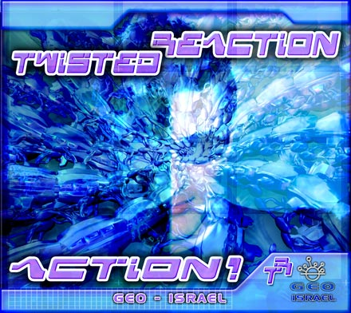 |  | RELEASE NOTES  "Action!" - a debut album from Twisted ReAction, opens for you the tunnel to a twisted and playful psychedelic world of the young Israeli artist Edvin. The album contains 8 full-on tracks, both morning and night styles. The last track of the album is Chillout/Electro that is dedicated to Edvin's girlfriend.The track was made featuring a Israeli underground punk rock band - Hero For A Day. All of this amazing album is a magical trip to another world where there is only love and happiness.....and we know that with it will bring a wave of pleasure through out the whole international trance scene!  Label Profile:  Geomagnetic.tv was established in the summer of 2001.  Their first major international release is the legendary DVD  project “MAGNUS” geodvd001. Since then they have added 30 label artists and have multitudes of projects in the works for 2006 and beyond. Based in San Francisco  and focusing mostly on visual and music related projects,  you can expect to see lots more cutting edge releases on the way from this award winning crew! Geomagnetic.tv was started by Spook one of the founders of the prominent San Francisco 3D FX and Multimedia boutique known as Minds Eye Media (est.1995). www.mindseyemedia.com  Artist Profile:  TWISTED REACTION is Edvin Alperavitch (1987),born in Lithuania and now living in Israel. At the age of 10 Edvin discovered the electronic music and started to produce and mix his own music at the age of 12. His musical influences came from chill out, drum`n bass, techno, house, trip hop .. and others. At the age of 15 Edvin went to some psy trance parties and then discovered his style of life - psychedelic trance.In 2005 Twisted ReAction project was born and the first release was made on SunDance records. Twisted ReAction style is morning fullon and night trance.He joined a San Francisco based psy-trance label Geomagnetic.tv in the end of 2005 as he also works with Tokyo X- Ray, Japan . His first album will be released during 2006 on Geomagnetic.tv and will make lot's of noize and damage all over the globe! Reaction has tracks coming out soon on:  - "Magical Forest Elves" on Pixan Recordings - June 2006  - "Mozart" on Sundance Rec. - Fall 2006  - "Roll It" - HIGH WAY 420 on Geomagnetic.tv Morningstar - April 2006  - "Brain Busters" - Trip Controllers on Geomagnetic.tv Darkstar June 2006  - "Civilysergia"- Civilysed Chaos on Geo- Israel June 2006  WHO IS TWISTED REACTION CIVILYSERGIA MUSIC VIDEO
  MINDSTORM vs TWISTED REACTION video Inteview:
Title: | ACTION!
Artist: | TWISTED REACTION Artist Album
Label: | Geo - Israel
Catalogue: | GEOCD008
Format: | 4-Panel Digipak Audio CD
Barcode: | 9366977745155
Release: | June 2006 World Wide
TRACK LIST
1. Heaven (Vocal Edit) 7:58 145 bpm
2. Acid Theater 8:30 145 bpm
3. Twisted Illusions 7:21 145 bpm
4. Action! 8:04 145 bpm
5. Drugs (Remix) 7:07 146 bpm
6. Morning Sun 8:00 145 bpm
7. On the Drumz 6:59 145 bpm
8. Civilysergia (Album Version) 145bpm
9. One Love 5:05 120 bpm (feat. Hero For A Day on Guitar)
CREDITS
Mastered by Chromatone Waveworks
Engineering by Random
Artwork by Doctor Spook
Distribution by Psyshop
(p) and © GEO - ISRAEL a division of Geomagnetic Records
http://geomagnetic.tv/releases/TwistedReAction_Action.htm
Hi-Res art online.



