DIGITAL SAMSARA : OBSERVING PHENOMENA (GEO – ISRAEL) a Division of Geomagnetic.tv

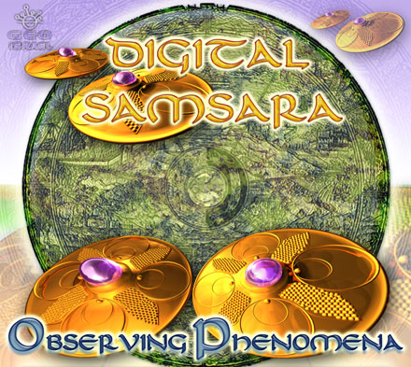 |  | RELEASE NOTES  "A mystical dance floor journey from beginning to end!" After amazing the world music and downtempo chill out crowd with their debut album BLUE BERRYL released earlier this year DIGITAL SAMSARA is back with a whole new sound fusing the best of their Acoustic roots with amazing crisp and powerful Israeli progressive full on blended with a vast array of live instruments. Mind blowing melodies and heartfelt bass lines take you on an evolving and constantly changing lavishly produced fantasy ride. This NEW ALBUM OBSERVING PHENOMENA takes you back to the time when you had nothing to worry about and all you wanted to do was to dance all day and all night with your friends and loved ones, embracing the best that life has to offer. When you hear this album you will instantly agree that if evokes these feelings again and again in a mysteriously addicting experience that will change and grow as you hear it repeatedly. We invite you to listen to 4 minutes of each track and you will know why we describe it like this... words can not explain....  Artist Profile:  Digital Samsara is an actual band consisting of Ben-Canar & Cobi Klar and their jamming partners: Camil Urmantsev, Dirk Kunesh and Shahar Kaufman. Together they tour the world spreading the mysteries of their modern and ancient blend of organic electronic ultra groovy tribal bliss beat. From the times of their childhood each of the band members has been called to make music and blend harmony and rhythm to create special hymns to mother nature and uplifting jams that celebrate the sunrise and sunset. If you seek a return to the roots as well as something different and fresh this powerful live touring group will rock you till your inner child releases itself in ecstatic dance. Each band member has trained for years to create their special unique sound and together they have a acquired a rare and hard to come by unison of their perfect strengths. Enjoy this sweet harmonic balance that is the result of over ten years of world travelling and dedicated, focused ultra clear studio production.  Label Profile: www.geomagnetic.tv  GEO-ISRAEL is a subdivision of Geomagnetic Records, offering the most cutting edge sounds from the hottest new artists of the Israeli psychedelic underground. With no distinguishing night and day, day and night, GEO-Israel offers a thick, light, full-on and dark aural journeys to enhance your trance dancing experience!  Geomagnetic.tv was established in the summer of 2001.  Their first major international release is the legendary DVD  project “MAGNUS” geodvd001. Since then they have added 30 label artists and have multitudes of projects in the works for 2006 and beyond. Based in San Francisco and focusing mostly on visual and music related projects, you can expect to see lots more cutting edge releases on the way from this award winning crew! Geomagnetic.tv was started by Spook one of the founders of the prominent San Francisco 3D FX and Multimedia boutique known as Minds Eye Media (est.1995). www.mindseyemedia.com
Title: | Observing Phenomena
Artist: | DIGITAL SAMSARA (2nd Artist Album)
Label: | Geo - Israel
Catalogue: | GEOCD014
Format: | 4-Panel Digipak Audio CD
Barcode: | 9366977745216
Release: | October 2006 World Wide
TRACK LIST
1.flying objects (ben-canar & cobi klar)
2.bashkir exe (ben_canar) camil urmantsev-vocal
3.riksha (ben-canar & cobi klar)
4.general exeption (ben-canar & cobi klar)
5.tribal jam (ben-canar,shahar kaufman & dirk kunesh) dirk kunesh- dijeredoo & vocals)
6.space kozak (ben-canar & cobi klar)
7.stop the earth (ben-canar & cobi klar)
8.the wave (ben-canar & cobi klar) cobi klar - bass guitar)
9.transit(ben-canar )
10.observing phenomena (ben_canar)
CREDITS
Mastered by Ben-Canar @ Geomagnetic @ Cosmic Event Studios Israel
Artwork by Doctor Spook
Distribution by File Rec & Arabesque via Crystal Code
(p) and © GEO - ISRAEL (a division of Geomagnetic Records)
info@geomagnetic.tv Hi-Res art online:
http://geomagnetic.tv/releases/DigitalSamsara_ObservingPhenomena.htm



