v/a DESERT DREAMING : Part 1 - Sunset (GEO – ISRAEL) Geomagnetic.tv Label Family

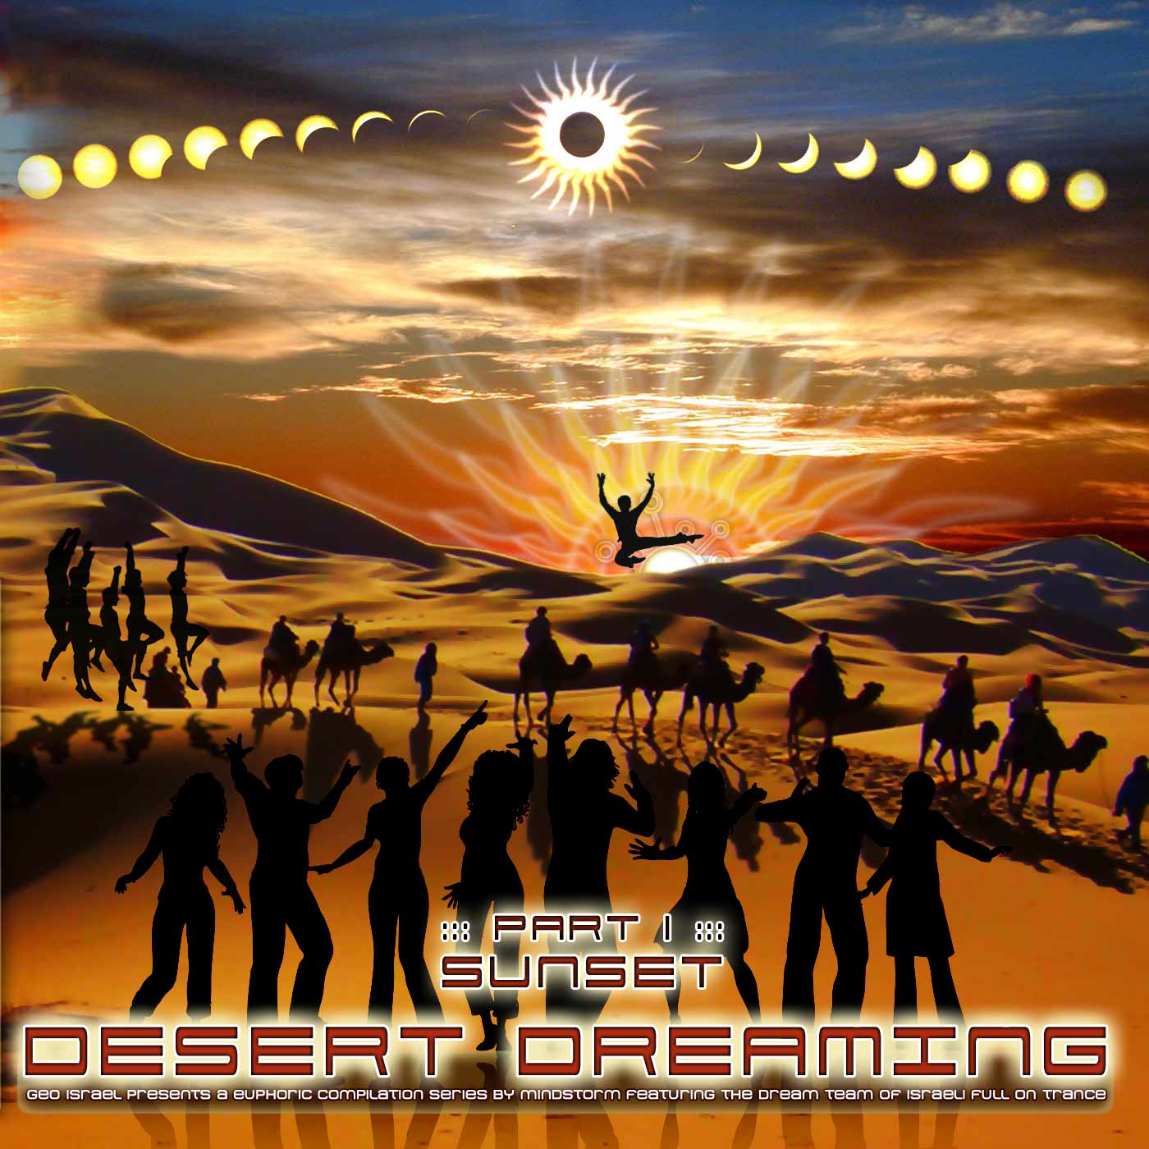 |  | RELEASE NOTES  Desert Dreaming 1 is the magical dancing series with a serious mission to spread peace and joy. Mindstorm assembles all of the essential components to help you dream and journey to those special magic moments. This truly inspired compilation features 14 of the leading Israeli Full On Psytrance producers. Get ready for collaborations with legendary super groups Power Source, Atomic Pulse and Safi Connection aka B-Tone as well as a strong central core of experienced artists with many jumping desert parties, releases and albums under their belts such as Switch, Raz, Twisted Reaction and Vectro Electro. Quantize (aka Bratz) bring us a break from their usual electro-progressive style to hit us with a Full on Psy-Electro ripper while Static Nation helps us find our mind. We are honoured to present a new artist, Richter + Hertz to the international release circuit. Each and every track has been carefully selected for the perfect experience to be danced and listened to again and again.  Mindstorm (aka Nathan Vogel aka Doctor Spook) is a world touring psytrance producer that has morphed into a revolutionary “Live Music & Visuals” project that Doctor Spook is realizing from the San Francisco based GeoMagnetic International HQ. Many high quality visual and music projects are being completed astounding the world with the masterful creations and lucid dreams with release on Spun, Sony, Tokyo X-Ray and more. Musically Spook is collaborating with a stream of the worlds leading musical master minds including Tamir Ozana of Atomic Pulse, Chromatone and Random, Altom, Earthling, Central Processing Unit, Twisted Reaction and more. Each track has a strong concept, a detail lacking in much of today’s dance music. Time to mend your mind with Mindstorm! www.myspace.com/mindstorm1 | www.geomagnetic.tv/artists/mindstorm.htm  Label Profile: www.geomagnetic.tv | www.myspace.com/geomagnetic  GEO-ISRAEL (Geomagnetic label family), offering the most cutting edge sounds from the hottest new artists of the Israeli psychedelic underground. We embrace music for the night and day, GEO-Israel offers a well balanced variety of pioneering producers presenting high quality and memorable hits to enhance your trance dancing experience!  GeoMagnetic.tv was established in the summer of 2001. Their first major international release is the legendary DVD project “MAGNUS”. Since then they have added over 30 label artists and have multitudes of projects in the works for 2008 and beyond. Based in San Francisco and focusing mostly on music and visual related projects, you can expect to see lots more cutting edge releases on the way from this award winning crew! Geomagnetic.tv was started by Spook one of the founders of the prominent San Francisco 3D FX and Multimedia boutique known as Minds Eye Media (est.1995). www.doctorspook.com | www.mindseyemedia.com
Title: | Desert Dreaming: Part 1 - Sunset
Artist: | V/A compiled by Mindstorm
Label: | Geo - Israel
Catalogue: | GEOCD023
Format: | 4-Panel Insert Jewel Case Audio CD
Barcode: | 9366977745650
Release: | June 2008 World Wide
TRACK LIST

1. Raz - No Limits In Your Mind
2. Switch – Universal Source
3. Power Source - Sky Walker [ Richter & Hertz RmX ]
4. A.p.e - Travelling The Cosmos
5. Virtual Light feat Intersys – X-perimental
6. Static Nation - Find My Mind!
7. Twisted Reaction feat Acid Drop - Man Turns Animal
8. Quantize (aka Bratz) –The Triangle
9. Vectro Electro – Just Say Know
10. B-Tone (Safi Connection) vs. Liquid Phase - Cyber Space
11. Atomic Pulse vs Mindstorm - Cybernetic

CREDITS
Compiled by Mindstorm (www.myspace.com/mindstorm1)
Mastered by Mishel Bitton @ Safi Connection Studios (Israel)
Artwork by Nathan Vogel (DoctorSpook@hotmail.com)
Distribution: Saikosounds, Psyshop & Goa - Records
(p) and © GEO - ISRAEL (a division of Geomagnetic Records)
Contact: info@geomagnetic.tv
Hi-Res art/samples:
http://geomagnetic.tv/labels/GEO-Israel/DesertDreaming.html





