A.P.E. : Advanced Psychedelic Energy – Geocd034 (GEO – ISRAEL) a Division of Geomagnetic.tv

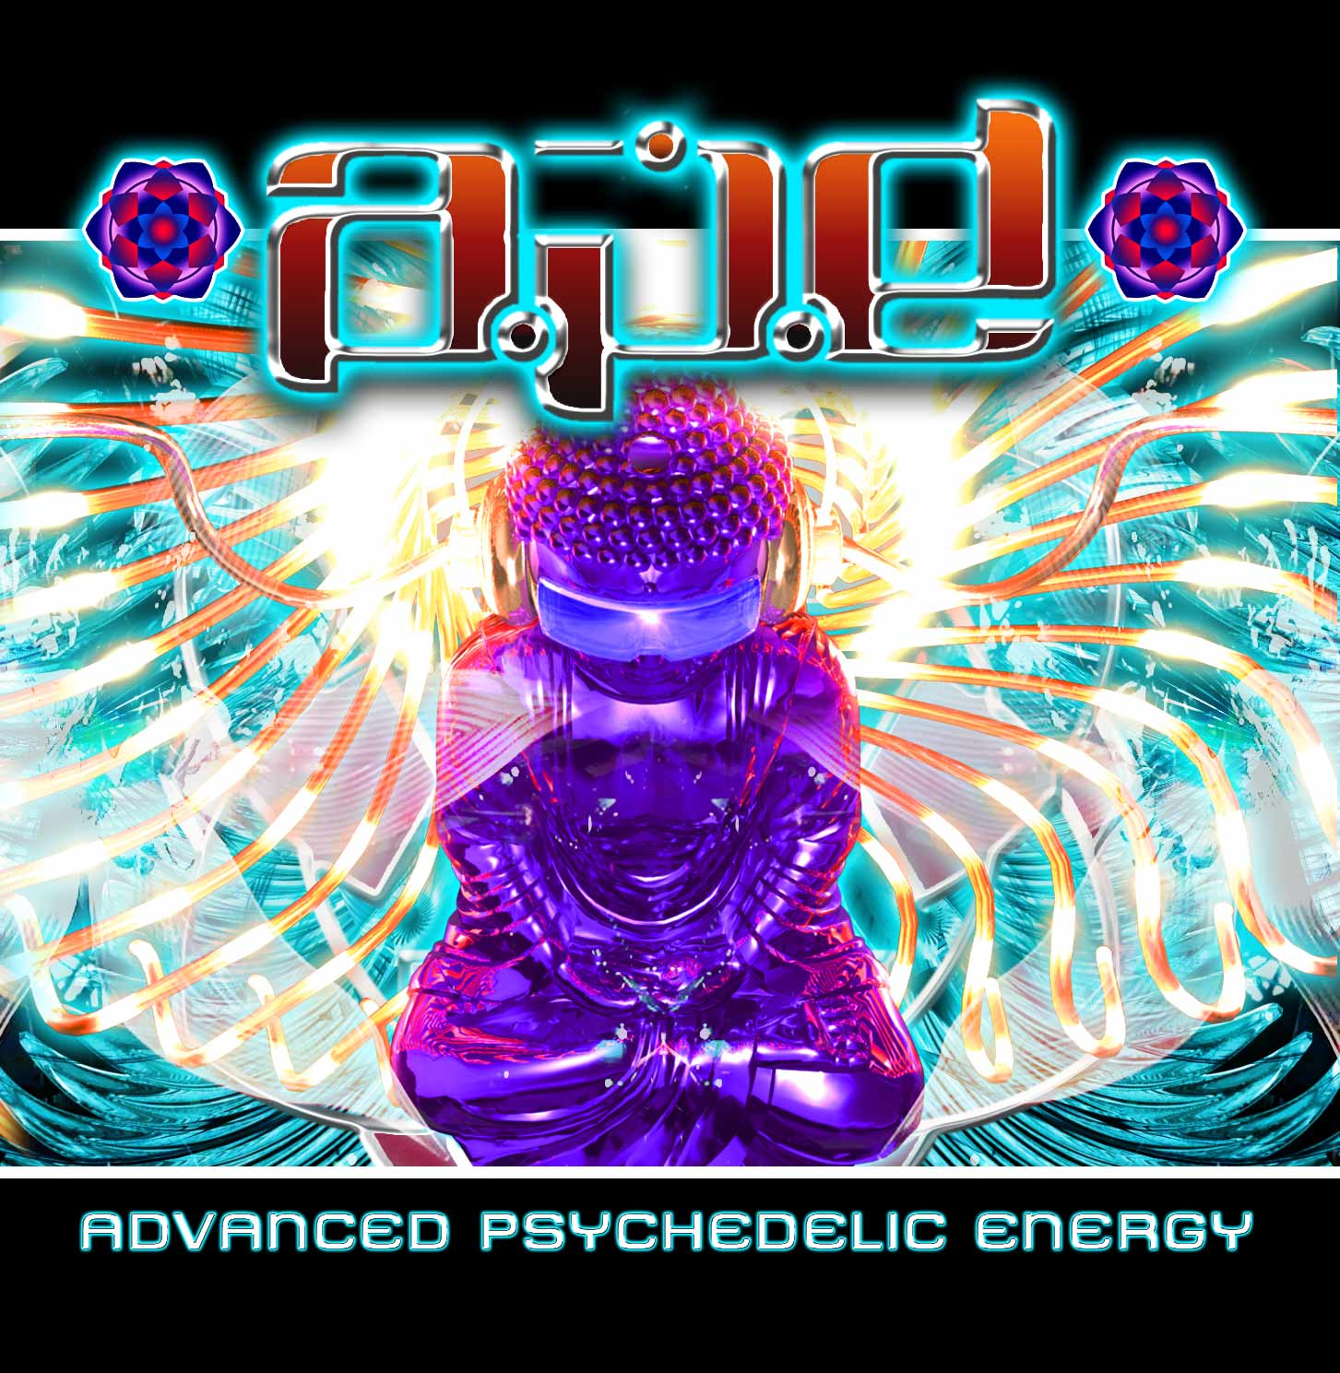 |  | RELEASE NOTES  A.P.E. aka Eran Aharoni (Israel, 1982) presents his long awaited debut full length mega blaster album self entitled “Advanced Psychedelic Energy”. His music can be described as a fun filled ride through the densest packed regions of deep outer space while spinning fast amidst the roller coasters and thickly clustered ganglions of the enlightened mental state achieved by taking a hit of this full power and strongly addicting concoction. Each track has been carefully crafted to contain all the right elements of dance floor explosions, strong leads and hooks, ferocious and funky bass lines all wrapped up in a unique style of highly refined yet dripping with scratchy, crunchy and raw, highly advanced psychedelic energy in all the right doses. The theme of this memorable and poignant epic is Illumination (of the mind) and that is the title track as well!. Following this is an enlightening look into the methods being used to dominate our planet with hints of how to break free. Then we take a quick travel to the stars in our galaxy blasting right through Cosmic Storms along the way. Having charged ourselves full of mental electricity we dig deep in our Electro Magnetic Stashbag for the key to freeing the planets population from the Illuminati’s Blueprints Of Global Enslavement. Then back to deep space to continue our cosmic journey. Our brave pilot, Eran is a dedicated and gifted musician (and Psychonaut) who as youth of 12 was turned on early to the sounds of goa and hard core underground techno and when given a gift of a synthesizer at only 15 he instantly fell in love with the art form thus beginning his career creating intense and powerful psychedelic electronic music. Now days Eran is booked constantly across the planet under his project title A.p.e. playing both memorable and electrifying live PA and DJ sets to packed dance floors in clubs, underground events and outdoor festivals. Currently Eran's style is a mixture of full on and dark trance with a touch of d&b / Techno. A.P.E.’s discography spans releases with many leading psytrance labels including: Doof, Shiva Space Japan, Geomagnetic, Ketuh, Spontaneous Aerobics, MoonSun, Inner Sound, Plutonic, Dacru-Rudrakesh and many more unforgettable hit tracks in the pipeline so stay tuned and check the site!  Artist Profile: www.myspace.com\psychedelicape  A.P.E. [Advanced Psychedelic Energy] aka Eran Aharoni (Israel, 1982) is a dedicated and gifted musician who as youth of 12 was turned on early to the sounds of goa and hard core underground techno and when given a gift of a synthesizer at only 15 he instantly fell in love with the art form thus beginning his career creating intense and powerful psychedelic electronic music. Now days Eran is booked constantly across the planet under his project title A.p.e. playing both memorable and electrifying live PA and DJ sets to packed dancefloors in clubs, underground events and outdoor festivals. Currently Eran's style is a mixture of full on and dark trance with a touch of d&b / Techno. A.P.E.s discography spans releases with many leading psytrance labels including: ShivaSpace Japan, Geomagnetic, Psytropic Records, Ketuh, Spontaneous Aerobics, MoonSun, Inner Sound, Plutonic, Doof, Dacru/Rudrakesh and many more in the pipeline.  Label Profile: www.geomagnetic.tv  GEO-ISRAEL is a subdivision of Geomagnetic Records, offering the most cutting edge sounds from the hottest new artists of the Israeli psychedelic underground. With no distinguishing night and day, day and night, GEO-Israel offers a thick, light, full-on and dark aural journeys to enhance your trance dancing experience! GEOmagnetic.tv was established in the summer of 2001. Based in San Francisco and focusing mostly on visual and music related projects, you can expect to see lots more cutting edge releases on the way from this award winning crew! Geomagnetic.tv was started by Spook one of the founders of the prominent San Francisco 3D FX and Multimedia boutique known as Minds Eye Media (est.1995). www.mindseyemedia.com
Title: | Advanced Psychedelic Energy
Artist: | A.P.E.
Label: | Geo - Israel
Catalogue: | GEOCD034
Format: | 4-Panel JewelCase Audio CD
Barcode: | 881034184726
Release: | September 2008 World Wide
TRACK LIST

01. Illumination
02. Fuck The Codex Alimentarius!
03. Electric Fury
04. A.p.e Vs Lagun - Travel To The Stars
05. Cosmic Storms
06. Electricity on demand
07. Electro Magnetic Stashbag
08. Blueprints Of Global Enslavement
09. Traveling The Cosmos (Album RMX)

CREDITS
Mastered by Ross (Random) Dubois @ Geomagnetic Studios – San Francisco
Artwork by Doctor Spook
Distribution: Saikosounds, Psyshop, Geomagnetic.tv
(p) and © GEO - ISRAEL (a division of Geomagnetic Records)
info@geomagnetic.tv Hi-Res art online:
http://geomagnetic.tv/labels/GEO-Israel/geocd034-APE-AdvancedPsy




