GEOSPIRIT1 – Virtual Vortex CD – Geomagnetic.tv

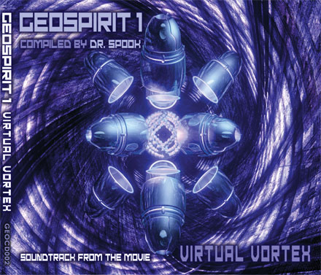 |  | RELEASE NOTES  Geomagnetic.tv is proud to present GEOSPIRIT1: Virtual Vortex. Featuring 11 breathtaking new psytrance journies by international psy-masters compiled by San Francisco DJ Dr. Spook.  Label Profile:  Geomagnetic.tv was established in the summer of 2001.  Their first major international release is the legendary DVD  project “MAGNUS” geodvd001. Based in San Francisco  and focusing mostly on visual and music related projects,  you can expect to see lots more cutting edge release on the way from this award winning crew! Geomagnetic.tv was started by one of the founders of the prominent San-  Francisco 3D FX and Multimedia boutique known as  Minds Eye Media (est.1995). www.mindseyemedia.com  Artist Profile:  DJ/VJ Doctor Spook (San Francisco,USA)  Also known as Nathan Vogel, Spook is an award winning  3D animator and music video director. He began creating  psychedelic visuals in 1992, recieving critical acclaim for  all of his projects. Nathan has worked with major music labels such as Arista, Geffen/Universal, Sony, Om and now with all of the most prominent Psytrance labels with this ground breaking new release. Spooks passion for electronic music drove him to start making music in 1990. He began djing at Burning man in 1998.  Dr.Spook has compiled a collection of the most innovative psy-producers as well as some blasting new surprises that have been exploding in San Francisco and soon all over the planet!!! Each track takes you to a uniquely amazing environment that will both boggle your mind and astound your senses.  Audio CD Format 11 Unreleased Psytrance Journeys by:  Altom vs Phoenix Family, Moontribe, Chromatone,  Mr. Peculiar, Scorb, CPU vs Phoenix Family, Neuromotor,  Rastaliens, Phoenix Family, Earthling vs Phoenix Family,  Nomad vs Jeremy. Presented Unmixed  Featuring the debut of the hottest project coming from San  Francsico, Geomagnetic.tv is proud to present:  Phoenix Family (San Francisco, USA)  This newly formed Psytrance production crew consists of  Lawrence Hoffman aka Chromatone, Ross Dubois aka Random and Nathan Vogel aka Doctor Spook. Together with their many guest producers they are responsible for an ever growing list of top notch releases.
Title: | GEOSPIRIT1: Virtual Vortex
Artist: | Dr. Spook - Various Artist
Label: | Geomagnetic.tv
Catalogue: | GEOCD002
Format: | 4-Panel Digipak
Barcode: | 9366977744981
Release: | Oct 14 2005 Japan  Oct 31 2005 Non Japan
TRACK LIST
01. Altom vs Chromatone & Phoenix Family
METADIMENSION
02. DesertDwellers(Random/Dr.Spook rmx)
HIGHER SENSORY PERCEPTION (RMX)
03. Chromatone
MIGHTONCHONDRIA (RMX)
04. Mr. Peculiar
CRYSTAL MYTH
05. Scrob
THUNDERMENTAL (Redeux)
06. CPU with Phoenix Family
DECENTRALIZE
07. Neuromotor
DANGER HIGHT VOLTAGE (RMX)
08. Rastaliens
EVIL EXTRATERRESTRIALS
09. Phoenix Family
PERPETUAL SUN
10. Earthling with Random and Chromatone
KILLER DOPE (Phoenix Family Mix)
11. Nomad and Jeremy Tsunami
HIGH VOLUME

CREDITS
Mastered by Chromatone
Distribution by Saiko Sounds
Artwork by Doctor Spook
(p) and © Geomgnetic.tv
http:/www.geomagnetic.tv
info@geomagnetic.tv

