PSYCHIC CHAKRA - V/A geocd015
2 CD Set Compiled by Doctor Spook –MORNINGSTAR / Geomagnetic.tv

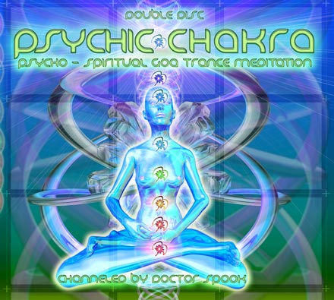 |  | RELEASE NOTES  The Good Doctor, leads you through an intentional sonic meditation for the Mind, Body, Soul combination. He creates an immediate uplifting response by using each chakra to cleanse and prepare the little known 8th 9th and 10th Psychic Chakras. These “Energy Chakras” are located outside your physical body but connect your personal trinity (M.B.S.) directly to your higher self. So gather your past and future energies together and ready your self to connect to the collective positive sub-conscious. Welcoming Digital Samsara (Israel), Virtual Light (Canada), Loud (Israel), Ovnimoon (Chile) and Pragmatix (Argentina) as new label artists. This DYNAMIC MEDITATION is packed with so many chakra swirling keys to inner joy and effortless abundance are bound to cause spontaneous evolutions throughout your  “Meta Body”.  Artist Profile:  DJ/VJ Doctor Spook (San Francisco, USA)  Also known as Nathan Vogel, Spook is an award winning  3D animator and music video director. He began creating  psychedelic visuals in 1992, receiving critical acclaim for  all of his projects. Nathan has worked with major music labels such as Arista, Geffen/Universal, Sony, Om and now with all of the most prominent Psy-trance labels with ground breaking new releases. Spooks passion for electronic music drove him to start making music in 1990. He began DJing Psy-trance at the Burning Man festival in 1998 and since has toured the world and shared the stage with the biggest names in dance music.  Label Profile:  Morningstar is a subdivision of Geomagnetic Records. Uplifting, melodic, progressive and perfect for those ecstatic moments of sunshine and awakening, the Morningstar label knows you want to be carried on a cloud of feel-good grooviness as you welcome the morning light!  Geomagnetic.tv was established in the summer of 2001.  Their first major international release is the legendary DVD  project “MAGNUS” geodvd001. Since then they have added 30 label artists and have multitudes of projects in the works for 2006 and beyond. Based in San Francisco and focusing mostly on visual and music related projects, you can expect to see lots more cutting edge releases on the way from this award winning crew! Geomagnetic.tv was started by Spook one of the founders of the prominent San Francisco 3D FX and Multimedia boutique known as Minds Eye Media (est.1995). www.mindseyemedia.com  
Title: | PSYCHIC CHAKRA
Artist: | v/a compiled by Dr. Spook
Label: | Morningstar / Geomagnetic.tv
Catalogue: | GEOCD015
Format: | 6-Panel Digipak Audio 2CD
Barcode: | 9366977745223
Release: | October 2006 World Wide
TRACK LIST
1. DIGITALSAMSARA – Space Kozak (Awakening Mix)
2. SIDHARTHA – The Rush
3. IMIX – Wa Hey Guru (Earn More Edit)
4. VIRTUAL LIGHT – Nuclear Sun
5. CHAIN REACTION – DMT Server (LOUD RMX)
6. WICKED WIRES vs DELYSID – Neuronal Language
7. MINDSTORM – Star Stuff
8. TWISTED REATION – Mutant Community
9. IBOJIMA – Natural Spirit
10. PRAGMATIX – Twisted Perception
11. OVNIMOON – Before The Dark Times
12. DELYSID vs WICKED WIRES – Neo Human
13. CLONE – Dragon Breath
14. A.X.L. – Are You Ready
15. VECTRO ELECTRO – Goa Dream
16. MECHANIX – Digital Shmok
17. TRYPTAMIND (HUX FLUX+ IBOJIMA) Organic Wizdom
18. MEGADROP - Guacamole
19. SHAPESTATIC – Real Experience
20. BUS (GUS TILL) – Full Monty Jacket Part 2
CREDITS
Mastered by Chromatone Waveworks
Artwork by Doctor Spook
Distribution by Saiko Sounds
(p) and © Geomagnetic.tv
http://geomagnetic.tv/releases/Highway420.htm info@geomagnetic.tv


