IMIX - “ONE” CD – Morningstar (Geomagnetic.tv Label Group)

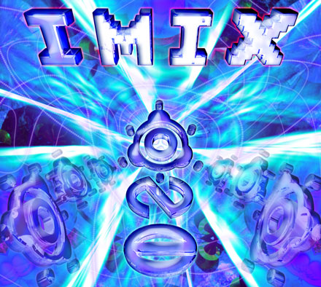 |  | RELEASE NOTES  IMIX aka DJ Anza is one of the premiere Psytrance producers hailing from the central European hot bed for trance culture, Austria. After producing 5 other dance floor blasters that all received critical acclaim released on hot rising labels from around the world he now has pulled out all the stops to bring us a 10 track masterpiece! From beginning to end you are treated to a lushly produced magical voyage that delivers on so many levels. To ensure a the highest quality far above the crowd Imix spent serious studio time with top experts from around the world refining his sound with the these technical gurus. The results are a quality level that can’t be denied, coupled with “pristine” mastering at world famous Geomagnetic Studios based in the USA psychedelic capital, San Francisco by veteran producer and proven master engineer Ross (Random) Dubois. Use these tracks to focus your thoughts and calm your mind while your body is given a pure energy boost from the cosmic galactic oneness. IMIX and the top International trance master producers collaborate to bring you dance floor hits from: Patchbay, 40%, Chaostherapy, Tacticmind vs Ultravoice, Beatfriends and Psyboriginal.  Label Profile:  Morningstar is a subdivision of Geomagnetic Records. Uplifting, melodic, full-on, progressive and perfect for those ecstatic moments of sunshine and awakening, the Morningstar label knows you want to be carried on a cloud of feel-good grooviness as you welcome the morning light!  Geomagnetic.tv was established in the summer of 2001.  Their first major international release is the legendary DVD  project “MAGNUS” geodvd001. Since then they have added 30 label artists and have multitudes of projects in the works for 2006 and beyond. Based in San Francisco and focusing mostly on visual and music related projects, you can expect to see lots more cutting edge releases on the way from this award winning crew! Geomagnetic.tv was started by Spook one of the founders of the prominent San Francisco 3D FX and Multimedia boutique known as Minds Eye Media (est.1995). www.mindseyemedia.com  Artist Profile:  IMIX aka Dj ANZA is Franz J. Bogendorfer, born 18th february 1960 in Vienna - Austria. In the age of 12 years Franz starts to discover and collect psychedelic music on vinyl & mc. Recently he is working - since 2002 - on his own psytrance project called IMIX. IMIX (KIN 161 "harmonic red dragon" ) is the mayan zodiac of Franz and significates "impulse". Influenced by this archaic energy and his huge experience as dj, aquariusminded IMIX starts his psytrance voyage with kikking basslines, psychedelic spacefunk, crunchy production and harmonic melodies for night and daytime. Performance Hotspots : Sonnenklang 2003 - 2006 Austria; Spiritbase 2006 - Austria; Microcosmos 2005 - Austria; Morocco NYE 2004/05; Earthdance Salzburg 2004 - Austria; Carneval 2003 - Itacaré Brasil; Buddha Bar Munich 2002- Germany; Psychofreak 2002 - Belo Horizonte Brasil; Kalki 2002 - Belo Horizionte Brasil; Carneval 2002 - Trancoso Brasil; Batusim Psy Camp 2002 & 2003- Austria; Dimension 2001 - Austria; Ruin Landsee 2001 - Austria; Psychedelic Circus 2000 - Netherlands; Sundance 2000 - Austria; more appearances in Austria, Croatia, Greece, Brasil, Ibiza, Hungary, Germany, ... In 2006 IMIX remixes some psymasters written by such great artists like: 40%, Tactic Mind vs Ultravoice, Jaia, Ovnimoon, ... Releases with Sonnenklang Records, Synergetic Records, Geomagnetic TV, ... Stay tuned for upcoming IMIX productions on V.A. Compilations and now this phenonmenal debut, IMIX “ONE” his artist album ...
Title: | IMIX – ONE
Artist: | IMIX
Label: | Morningstar/Geomagnetic.tv
Catalogue: | GEOCD021
Format: | 4-Panel Digipak Audio CD
Barcode: | 9366977745636
Release: | February 2007 World Wide
TRACK LIST
1. IMIX vs PATCHBAY - Patchmix
2. 40% - Swift (IMIX RMX Album Version)
3. IMIX - Once Again
4. CHAOS THERAPY - Deep Trance (IMIX RMX)
5. TACTIC MIND vs ULTRAVOICE - Top Of The Hill (IMIX RMX)
6. BEATFRIENDS - Supersonic (IMIX EDIT)
7. IMIX - Wa Hey Guru (LIVE MIX)
8. IMIX vs PSYBORIGINAL - Level Schmevel
9. IMIX - What Ya Think
10. IMIX - Dance And Act

CREDITS
Mastered by Random @ Geomagnetic
Artwork by Spook@geomagnetic.tv
Distribution by Arabesque/ SaikoSounds /Psyshop (p) and © Geomagnetic.tv
http://geomagnetic.tv/releases/IMIX-ONE.htm
info@geomagnetic.tv Hi-Res art online.





