v/a Piloted by Doctor Spook –“Fed-X - Overnight X press” CD– [geocd025] Morningstar (Geomagnetic.tv)

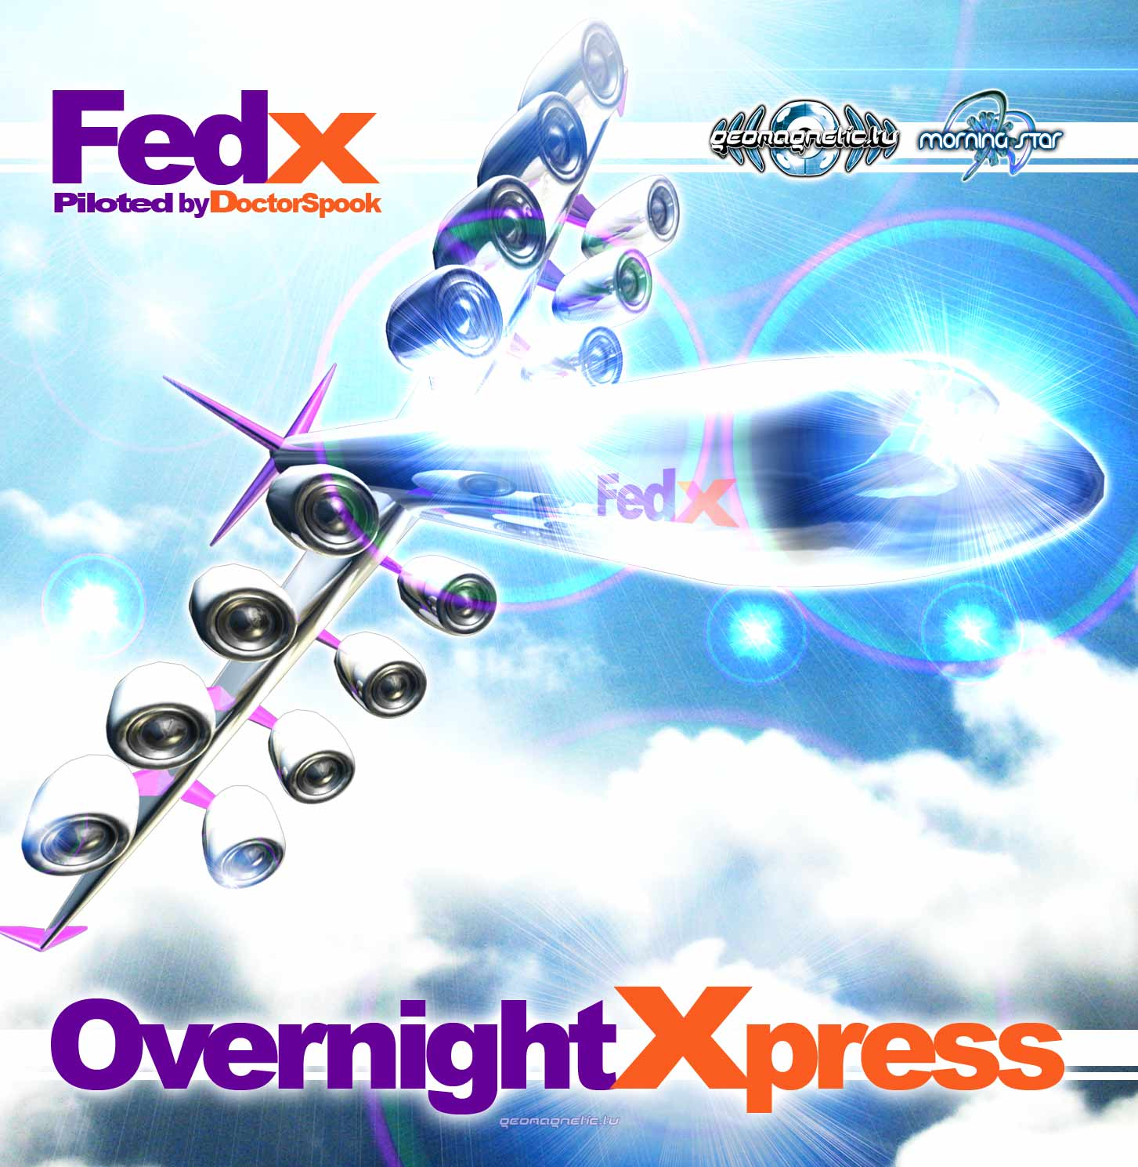 |  | RELEASE NOTES  Fed - X: Overnight Express ... Imagine you are the co-Pilot of an interstellar X press delivery trance-port with important destinations across the galaxy for an Overnight X press round trip. You embark from THE DUNE of a mysterious desert planet after taking your special dose of spice to allow you to navigate space. If your voyage is succesful you will have reignited the SUNSHINE. Using your MIND CREATION to guide your ship's probabilty drive you manifest a safe ATMOTRIP through dangerous space time. Within the ship's power core lies a specially charged RUBY that allows you to jump dimensions with your MODERN STIMULATIONS smoothly accelarating to warp velocity. Now you are nearing your first delivery to the hard dancing THUG in charge. With skill and mastery you manage to safely deliver your package to the CONCENTRATION CAMP where you are encountering DISTORTED REALITY the ONE trains you and the new initates to prepare your mind for the final TRANCE SYSTEM BURNZ that will send us safely home. Its important to notice that your ships auto pilot is set to safely guide you home where you will soon be ready for another adventure on the intergalactic FED - X - OVER NIGHT X-PRESS. Doctor Spook pilots the way once again on another space voyage full of fresh new unreleased treats for your mind, body and soul. Oodles of Hits from well known master trance artists as well as a healthy Dose of new comers with suprisingly amazing new sounds from across the globe and beyond. Featuring 11 world class international psytrance masters of their art: Reactive (Russia), Sinewave (UK/Australia), Ovnimoon(Chile), Te-Tuna(France), Tryptamind aka Hux Flux vs Ibojima (Sweden), Skyloops (Argentina), Predators (Greece), Virtual Light (Canada), Atma (Romania), Static Nation (Israel), and Micro Scan (France).  Artist Profile: http://www.myspace.com/mindstorm1  Doctor Spook (Mindstorm) MINDSTORM (aka Nathan Vogel aka Doctor Spook) has morphed into an amazing LIVE VISUALS AND MUSIC project that Doctor Spook has been realizing from the SAN FRANCISCO based GEOMAGNETIC World Headquarters. Musically Spook is collaborating with a stream of the worlds leading musical masterminds inlcuding Tamir Ozana from Atomic Pulse, Chromatone and Random, Altom, Earthling, Central Processing Unit & Twisted Reaction Mindstorm has a strong concept with each track, a detail lacking in much of todays dance music.  Label Profile:  Morningstar is a subdivision of Geomagnetic Records. Uplifting, melodic, full-on, progressive and perfect for those ecstatic moments of sunshine and awakening, the Morningstar label knows you want to be carried on a cloud of feel-good grooviness as you welcome the morning light! www.myspace.com/geomagnetic  Geomagnetic.tv was established in the summer of 2001.  Their first major international release is the legendary DVD  project “MAGNUS” geodvd001. Since then they have added 30 label artists and have multitudes of projects in the works for 2006 and beyond. Based in San Francisco and focusing mostly on visual and music related projects, you can expect to see lots more cutting edge releases on the way from this award winning crew! Geomagnetic.tv was started by Spook one of the founders of the prominent San Francisco 3D FX and Multimedia boutique known as Minds Eye Media (est.1995). www.mindseyemedia.com  
Title: | Fed X – Overnight X press
Artist: | Va piloted by Doctor Spook
Label: | Morningstar/Geomagnetic.tv
Catalogue: | GEOCD025
Format: | 6-Panel JewelCase Audio CD
Barcode: | 9366977745674
Release: | November 2008 World Wide
TRACK LIST

01. Reactive - The Dune - 145
02. Sinewave - Sunshine - 145
03. Ovnimoon - Mind Creation - 145
04. Te-Tuna - Atmotrips (Live Mix) - 146
05. Tryptamind - Ruby - 145
06. Skyloops - Modern Stimulation - 155
07. Predators - Thug - 145
08. Virtual Light - Concentration Camp - 145
09. Atma - Distorted Reality - 148
10. Static Nation - One - 150
11. Micro Scan – Trance System Burnz - 145

CREDITS

Mastering: Sidhartha (Portugal)
Artwork by: Doctor Spook - SanFrancisco
Distribution:SaikoSounds.com / Psyshop.com
(p) and © Geomagnetic.tv / Morningstar Rec
http://geomagnetic.tv/labels/GEO-Morningstar/GEOCD025-FedX-OvernightXpress
info@geomagnetic.tv mp3 Samples online.



