Random Robot –“Sonic Life” CD – geocd042 Morningstar (Geomagnetic.tv)

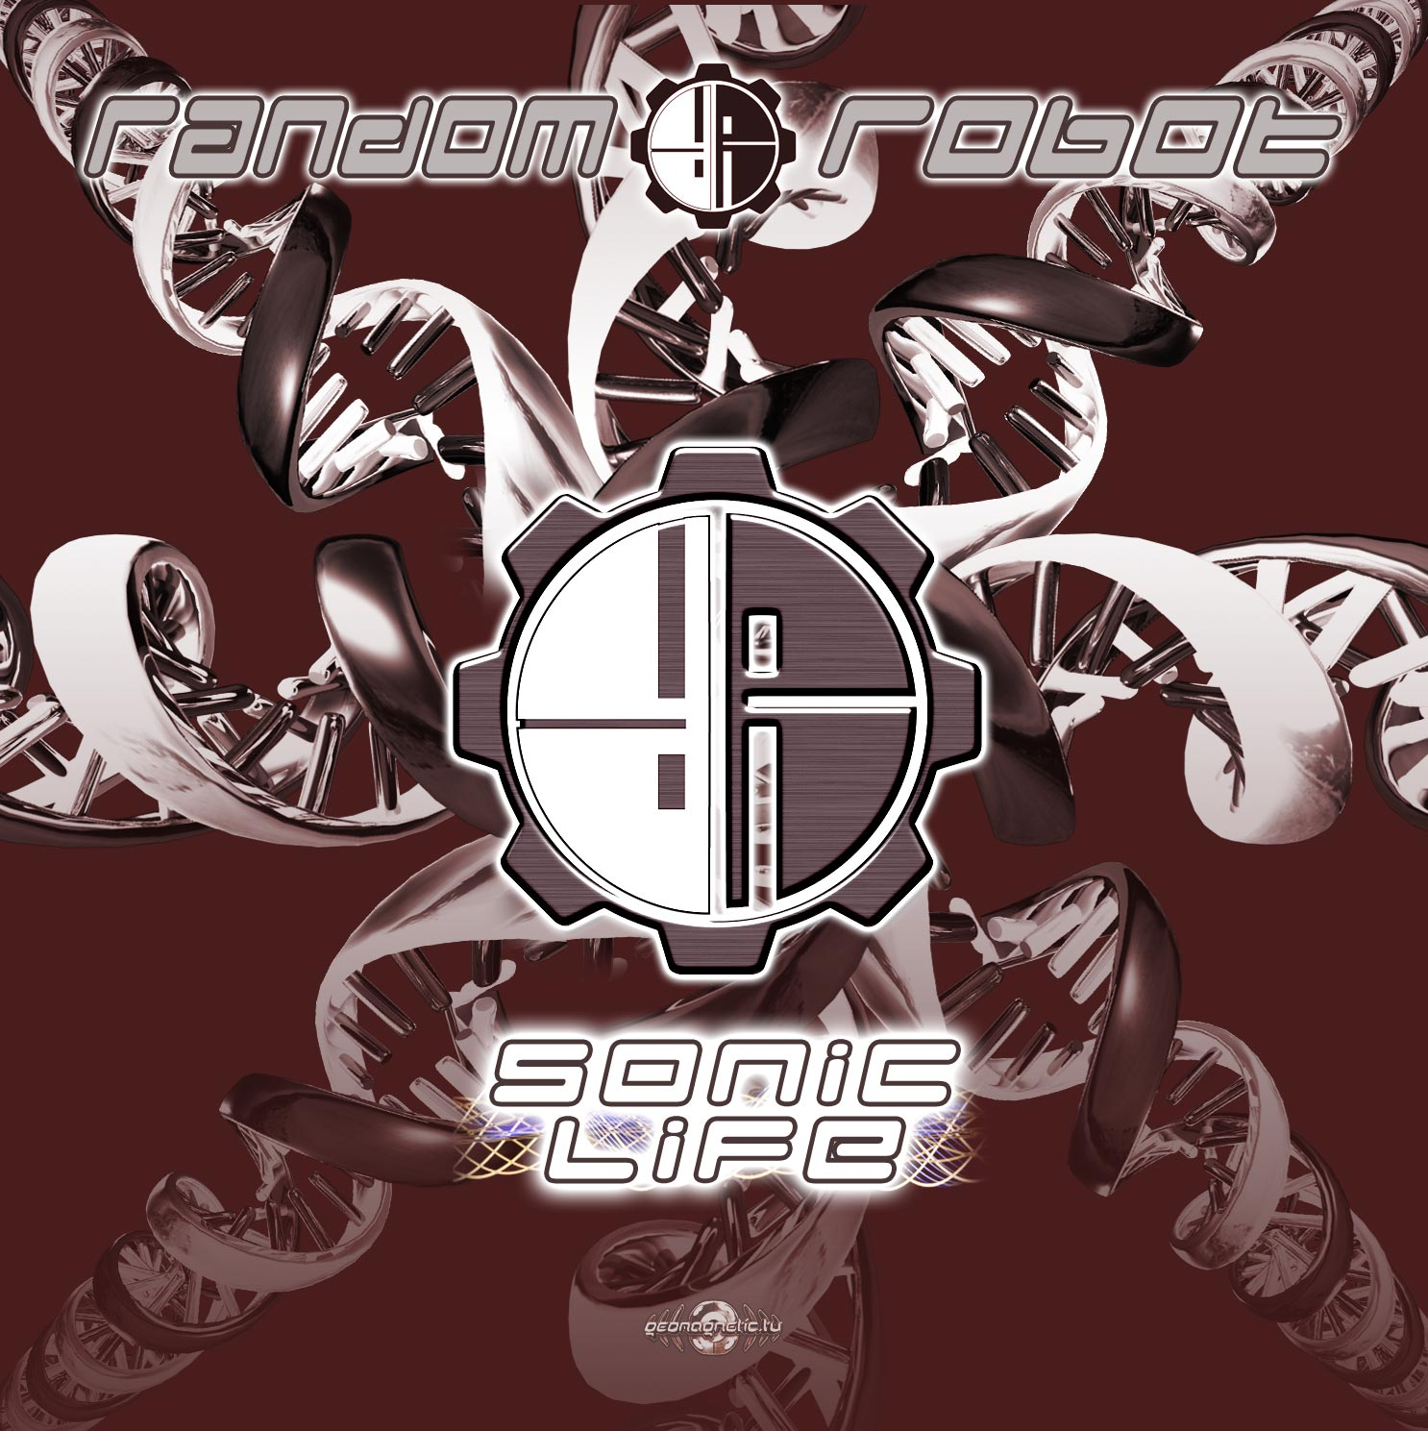 |  | RELEASE NOTES  Random Robot are Ross Du Bois (Solo aka Random, half of Megadrop, Random Light, Phoenix Family, Chromatone & Random) and Rob Watson (Solo aka Robot, half of M-Field), both natives of San Francisco and veterans of the American psychedelic and progressive trance scene. Their debut full length collaboration album Sonic Life takes us on a finely tuned harmonically resonant uplifting journey through psychedelic progressive trance, full on and dub step. Each track delivers a clear message combining with the frequency of the previous to culminate in audio orgasmic bliss! Before you know it your senses have been refreshed and your body in alignment with your spirit as this full spectrum audio upgrade graces your perceptions. After over 3 years of refinement and crystallization this masterpiece finally is unveiled. Tested at the Boom Festival 2008, Burning Man 2007, The Love Parade SF and more each song has proven to be memorable and transce Ross is known worldwide as Random, and has numerous psytrance releases to his credit, including a full artist album (Implicate Order, Geomagnetic.tv, 2005), and a slew of intricate, mind bending and stomping singles on some of the worlds best labels. Random also has a successful collaboration with the world renowned producer Chromatone (Chromatone vs. Random, numerous singles and the album Chromaconnection , Vaporvent, 2006). Rob is one half of the progressive duo M-Field, who has released 2 singles and an album on PsyBooty Records to worldwide acclaim. Ross and Rob have been good friends for years, and have collaborated in the past on many other tracks both released (Implicate Order, Geomagnetic.tv, 2005) and unreleased. Now having debuted their full length collaboration Random Robot, album spanning many BPMs and psychedelic genres, they are literally primed and ready for any style dance floor. Random Robot represents the intersection of two very active minds that are always looking to produce high quality, intelligent, funky and psychedelic dance music in both the morning-full-on and the deep driving psy progressive genres. The tracks get the floor moving, but also have a high level of detail and layering that begs for repeat listening both at home, in the car, or of course, out rocking the party.  Artist Profile: www.myspace.com/randomrobot  Random Robot are Ross Du Bois (Solo aka Random, half of Megadrop, Random Light, Phoenix Family) and Rob Watson (Solo aka Robot, half of M-Field), both natives of San Francisco and veterans of the American psychedelic and progressive trance scene. Ross is known worldwide as Random, and has numerous psytrance releases to his credit, including a full artist album (Implicate Order, Geomagnetic.tv, 2005), and a slew of intricate, mind bending and stomping singles on some of the worlds best labels. Random also has a successful collaboration with the world renowned producer Chromatone (Chromatone vs. Random, numerous singles and the album Chromaconnection , Vaporvent, 2006). Rob is one half of the progressive duo M-Field, who has released 2 singles and an album on PsyBooty Records to worldwide acclaim. Ross and Rob have been good friends for years, and have collaborated in the past on many other tracks both released (Implicate Order, Geomagnetic.tv, 2005) and unreleased. Now having debuted their full length collaboration Random Robot album, spanning many BPMs and psychedelic genres they are literally primed and ready for any style dance floor. Random Robot represents the intersection of two very active minds that are always looking to produce high quality, intelligent, funky and psychedelic dance music in both the morning-full-on and the deep driving psy progressive genres. The tracks get the floor moving, but also have a high level of detail and layering that begs for repeat listening both at home, in the car, or of course, out rocking the party.  Label Profile:  Morningstar is a subdivision of Geomagnetic Records. Uplifting, melodic, full-on, progressive and perfect for those ecstatic moments of sunshine and awakening, the Morningstar label knows you want to be carried on a cloud of feel-good grooviness as you welcome the morning light! www.myspace.com/geomagnetic  Geomagnetic.tv was established in the summer of 2001. Their first major international release is the legendary DVD project “MAGNUS” geodvd001. Since then the label has grown into a full fledged major electronic music and media label. Based in San Francisco and focusing mostly on music and visual related projects, you can expect to see lots more cutting edge releases on the way from this award winning crew! Geomagnetic.tv was started by Spook one of the founders of the prominent San Francisco 3D FX and Multimedia boutique known as Minds Eye Media (est.1995). www.mindseyemedia.com
Title: | Sonic Life
Artist: | Random Robot
Label: | Morningstar/Geomagnetic.tv
Catalogue: | GEOCD042
Format: | 4-Panel Jewel Case Audio CD
Barcode: | 881034279071
Release: | June 2009 World Wide
TRACK LIST

1 - Sonic Life - 130 D
2 - Rest & Relax - 130 A
3 - Department of State - 132 F
4 - Manx - 140 G
5 - Indigo - 144 G
6 - Equinox - 144 G
7 - Reverse Engineering - 145 F#
8 - Choices - 146 A
9 - The Penultimate - 147 D#
10 - Select Function - 126 A

CREDITS
Artwork by Dr. Spook + Frenz
Distribution:SaikoSounds.com / Geomagnetic Distro
(p) and © Geomagnetic.tv / Morningstar Rec
http://geomagnetic.tv/news/geocd042
info@geomagnetic.tv mp3 Samples online.

