POLYPHEME –“BLACK MAGIC” CD – geocd044 Morningstar (Geomagnetic.tv)

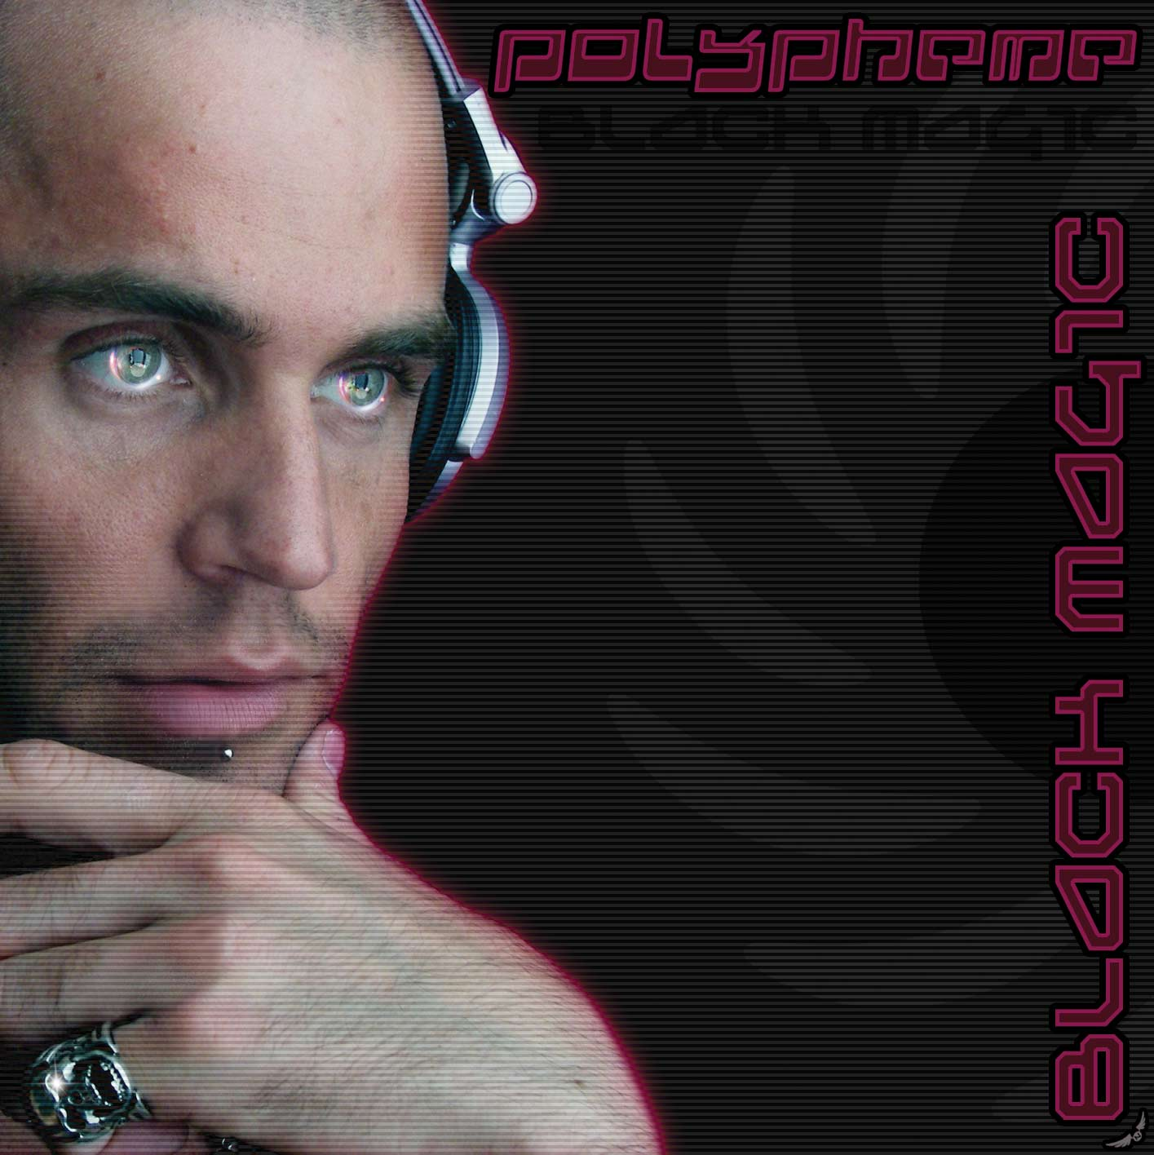 |  | RELEASE NOTES  POLYPHEME is a new French FULL ON project from Dj Cyclopes aka CHRISTOPHE DONNA 28 years old from PARIS. Early in his psytrance development the Polypheme project received special training from psytrance master and legend POLARIS. These amazing tutoring sessions allowed Christophe to focus on his concept and now he has a powerful sound that rivals the most well known producers coupled with his uncanny knack for flow and arrangement makes the sexy sounds of Polypheme an instant world wide hit! Following his smashing success of his debut EP this album comes out just in time to explode the summer festival circuit! Look for Polypheme on the “BLACK MAGIC” world tour. Christophe was born in 1979 in the north of France and he's fund of electronic music since the secondary school. He discovered the trance music in 2000 at the time of a New Year party organized by Gaia Concept. After several party he has taken part in the organization of Symbiosis’ party in 2001 and 2002 and after some experiences and much training with decks, he joined ANTHARES Team in 2002 as DJ for the greater pleasure - (big thought for "MAN'S" which left us) In 2003, he has joined the Psychedelik.com team (your trance web radio) with DJ NAYA(Mahogany Rec) / DJ KRISTONIC / YUMAN(mind control Rec) / BERTRAND and LILIE for 2 years of pure happiness and good vibes during the organization of the LIVE! shows. Currently DJ Cyclopes is located in Paris area and he begun a musical project called POLYPHEME. In 2004, he has taken part in the realization of the track "Moon Shot" with POLARIS left on NEUROBIOTIC RDS. Since then, he has worked on new Full-on style's tracks that you can discover on his MySpace. In 2007, he joined the Mahogany records crew with MESMERIZER,BOBBY WAN,CRYING FREEMEN,PHONIC REQUEST, DYNO... and more. Thanks to DJ NAYA!!! in 2008, he started a new project Electro Progressive "CRISTO DISTO" and he prepared POLYPHEME album 'black magic" soon available on GEOMAGNETIC records composed by dynamic beat and energetic bass lines with a full effect on any dance floor! In 2009 POLYPHEME joins MIND CONTROL records team with TALAMASCA, XSI, LIFE EXTENSION and more.  Artist Profile: www.myspace.com/polyphemeproject  POLYPHEME is a new French FULL ON project of CHRISTOPHE DONNA 28 years old from PARIS. He was born in 1979 in the north of France and he's fund of electronic music since the secondary school. He discovered the trance music in 2000 at the time of a New Year party organized by Gaia Concept. After several party he has taken part in the organization of Symbiosis’ party in 2001 and 2002 and after some experiences and much training with decks, he joined ANTHARES Team in 2002 as DJ for the greater pleasure - (big thought for "MAN'S" which left us) In 2003, he has joined the Psychedelik.com team (your trance web radio) with DJ NAYA(Mahogany Rec) / DJ KRISTONIC / YUMAN(mind control Rec) / BERTRAND and LILIE for 2 years of pure happiness and good vibes during the organization of the LIVE! shows. Currently DJ Cyclopes is located in Paris area and he begun a musical project called POLYPHEME. In 2004, he has taken part in the realization of the track "Moon Shot" with POLARIS left on NEUROBIOTIC RDS. Since then, he has worked on new Full-on style's tracks that you can discover on his MySpace. In 2007, he joined the Mahogany records crew with MESMERIZER,BOBBY WAN,CRYING FREEMEN,PHONIC REQUEST,DYNO... and more. Thanks to DJ NAYA!!! in 2008, he started a new project Electro Progressive "CRISTO DISTO" and he prepared POLYPHEME album 'black magic" soon available on GEOMAGNETIC records composed by dynamic beat and energetic bass lines with a full effect on any dance floor! In 2009 POLYPHEME joins MIND CONTROL records team with TALAMASCA, XSI, LIFE EXTENSION and more.  Label Profile:  Morningstar is a subdivision of Geomagnetic Records. Uplifting, melodic, full-on, progressive and perfect for those ecstatic moments of sunshine and awakening, the Morningstar label knows you want to be carried on a cloud of feel-good grooviness as you welcome the morning light! www.myspace.com/geomagnetic  Geomagnetic.tv was established in the summer of 2001. Their first major international release is the legendary DVD project “MAGNUS” geodvd001. Since then the label has grown into a full fledged major electronic music and media label. Based in San Francisco and focusing mostly on music and visual related projects, you can expect to see lots more cutting edge releases on the way from this award winning crew! Geomagnetic.tv was started by Spook one of the founders of the prominent San Francisco 3D FX and Multimedia boutique known as Minds Eye Media (est.1995). www.mindseyemedia.com
Title: | Black Magic
Artist: | Polypheme
Label: | Morningstar/Geomagnetic.tv
Catalogue: | GEOCD044
Format: | 6 -Panel Jewel Case Audio CD
Barcode: | 881034278944
Release: | May 2009 World Wide
TRACK LIST

01 - Polypheme - Freak 140
02 - Polypheme - Hénawo 142
03 - Block Device vs. Polypheme - Shockwave 142
04 - Polypheme - To The Record 140
05 - Polypheme - Té Quiéro Puta (Block Device rmx) 145
06 - Polypheme - Nicotine For Silver Screen part.2 142
07 - Block Device - Way Back Machines (Polypheme rmx) 143
08 - Polaris - Control (Polypheme rmx) 143
09 - Polypheme feat. Hich' - Locomotiv' 135

CREDITS
Mastering: Charles @ preference (France)
Artwork by Nico PsyArt - France
Distribution:SaikoSounds.com / Goa Records
(p) and © Geomagnetic.tv / Morningstar Rec
http://geomagnetic.tv/news/geocd044
info@geomagnetic.tv mp3 Samples online.




