Dr. Hoffman –“RIDE ON” CD – geocd046 Morningstar (Geomagnetic.tv)

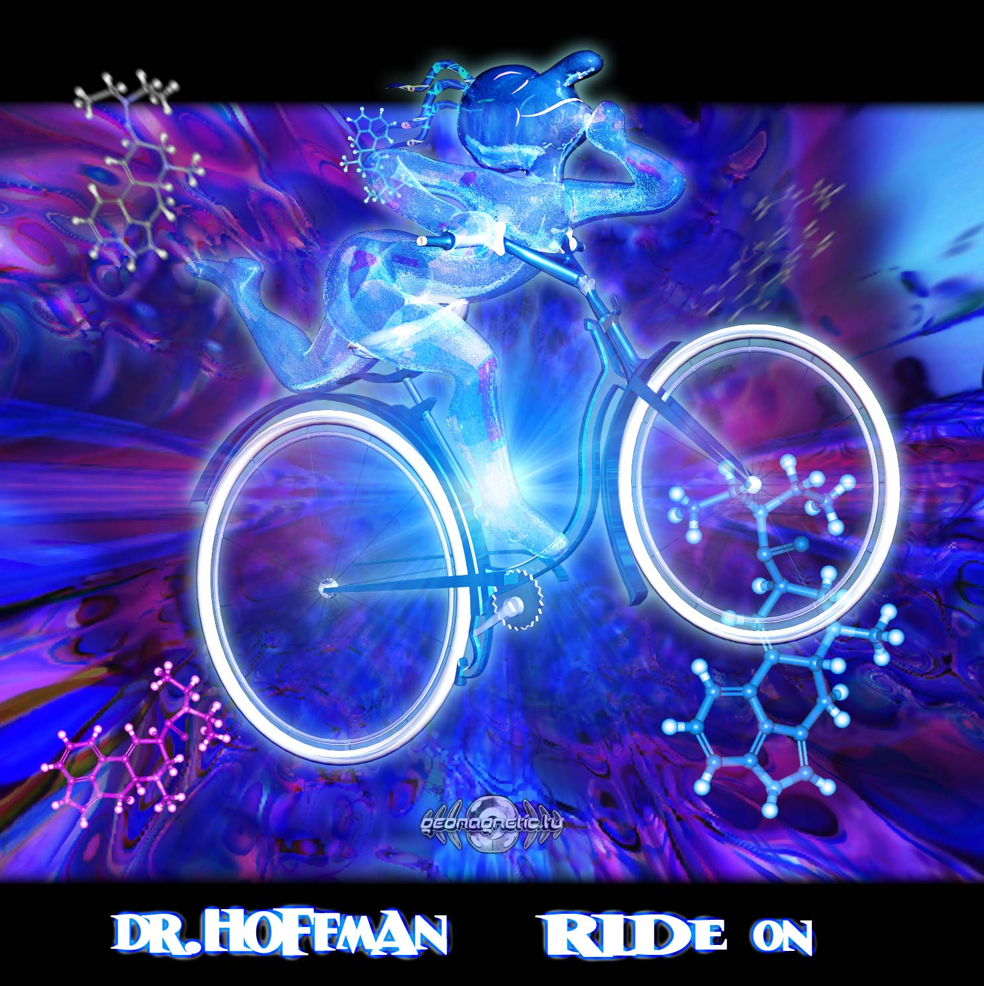 |  | RELEASE NOTES  Dr. Hoffman’s debut hit album Ride On drops us deep into the party experience all at once and sends you on a fun filled TRIP to the happy fantastic land where all of the children of our dear sweet Albert Hoffman live forever and play together in a happy full power wonderland! 10 Amazing unreleased musical voyages treat us like royalty and your ears and minds are filled to the top with powerful messages of freedom and unity and a love for nature. After collaborating with GMS, Poli and many of the other top producers of psytrance Dr. Hoffman is primed for the big time like never before and this album effortlessly struts his stuff as cascades of delicately manipulated psychedelic ear candy deluges you with the sweet sensations of audio ecstasy and lysergically laced bass waves. Jump on your psychedelic psy-cycle and ride on out to the party where Hoffman is holding down the decks in front of 5000 screaming Mexican party freaks in the mountains of Guadalajara Mexico, the heart of the huge trance scene in Mexipsy-wonderland. Dr. Hoffman a.k.a. Cristhian Robles began to DJ in the year 2000 at the age of 18. In the year 2001 he began the old school Mexican Trance project 'Total Sickness' and SICK Rec crew. He started playing his music and Dj'ing in very underground parties on several cities in Mexico. In the year 2003, Hoffman starts playing for dance floors of more than 1500 people. Hoffman's full on melodic style with powerful basslines, crazy tweakage and accurate harmonic mixing was quickly accepted in all dance floors. Soon Hoffman began DJing and performing live in big parties and festivals from Tijuana to Playa del Carmen in Mexico for dancefloors up to 10,000 people. Hoffman has DJ'd and performed live with artists like Hallucinogen, Sphongle, Infected Mushroom, Astrix, CPU, GMS, Skazi, Dimitri Nakov, Pixel, Michele Adamson, Poli, Bushman, Bizarre Contact, Xerox & Illumination, Neuromotor among several others. Hoffman produces music using Logic Studio Pro & Cubase SX. In the year 2007 after visiting Spain he got invited to the legendary Growling Mad Scientists studio, where he collaborated in a killer track and joined SPUN crew. This track proved to be a super hit blasting dance floors and being played by almost every Psytrance Dj around the world in the year 2008. Hoffman will finally release his debut album this year for GeoMagnetic Records. Stay tuned for his second album slated for later on SPUN Records.  Artist Profile: www.myspace.com/drhoffmanlive  Cristhian a.k.a. Dr. Hoffman began to DJ in the year 2000 at the age of 18. In the year 2001 he began the old school Mexican Trance project 'Total Sickness' and SICK Rec crew. He started playing his music and Dj'ing in very underground parties on several cities in Mexico. In the year 2003, Hoffman starts playing for dance floors of more than 1500 people. Hoffman's full on melodic style with powerful basslines, crazy tweakage and accurate harmonic mixing was quickly accepted in all dance floors. Soon Hoffman began DJing and performing live in big parties and festivals from Tijuana to Playa del Carmen in Mexico for dancefloors up to 10,000 people. Hoffman has DJ'd and performed live with artists like Hallucinogen, Sphongle, Infected Mushroom, Astrix, CPU, GMS, Skazi, Dimitri Nakov, Pixel, Michele Adamson, Poli, Bushman, Bizarre Contact, Xerox & Illumination, Neuromotor among several others. Hoffman produces music using Logic Studio Pro & Cubase SX. In the year 2007 after visiting Spain he got invited to the legendary Growling Mad Scientists studio, where he collaborated in a killer track and joined SPUN crew. This track proved to be a super hit blasting dance floors and being played by almost every Psytrance Dj around the world in the year 2008. Hoffman will finally release his debut album this year for SPUN Records.  Label Profile:  Morningstar is a subdivision of Geomagnetic Records. Uplifting, melodic, full-on, progressive and perfect for those ecstatic moments of sunshine and awakening, the Morningstar label knows you want to be carried on a cloud of feel-good grooviness as you welcome the morning light! www.myspace.com/geomagnetic  Geomagnetic.tv was established in the summer of 2001. Their first major international release is the legendary DVD project “MAGNUS” geodvd001. Since then the label has grown into a full fledged major electronic music and media label. Based in San Francisco and focusing mostly on music and visual related projects, you can expect to see lots more cutting edge releases on the way from this award winning crew! Geomagnetic.tv was started by Spook one of the founders of the prominent San Francisco 3D FX and Multimedia boutique known as Minds Eye Media (est.1995). www.mindseyemedia.com
Title: | Ride On
Artist: | Dr.Hoffman
Label: | Morningstar/Geomagnetic.tv
Catalogue: | GEOCD046
Format: | 4-Panel Jewel Case Audio CD
Barcode: | 881034278951
Release: | June 2009 World Wide
TRACK LIST

1. Ride on - 138
2. Drop out feat. Blue Lunar Monkey - 146
3. Logic crash - 144
4. Trance del Caribe pt.2 - 145
5. Mexican Acid - 145
6. Kymatica -144
7. The Apics - 148
8. Dont mess with the Mafia - 145
9. Mutant Virus - 142
10. Jumpingjack - 144

CREDITS
Artwork by Dr. Spook + Dr. Frank Quantum
Distribution:SaikoSounds.com / Geomagnetic Distro
(p) and © Geomagnetic.tv / Morningstar Rec
http://geomagnetic.tv/news/geocd046
info@geomagnetic.tv mp3 Samples online.




