ABDCTN - “New Atlantis” basscd004 CD – Bass-Star Rec (Geomagnetic.tv)

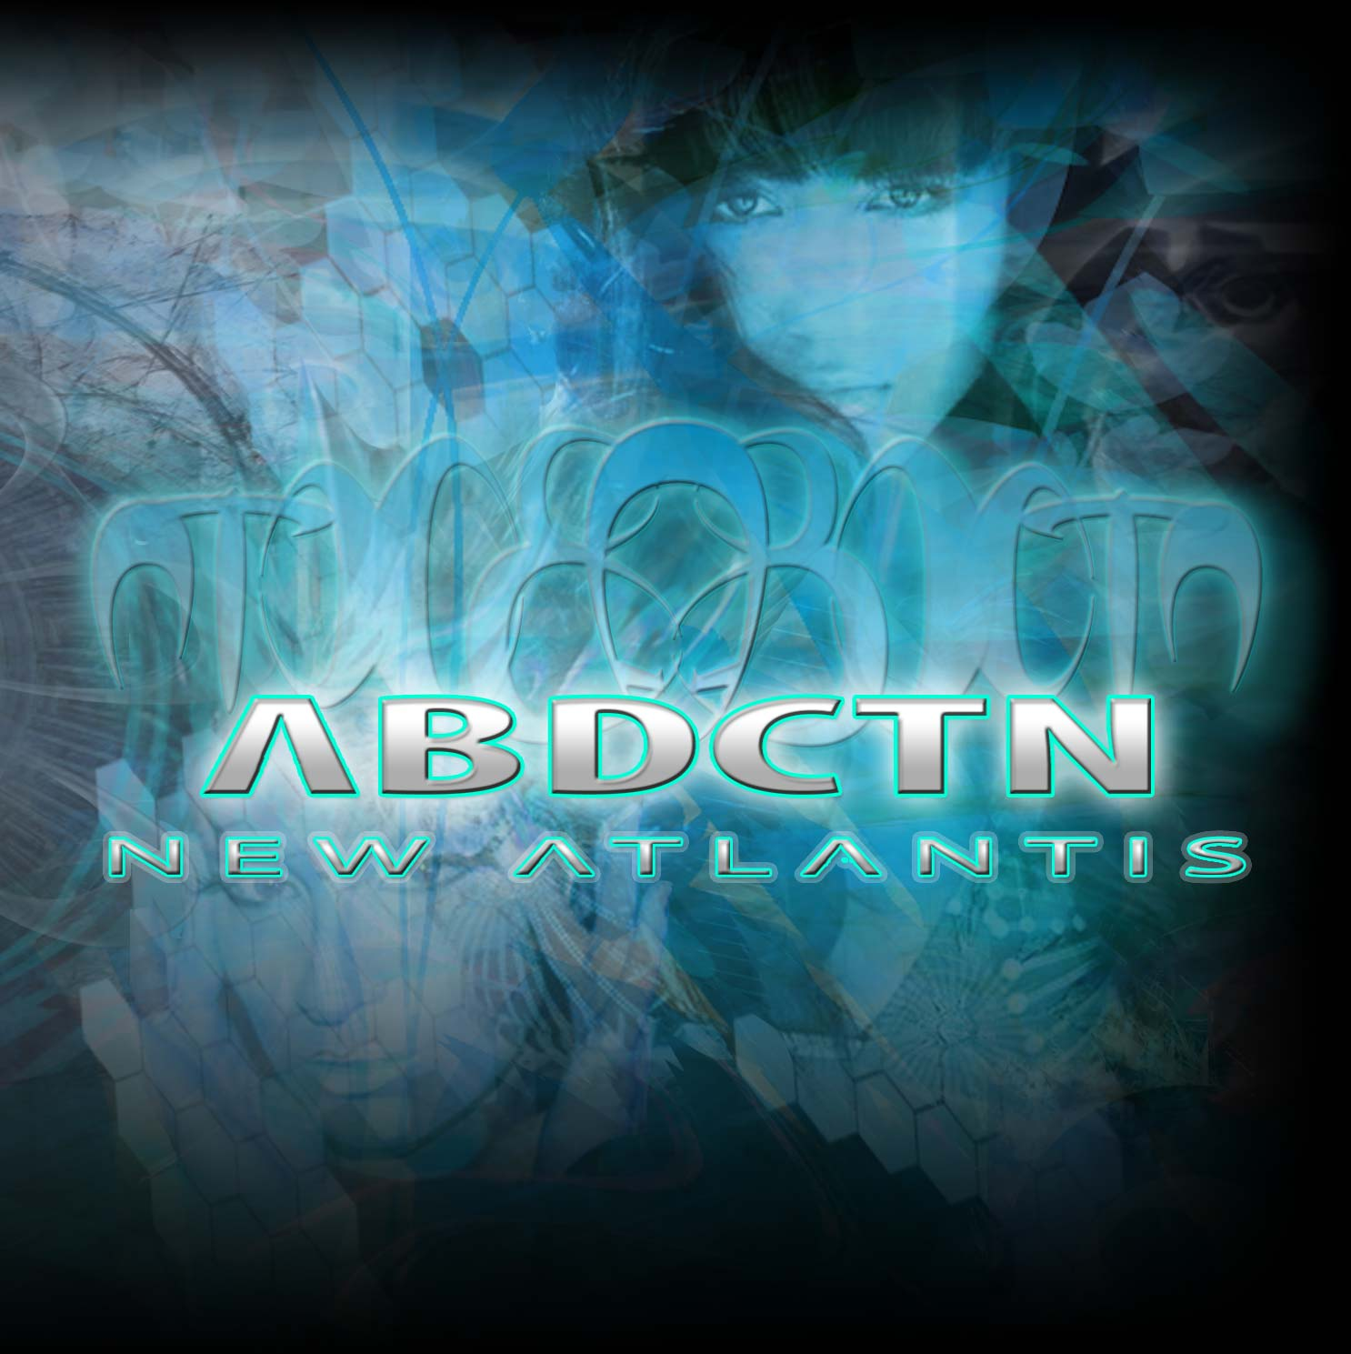 |  | RELEASE NOTES  ABDCTN debut album is a culmination of over 4 years of metabolic transformations and grand scheme space born downloads synthepsysed into a freak tastic boom-bastic orgas-mastic psychic brain probe that re-awakens you to your past and future lives in the city of Atlantis! Drenched with Bass, Laden with glitch, saturated by dubstep, immersed in IDMaddness, composed of Trip Hopian mentalities and finely tuned with an ear for dance floor oblivion this shameless exposition of the inner souls of the West Coast American youth and all wrapped up in a cosmic package of self prophetic proportions suddenly the light shines down from above and beams you to the Alien operating tables (Dj tables that is…). Pump up your gyrations to 145 blistering BPMs of Break Beat mayhem while you get teleported to the other psyde of the Kaosmos. ABDCTN is Jeremiah Allen Welch and John Adam Espinoza, collaborating since 2007. Jeremiah is a conceptual visionary artist and producer who was raised in the entertainment industry and John is a professional audio engineer who has been a part of many bands and music projects since 2003. Their influence is both audio and visual, a mix of visionary art and cutting edge electronic music spanning many genres from trance to hip hop, downtempo to psychedelic breaks. ABDCTN is now residing in San Francisco, CA putting all of their energy into making ABDCTN a fully interactive experience which stimulates all the senses. Currently abducting your eyes and ears with a combination of live painting and live pa, ABDCTN blurs the boundaries between art and music. Currently accepting all applications for ABDCTZ.  Artist Profile  ABDCTN is Jeremiah Allen Welch and John Adam Espinoza, collaborating since 2007. Jeremiah is a conceptual visionary artist and producer who was raised in the entertainment industry and John is a professional audio engineer who has been a part of many bands and music projects since 2003. Their influence is both audio and visual, a mix of visionary art and cutting edge electronic music spanning many genres from trance to hip hop, downtempo to psychedelic breaks. ABDCTN is now residing in San Francisco, CA putting all of their energy into making ABDCTN a fully interactive experience which stimulates all the senses. Currently abducting your eyes and ears with a combination of live painting and live pa, ABDCTN blurs the boundaries between art and music.  Currently accepting all applications for ABDCTZ.  BasStar Records formed in summer of 2007 and is focused primarily on breaks, dub step, electro house and down tekno grooves. Expect lots of wild unpredictable new cuts coming from this phatty side project from Geomagnetic Records Label Group.  Geomagnetic.tv www.geomagnetic.tv was established in the summer of 2001. Their first major international release is the legendary DVD project “MAGNUS” geodvd001. Since then they have added 30 label artists and have multitudes of projects in the works for 2006 and beyond. Based in San Francisco and focusing mostly on visual and music related projects, you can expect to see lots more cutting edge releases on the way from this award winning crew! Geomagnetic.tv was started by Spook one of the founders of the prominent San Francisco 3D FX and Multimedia boutique known as Minds Eye Media (est.1995). www.mindseyemedia.com
Title: | New Atlantis
Artist: | ABDCTN
Label: | BasStar/Geomagnetic.tv
Catalogue: | BASSCD004
Format: | 6 Panel Jewel Case Audio CD
Barcode: | 881034378088
Release: | July 2009 World Wide
TRACK LIST

01 - New Atlantis
02 - Of the Abyss
03 - Capsule
04 - Aphrodte
05 - Sentient
06 - Oceanus
07 - Float
08 - PSI
09 - Spacious
10 – Submerge

CREDITS
Mastered: John Espinosa (aka Kid E)
Artwork: ABDCTN
Distribution by SaikoSounds /Psyshop
(p) and © Geomagnetic.tv
info@geomagnetic.tv
Hi-Res art online.


