LOKESH - “UTOPIA” basscd005 CD – Bass-Star Rec (Geomagnetic.tv)

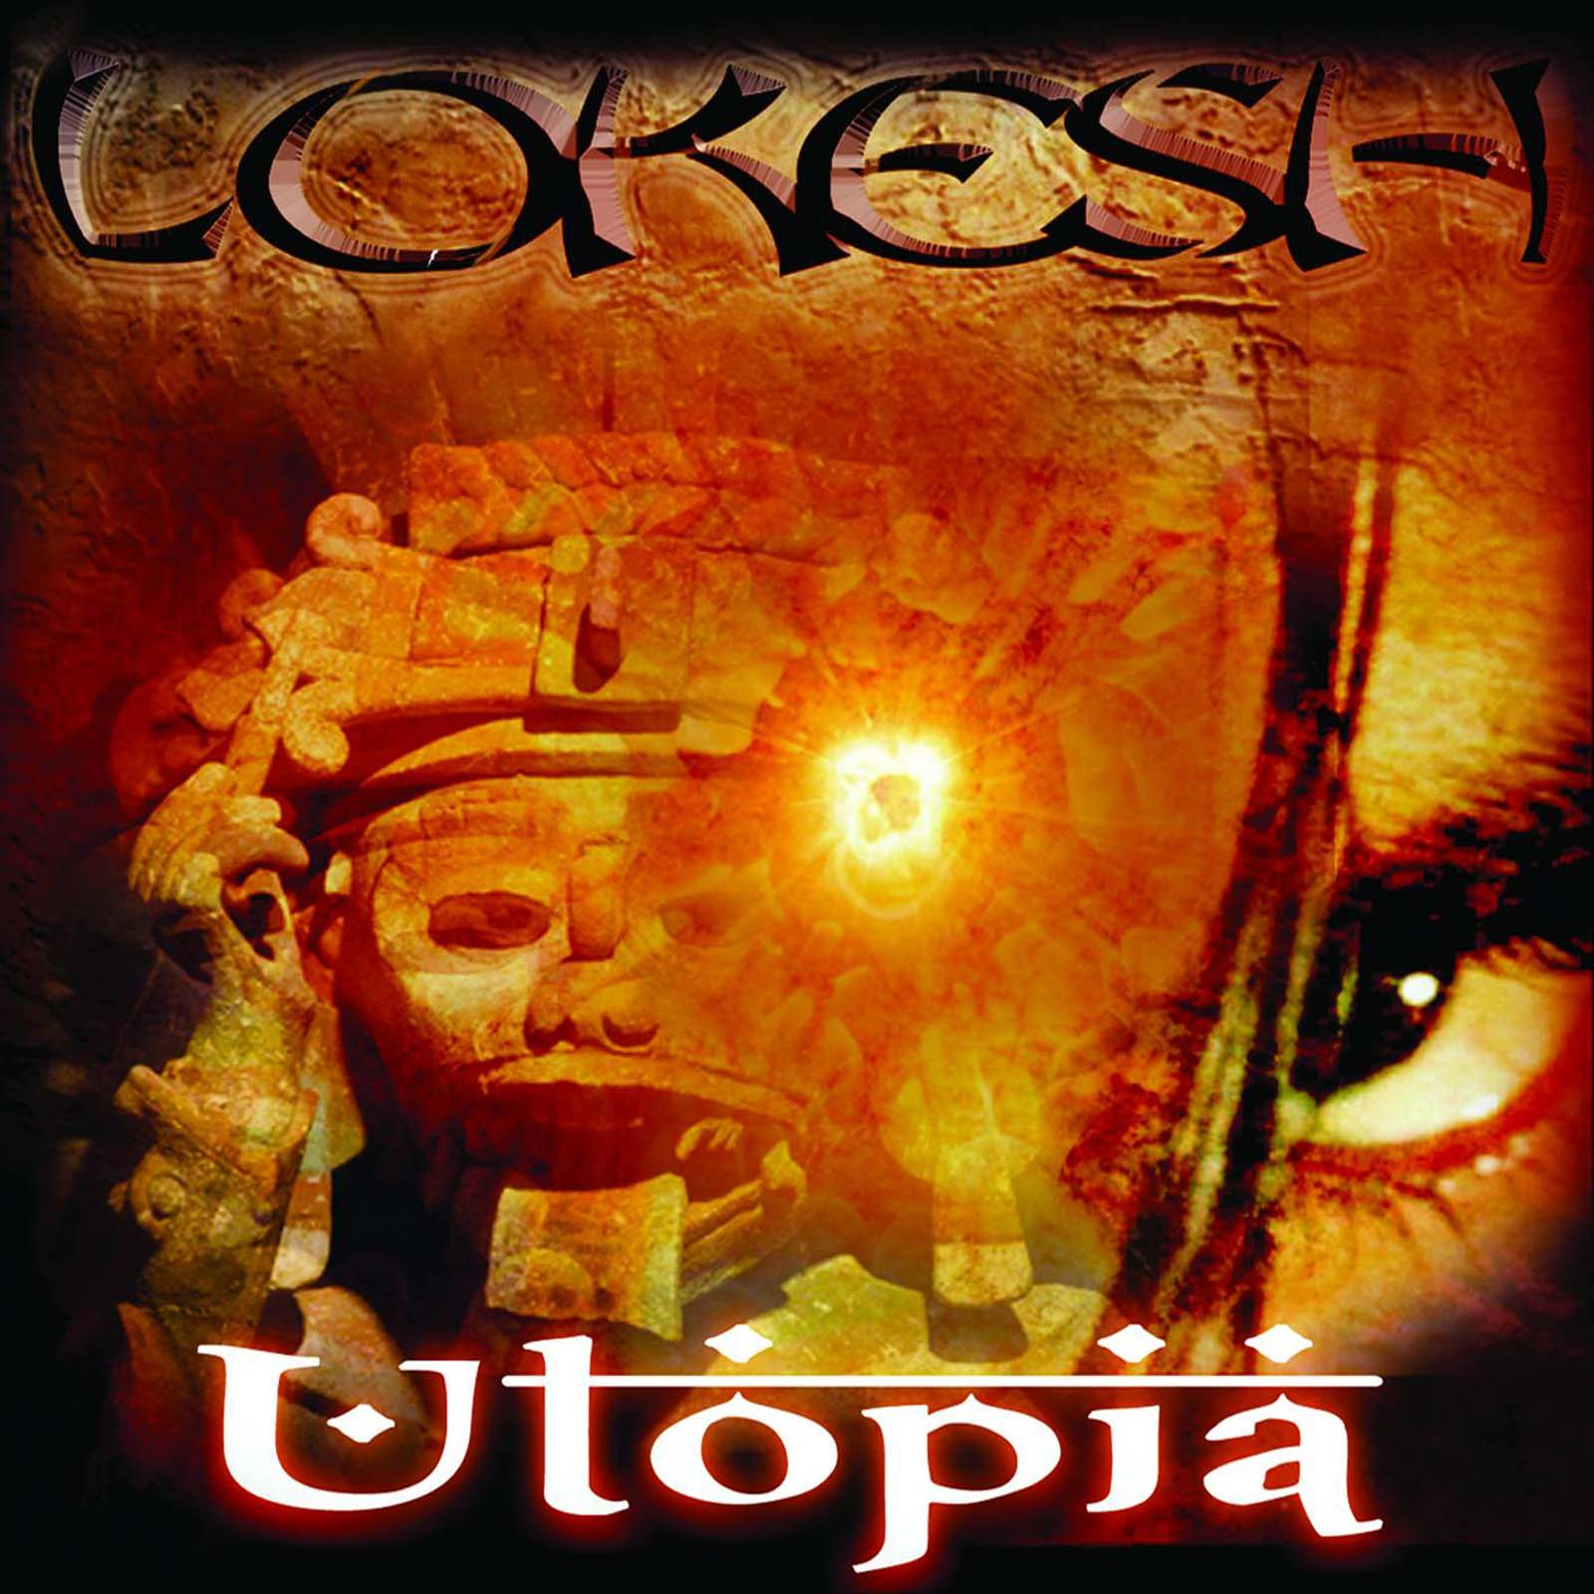 |  | RELEASE NOTES  UTOPIA is the first full-length album from San Francisco based Lokesh. It’s a concept album with heavy Ethnic, Rock and Electronica influences. As a follow-up to the successful Soul Rush EP by Lokesh, Utopia blurs the line between various electronic music genres, especially Trance, Drum-N-Bass, Dubstep, Progressive House and Indian/World Electronica. And its message is loud and clear - Music is the new universal language that’s always evolving. Lokesh aka Tranzatma, born in New Delhi, currently lives, DJs and produces music in San Francisco, California. His genre defying music includes Indian/World Fusion, Ethnic Electronica, Progressive Trance, Psytrance, Dubstep and Drum-N-Bass. His music transcends geographical or cultural boundaries, and mixing eastern and western sounds seamlessly comes naturally to him. His compositions tell a story which is both mysterious and in-your-face. Lokesh signed up with Geomagnetic in 2008, the futuristic Trance label out of San Francisco. He released his first EP 'Soul Rush' in Jan'09 and UTOPIA is his first full-length concept album with them. He is also part of two more Bay Area collectives - Vishnu Operative and Ultraviolet Carnival. He has performed all over the Bay area including the legendary 1015 Folsom, Supperclub, at Burning Man Festival, Kellys, Shine etc. He has shared the stage with international artists like Karsh Kale, Chebi Sabah, Doctor Spook, Tall Sasha, Micropixie etc. His tracks and sets have been featured on BBC Asia Network, World Fusion Radio and IndianElectronica.com.  Artist Profile  Lokesh aka Tranzatma, born in New Delhi, currently lives, DJs and produces music in San Francisco, California. His genre defying music includes Indian/World Fusion, Ethnic Electronica, Progressive Trance, Psytrance, Dubstep and Drum-N-Bass. His music transcends geographical or cultural boundaries, and mixing eastern and western sounds seamlessly comes naturally to him. His compositions tell a story which is both mysterious and in-your-face. Lokesh signed up with Geomagnetic in 2008, the futuristic Trance label out of San Francisco. He released his first EP 'Soul Rush' in Jan'09 and UTOPIA is his first full-length concept album with them. He is also part of two more Bay Area collectives - Vishnu Operative and Ultraviolet Carnival. He has performed all over the Bay area including the legendary 1015 Folsom, Supperclub, at Burning Man Festival, Kellys, Shine etc. He has shared the stage with international artists like Karsh Kale, Chebi Sabah, Doctor Spook, Tall Sasha, Micropixie etc. His tracks and sets have been featured on BBC Asia Network, World Fusion Radio and IndianElectronica.com.  More info and downloads: http://www.tranzatma.com / http://www.myspace.com/lokeshsf  BasStar Records formed in summer of 2007 and is focused primarily on breaks, dub step, electro house and down tekno grooves. Expect lots of wild unpredictable new cuts coming from this phatty side project from Geomagnetic Records Label Group.  Geomagnetic.tv www.geomagnetic.tv was established in the summer of 2001. Their first major international release is the legendary DVD project “MAGNUS” geodvd001. Since then they have added 30 label artists and have multitudes of projects in the works for 2006 and beyond. Based in San Francisco and focusing mostly on visual and music related projects, you can expect to see lots more cutting edge releases on the way from this award winning crew! Geomagnetic.tv was started by Spook one of the founders of the prominent San Francisco 3D FX and Multimedia boutique known as Minds Eye Media (est.1995). www.mindseyemedia.com
Title: | Utopia
Artist: | Lokesh
Label: | BasStar/Geomagnetic.tv
Catalogue: | BASSCD005
Format: | 6 Panel Jewel Case Audio CD
Barcode: | 881034378095
Release: | July 2009 World Wide
TRACK LIST

01. Maya
02. Ohm Tripper
03. Paradox
04. Oscillations
05. Quantum Chant Machine
06. Utopia (Here And Now)
07. Traanstoned
08. PsySwarg
09. Infinite Love
10. Tantra Mantra

CREDITS
Mastering: DJ Random @ Geomagnetic
Artwork: Daniel Robert Cohn @ Namaste
Distribution by SaikoSounds /Psyshop
(p) and © Geomagnetic.tv
info@geomagnetic.tv
Hi-Res art online.


