Chilldren Of The Blue Ray v2. – Awaken 2013 basscd007 CD – Bass-Star Rec (Geomagnetic.tv)

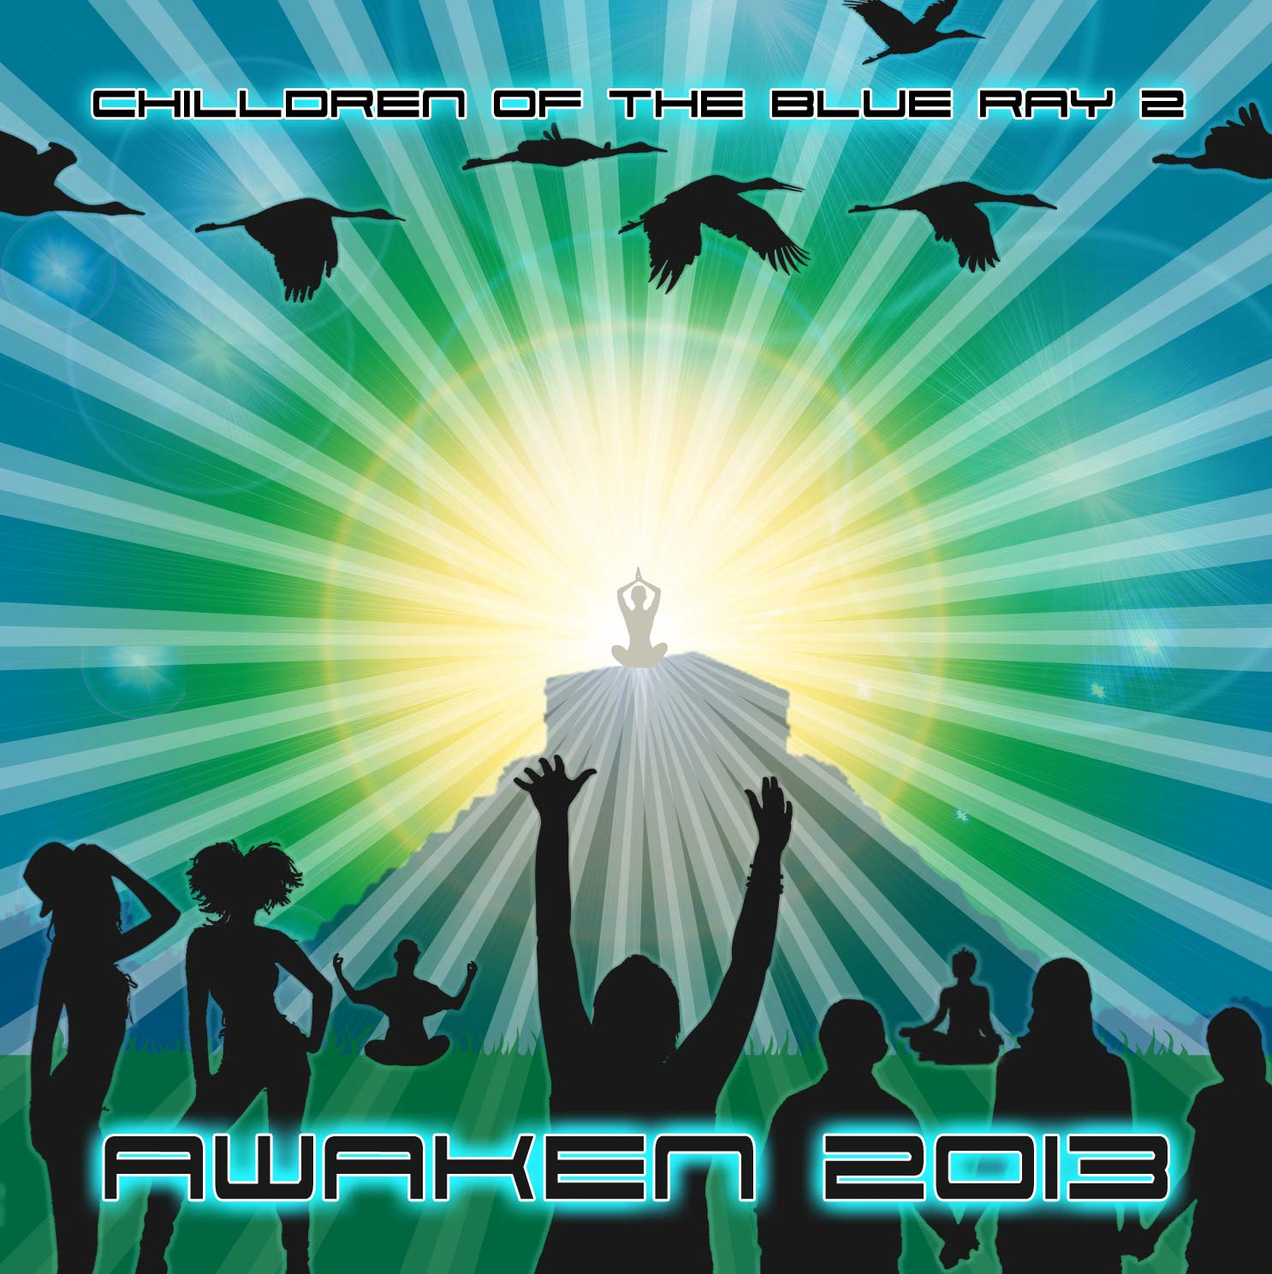 |  | RELEASE NOTES  This CD is a showcase of the leading psychedelic electronic music artists of this time featuring rare and hard to find tracks from across the spectrum of downtempo, breaks, tech house, chill out, trip hop, Dubstep, Ambient and otherwise relaxing and meditative styles fused together with a modern sounding backdrop of at times danceable yet always moving and grooving laced with melodies and rich soundscapes. This audio journey tells a story of self discovery through seeking inner peace and bliss. A tale of our own past and future... Awaken 2013 is a call to the people of the world to unify our cultures in a peaceful coalition of active participants in the collective tribes of the Earth. There is no better time than now to put down the old ways of discord and adopt new harmonious ways of working together to create a utopian age where all of our potential knowledge and wisdom of the human race benefits the whole by efficiently creating clean, green solutions that exist today for a better reality for all life. The Children of the Blue Ray are the prophesied generation of souls who will incarnate with the mission of exposing the broken, unfair and outdated policies that have been inflicted on our planet in a sorry attempt at halting our collective planetary evolution. This CD is a call to action to this generation of Blue Ray Chilldren who are ready to ACT!  BasStar Records formed in summer of 2007 and is focused primarily on breaks, dub step, electro house and down tekno grooves. Expect lots of wild unpredictable new cuts coming from this phatty side project from Geomagnetic Records Label Group.  Geomagnetic.tv www.geomagnetic.tv was established in the summer of 2001. Their first major international release is the legendary DVD project “MAGNUS” geodvd001. Since then they have added 30 label artists and have multitudes of projects in the works for 2006 and beyond. Based in San Francisco and focusing mostly on visual and music related projects, you can expect to see lots more cutting edge releases on the way from this award winning crew! Geomagnetic.tv was started by Spook one of the founders of the prominent San Francisco 3D FX and Multimedia boutique known as Minds Eye Media (est.1995). www.mindseyemedia.com
Title: | Chilldren Of The Blue Ray v2. – Awaken 2013
Artist: | Various (Compiled and Mixed by Mindstorm)
Label: | BasStar/Geomagnetic.tv
Catalogue: | BASSCD007
Format: | 6 Panel Jewel Case Audio CD
Barcode: | 881034278937
Release: | October 2009 World Wide
TRACK LIST

01 - Chang - Hold on
02 - Nov Sanus - Forgotton Ages
03 - Predators feat. Hideyo Blackmoon - Mahaloba
04 - Cybervixen - Into the unknown
05 - Chillaxian (aka Helios) - High Use World
06 - The Antiserum vs Ripple - Blaze It
07 – Frost RAVEN - Seraki Mire
08 - TeTuna - Dahilalaoh
09 - Bratex - Chillas
10 - The Lorax - Whatever Happened
11 - ABDCTN - New atlantis
12 - Random Robot - Select Function
13 - Sound Capsule - Strange Transmission (Chlorophil remix)

CREDITS
Compiled and mixed by: Mindstorm (San Francisco) www.myspace.com/mindstorm1
Artwork: Doctor Spook & Shanti Lovejoy
Distribution by SaikoSounds / Geomagnetic Records
(p) and © Geomagnetic.tv
info@geomagnetic.tv
Hi-Res art online.


