Mr. Rogers – The Ooze System (***)
Ooze System Recordings. Cat.#:
 |  | 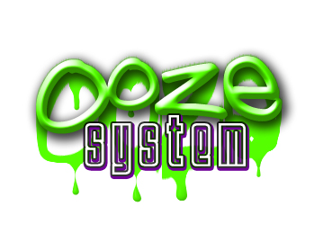  RELEASE NOTES  Mr. Rogers is doing big things in the west coast psy and breaks scene. His all original, funky psychedelic breaks sets have gained the attention of fellow artists and producers across the united states and have earned him headlining spots across the west coast, including most recently the Hawaiian Electronic Music Festival, the Priceless Campout, the now infamous Full Melt parties in San Francisco, Burningman, the Phoenix Festival in Washington, and many other events from Arizona, to Oregon, and Nevada.  His unique take on breaks is fun and quirky, but aggressive and full of movement. His recent Synchro remix is soon to be released on Illumination Records. He is also currently working with Phokus from Ritual Sounds, and Dirt with Cymbalic Records.  Label Profile:
Title: | The Ooze System
Artist: | Mr. Rogers
Label: | Ooze System
Catalogue:
Format: | 4-Panel Digipak
Barcode:
Release:
TRACK LIST
1. Gangsta Goose
2. Mr. Lemurian
3. Space Vagina
4. The DMT Factor
5. Sparkplug feat. Agustus thElephant
6. Spookey Kabluey
7. Bahroo! feat. Jacinda
8. A Boy and His Blob
9. Tameron’s Cube

CREDITS

Distribution: Geomagnetic Distribution
(p) and © Ooze System Recordings
Website : www.oozesystem.com Mobile : 415-516-7662
www.geomagnetic.tv
info@geomagnetic.tv

