MR ROGERS - “OOZE SYSTEM” CD – Bass-Star Rec (Geomagnetic.tv Group)

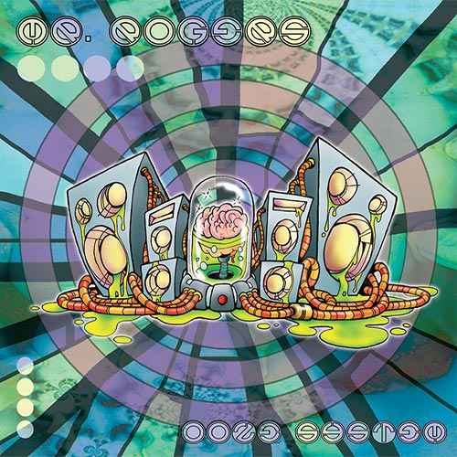 |  | RELEASE NOTES  Mr. Rogers is doing big things in the west coast psy and breaks scene. His all original, funky psychedelic breaks sets have gained the attention of fellow artists and producers across the united states and have earned him headlining spots across the west coast, including most recently the Hawaiian Electronic Music Festival, the Priceless Campout, the now infamous Full Melt parties in San Francisco, Burningman, the Phoenix Festival in Washington, and many other events from Arizona, to Oregon, and Nevada.  Artist Profile:  Mr Rogers unique take on breaks is not only fun and quirky, but aggressive and full of movement. His recent Synchro remix is soon to be released on Illumination Records. He is also currently working with Phokus from Ritual Sounds, and Dirt with Cymbalic Records.  Label Profile:  BasStar Records formed in summer of 2007 and is focused primarily on breaks, dub step, electro house and downtempo groove. Expect lots of wild unpredictable new cuts coming from this phatty side project from Geomagnetic Records Label Group.  Geomagnetic.tv was established in the summer of 2001.  Their first major international release is the legendary DVD project “MAGNUS” geodvd001. Since then they have added 30 label artists and have multitudes of projects in the works for 2006 and beyond. Based in San Francisco and focusing mostly on visual and music related projects, you can expect to see lots more cutting edge releases on the way from this award winning crew! Geomagnetic.tv was started by Spook one of the founders of the prominent San Francisco 3D FX and Multimedia boutique known as Minds Eye Media (est.1995). www.mindseyemedia.com  
Title: | OOZE SYSTEM
Artist: | MR. ROGERS
Label: | BasStar/Geomagnetic.tv
Catalogue: | GEOCD030 / BASSCD001
Format: | 4-Panel Digipak Audio CD
Barcode: | 881034098474
Release: | October 2007 World Wide
TRACK LIST

1. Gangsta' Goose
2. Mr. Lemurian
3. Space Vagina
4. DMT Factor
5. Sparkplug Feat. M.C. Agustus
6. Spooky Kabluey
7. Bahroo!
8. A Boy and His Blob
9. Tamerons Cube
10. Life

CREDITS
Mastered: Random @ Geomagnetic
Artwork: Dusty (Mr.) Rogers
Distribution by Arabesque/ SaikoSounds /Psyshop www.crystal-code.com
(p) and © Geomagnetic.tv
http://geomagnetic.tv/labels/Geo-Basstar/MrRogers-OozeSystem.html info@geomagnetic.tv
Hi-Res art online.



