Skyloops – Modern Stimulation EP – GOAEP004 – Goa Records/Geo-Morningstar

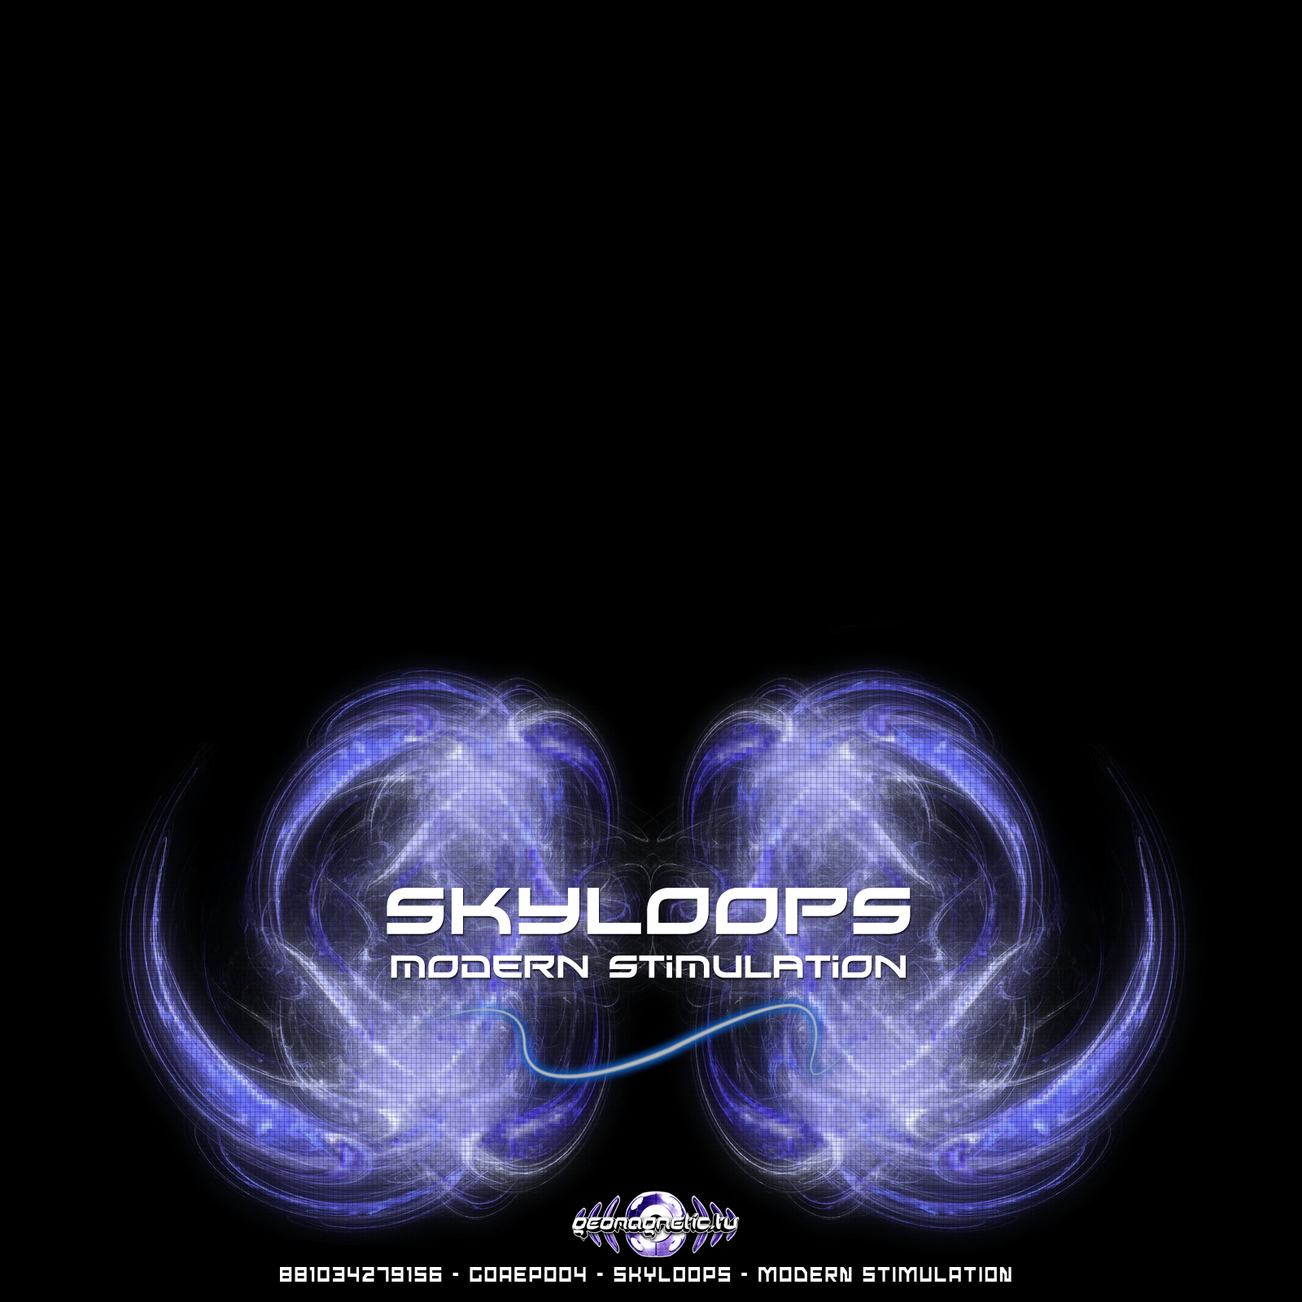 |  | RELEASE NOTES: Skyloops – Modern Stimulation EP  Modern Stimulation is the debut EP from this creative Argentina based dance music duo. The sky is the limit with these two while they send you sailing into the clouds with track after track of acid drenched dirty gritty full power fluff!  Artist Profile:  Skyloops is the psychedelic trance project of Sebastian Strazza (26 years old) and Mariana Zarankin (25 years old) from Buenos Aires, Argentina. They are both musicians since the age of 14 years old, they meet each other at beginning of 2000 and since then where involve in differents projects and the psychedelic music get into their minds. At the end of 2004 Sebastian starts his carer as a dj playing with artists like Sesto Sento, Cycle Sphere, Ferbi Boys, Analog Pussy, Azax Syndrom, Rinkadink, System Nypel, Electro Sun, Chromossome, Andromeda, Alternative Control, Zen Mechanics, Altom, etc; and with Mariana start to produce psytrance parties called Under Attack. Later the feeling for music get so strong that they start to produce psychedelic music and with this new project they are making they dream come true, the dream of express what is in their souls. On 2008 Skyloops has joined Geomagnetic Records. We will see the things that this couple is going to give us. Bookings & info to skyloops@hotmail.com  Label Profile:    Goa Records is a new label founded in 2006 based in California/USA. Focused on finding the very best of the worlds leading psy-trance and goa-trance hits and compiling these into a highly commercialized package suitable for mainstream distribution outlets. Expect a steady stream of high quality, cutting edge releases from this already amazingly popular new label.  Morningstar is a subdivision of Geomagnetic Records. Uplifting, melodic, full-on, progressive and perfect for those ecstatic moments of sunshine and awakening, the Morningstar label knows you want to be carried on a cloud of feel-good grooviness as you welcome the morning light! Geomagnetic.tv (Label Group) was established in the summer of 2001. Based in San Francisco and focusing mostly on visual and music related projects, you can expect to see lots more cutting edge releases on the way from this award winning crew! Geomagnetic.tv was started by Spook one of the founders of the prominent San Francisco 3D FX and Multimedia boutique known as Minds Eye Media (est.1995). www.mindseyemedia.com
Title: | Skyloops - Modern Stimulation EP
Artist: | Skyloops
Label: | Goa Records and Geo-Morningstar
Catalogue: | GOAEP004
Format: | 1 Panel Insert Audio CD & DDL
Barcode: | 881034098511
Release: | Dec 2008
TRACK LIST

01_-_Skyloops_-_Roll_Out

02_-_Skyloops_-_Computers

03_-_Skyloops_-_Modern_Stimulation

04_-_Skyloops_-_Uncensored

05_-_Skyloops_-_One_Hundred_Million_Stars

CREDITS:
MASTERED BY: Skyloops, Chile
Artwork by: Skyloops
Distribution by: Ingrooves / Geomagnetic.tv
(p) and © Geomagnetic.tv / Goa Rec. 2008
info@geomagnetic.tv More info online.
http://geomagnetic.tv/labels/Goa-Records/GOAEP004-Skyloops



