FrostRaven – MUSE EP – GOAEP005 – Goa Records/Geo-Morningstar

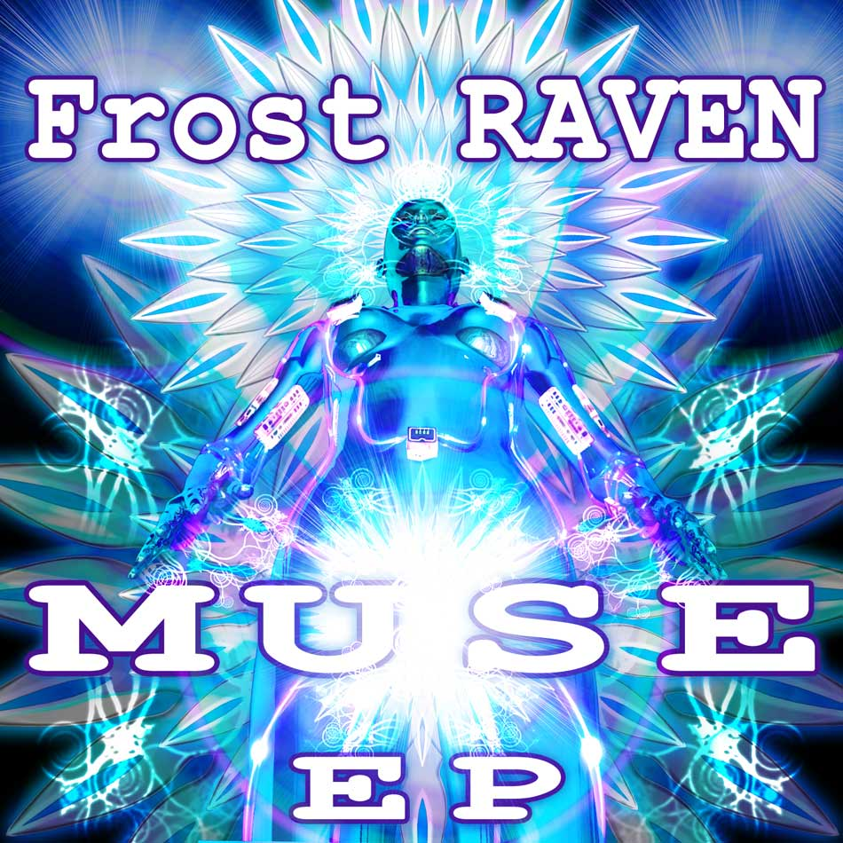 |  | RELEASE NOTES: FrostRaven – MUSE EP  Muse is the latest in cutting edge full power and progressive psychedelic goa trance music. Artists like FrostRaven from the San Francisco bay area underground are the creative force for this seminal sound. Since the early 90s this genre has continued on to become the leading sound in the underground dance culture. This world class EP demonstrates the style, production skill, and catchy hooks that have driven this sound to the top of the charts. FrostRaven’s unmistakable melodic sound is crystal clear and full of heart. Get ready to upgrade your music collection with this top of the stack winner!  Artist Profile:  With a background in film and theater soundtrack composition, Frost Raven started out with applications such as Soundforge and ACID Pro. After attending Pyramind; The Institute for Advanced Digital Audio Training, Dustin Musser (aka Frost-RAVEN) gained the skills and exposure necessary to elevate his music to a new level. While in school Dustin was offered a digital contract for his album Desert Walker, which alongside his electro-house EP Fire City, quickly began to dominate INgroove's new releases charts on Beatport.com. However Dustin Musser's true passion is psychedelic trance music. Currently Frost-RAVEN has a number of projects on tap. His new down-tempo EP Deep in Blue is set for spring release on the INgooves digital label. Also new tracks can be heard CD compilation due out February on the Geomagnetic label. Frost-RAVEN is also the co-founder of Somasoundsystem, a Bay Area collective of DJs and producers. Together they represent fresh sounds and pre-current trends:  Label Profile:    Goa Records is a new label founded in 2006 based in California/USA. Focused on finding the very best of the worlds leading psy-trance and goa-trance hits and compiling these into a highly commercialized package suitable for mainstream distribution outlets. Expect a steady stream of high quality, cutting edge releases from this already amazingly popular new label.  Morningstar is a subdivision of Geomagnetic Records. Uplifting, melodic, full-on, progressive and perfect for those ecstatic moments of sunshine and awakening, the Morningstar label knows you want to be carried on a cloud of feel-good grooviness as you welcome the morning light! Geomagnetic.tv (Label Group) was established in the summer of 2001. Based in San Francisco and focusing mostly on visual and music related projects, you can expect to see lots more cutting edge releases on the way from this award winning crew! Geomagnetic.tv was started by Spook one of the founders of the prominent San Francisco 3D FX and Multimedia boutique known as Minds Eye Media (est.1995). www.mindseyemedia.com
Title: | Muse
Artist: | FrostRaven
Label: | Goa Records and Geo-Morningstar
Catalogue: | GOAEP005
Format: | 1 Panel Insert Audio CD & DDL
Barcode: | 881034098511
Release: | Nov 2008
TRACK LIST

Muse

Lore

Night_Freak

The_Hole

Nightmares

CREDITS:
MASTERED BY: Tyler Straub, San Francisco
Artwork by: doctorspook@hotmail.com
Distribution by Crystal-Code
(p) and © Geomagnetic.tv / Goa Rec. 2008
info@geomagnetic.tv More info online.
http://geomagnetic.tv/labels/Goa-Records/GOAEP005-FrostRaven



