GOA TRIP vol1 goarec001 - V/A
2 CD Set Compiled by Doctor Spook and Chemicus – GOA RECORDS

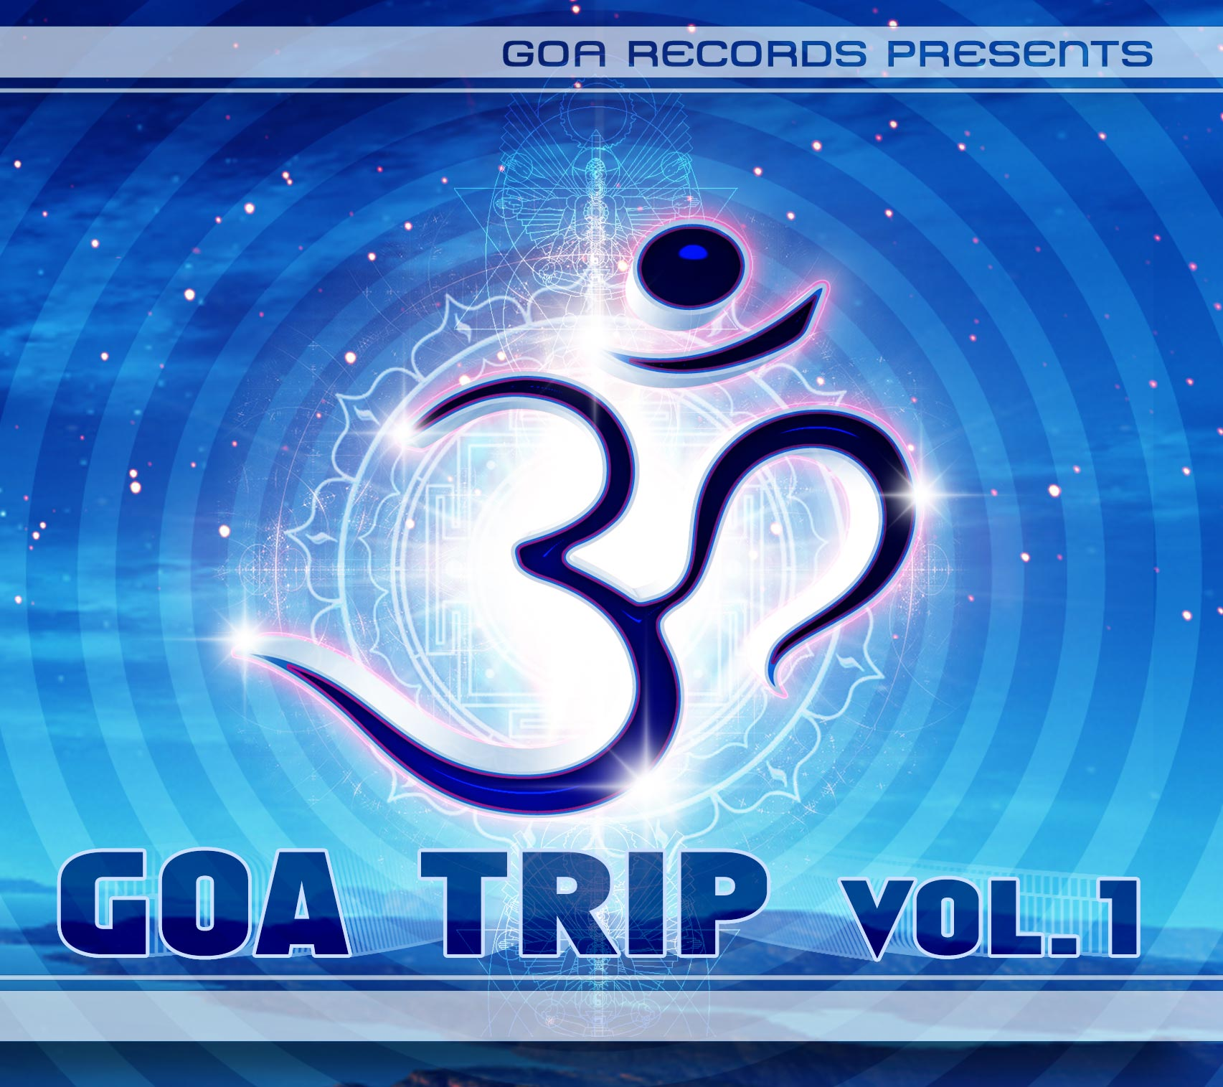 |  | RELEASE NOTES: Goa Trip Vol. 1  Goa Trip Vol. 1 is the first enlightening and smashing double-cd series compilation which will lead you to a track of darkness and light, day and night – the consciousness and the unknown. You will be in the middle of sane and insane – between two worlds of the psychedelic trance genre. Each of these killer tracks brings you to the far end of reality and self-awareness. CD 1 will be featured by big names like … Genetic Spin, Ultravoice, Quadra, Cosmic Tone and Chromosome.  CD 2 is representing the darker tunes of the goa-psy-world and its styles in between. So check out the tracklist with such burning names like… Neuromotor, Penta, BUS, Rastaliens and more!  Both CDs will show you that only these two pieces together can be one in the end like the Yin Yang symbol itself. Enjoy 21 amazing good-listening tracks for any mood of your GOA trip !  Label Profile:  Goa Records is a new label founded in 2006 based in California/USA. Focused on finding the very best of the worlds leading psy-trance and goa-trance hits and compiling these into a highly commercialized package suitable for mainstream distribution outlets. Expect a steady stream of high quality, cutting edge releases from this already amazingly popular new label.  Artist Profile:  DJ/VJ Doctor Spook (San Francisco, USA)  Also known as Nathan Vogel, Spook is an award winning  3D animator and music video director. He began creating  psychedelic visuals in 1992, receiving critical acclaim for  all of his projects. Nathan has worked with major music labels such as Arista, Geffen/Universal, Sony, Om and now with all of the most prominent Psy-trance labels with ground breaking new releases. Spooks passion for electronic music drove him to start making music in 1990. He began DJing Psy-trance at the Burning Man festival in 1998.  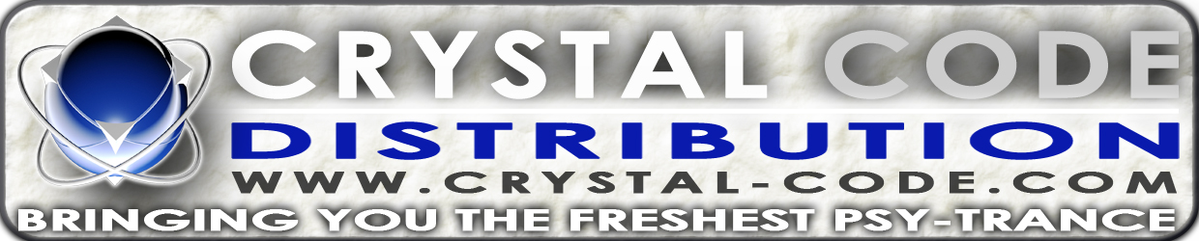
Title: | Goa Trip Vol. 1
Artist: | V/a by Spook & Chemicus
Label: | Goa Records
Catalogue: | GOAREC001
Format: | 6-Panel Digipak Audio 2CD
Barcode: | 9366977745506
Release: | Dec 2006
TRACK LIST
1. GENETIC SPIN – Digital Dollars
2. ATMA – Beyond Good and Evil
3. MR PECULIAR – Crystal Myth
4. QUADRA - Vibrations
5. INTERSYS - Sycoactive
6. COSMIC TONE – Liquid Dwarf
7. BRAIN DAMAGE – Virus Player
8. ELEC 3 – 40 Amps
9. ULTRAVOICE - Multi
10. TWISTED REACTION – Twisted Illusions 11. CHROMOSOME - Unstreamable
1. DARK NEBULA – Space Weed
2. PHOENIX FAMILY – Chronic Tonic
3. META (Formerly AEON) - Amorphous
4. PSYNINA – The Legend Sophia Scholl
5. RANDOM – Cosmic Puzzle
6. BODHISATTVA 13:20 – Gung Fu Trippers
7. NEUROMOTOR – Drumatik Vision
8. RASTALIENS – Evil Extra Terrestrials
9. BUS – Full Monty Jacket
10. PENTA – Frankenstein 2001

CREDITS:
Artwork by: Nico Psyart and Doctor Spook
Compiled By: Doctor Spook and Chemicus
Distribution by Saiko Sounds
(p) and © Geomagnetic.tv
info@geomagnetic.tv Hi-Res art online.

