Solar System – Private Selection – GOAREC005 – Goa Records / Sonesta Records

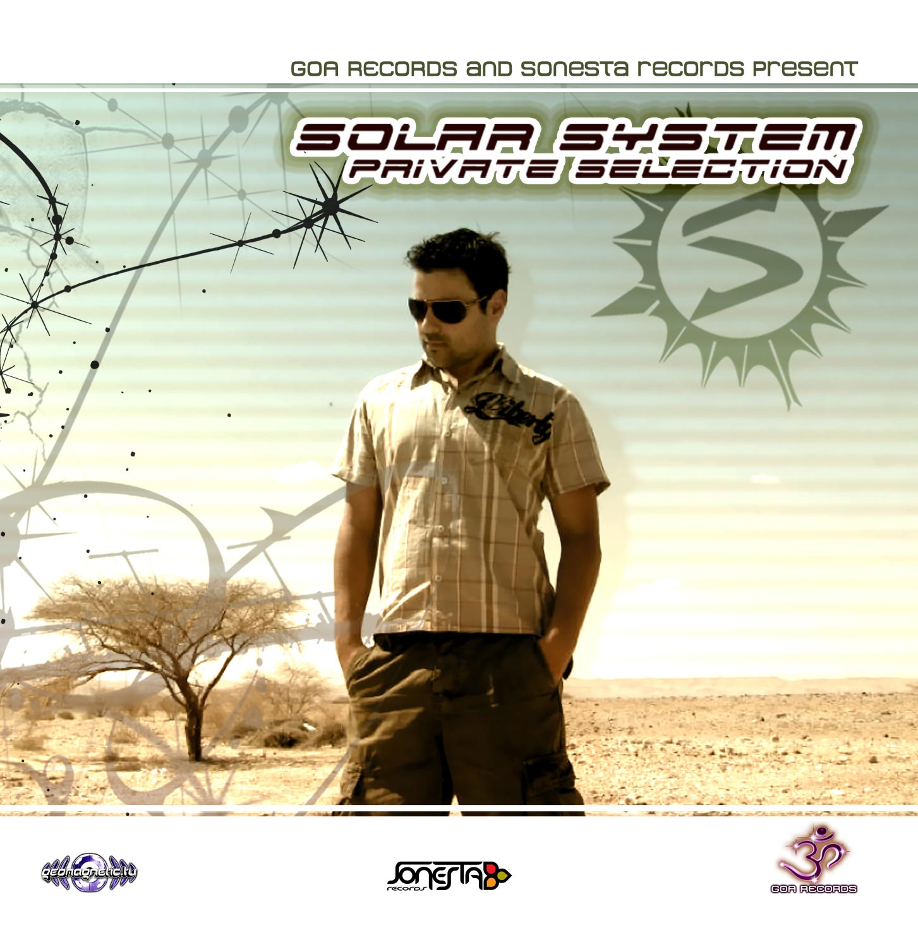 |  | RELEASE NOTES:  Solar System – Private Selection – GOAREC005  Goa Records with Sonesta Records are pleased to present Solar System, Dj magazines #85 top 100 Producer for 2008, featuring his Private Selection of his all time hit singles never before compiled in one place. Lior Lahav a.k.a Solar System was born in the city of Naharyia in 1982. A truly diligent artist, Lior has contributed immensely to the Trance culture in Israel. Taking inspiration from various disc jockeys and artists, Lior became a disc jockey at the youthful age of 18. It was not long before he exploited his potential and started production. Liors' project Solar System, reflects his Full On style of composition, which is particularly appreciated at open-air gatherings. Although his style may be broadly defined as Full On, his upbeat, melodious and deeply tuneful tracks segregate his music from the rest of the artists that fall in this category. Lior..s inclination to make powerful tracks allows him to pull the crowd into the vortex of energy that revolves around his persona. His ability to create a vigorous atmosphere is highly appreciated by many personalities in the Trance community around the globe. He has been producing for over 10 years at his home studio in Israel. Solar System has 20 releases on prominent compilations such as Desert Dreaming v.2 (Geo-Israel), K-Files (Utopia Recs.), Goa 2005 Vol. 2 (YSE), Radioactivity (Point Zero Recs.), Radioactivity Part 2 (Point Zero Recs.) and Open Air Vol. 4. (YSE). Solar System tracks are released by distinguished record labels such as Geomagnetic, Yellow Sunshine Explosion, Midijum, Trancelucent, Alchemy, Vision Quest/MP, Tribal, Point Zero, Magma, Substical, Utopia, Heart of Trance, Darcu, and more etc. To add to his credentials, Lior has traveled extensively to showcase his talent to many cities. Solar System has played in cosmopolitan cities such as England, Denmark, Germany, Portugal, Switzerland and Brazil. He shall now commence his latest world tour. BOOKING@SOLARSYSTEMUSIC.COM  Artist Profile: myspace.com/liorlahav myspace.com/djsolarsystem  Label Profile: myspace.com/geomagnetic  Goa Records is a new label founded in 2006 based in California/USA. Focused on finding the very best of the worlds leading psy-trance and goa-trance hits and compiling these into a highly commercialized package suitable for mainstream distribution outlets. Expect a steady stream of high quality, cutting edge releases from this already amazingly popular new label.  GEO-ISRAEL is a subdivision of Geomagnetic Records, offering the most cutting edge sounds from the hottest new artists of the Israeli psychedelic underground. With no distinguishing night and day, day and night, GEO-Israel offers full-on and dark aural journeys to enhance your trance dancing experience!  Geomagnetic.tv was established in the summer of 2001 by Dr. Spook one of the founders of the prominent San Francisco 3D FX and Multimedia boutique known as Minds Eye Media (est.1995). www.mindseyemedia.com  Sonesta Reords is a new recording label which was set up by the artist Lior Lahav at 2008, focused on exclusive productions by Lior Lahav himself and other special projects offering unique collaborations in the Psytrance, Trance and House/Progressive/Electro dance music genres.  Label Profile: www.myspace.com/sonestarecords
Title: | Private Selection
Artist: | Solar System
Label: | Goa Records / Sonesta Records
Catalogue: | GOAREC005 / SONCD001
Format: | 4 Panel Insert Jewel CD / DDL
Barcode: | 881034279088
Release: | Oct 30 2008
TRACK LIST

1. 3 Days
2. Bible of trance
3. Cycle Of Life
4. Bamboo Forest - Voyager (Solar System Rmx)
5. Dark Star
6. Majestic
7. Noga - Moksha Mania (Solar System Rmx)
8. Mastermind
9. Move to the groove
10. Noga Vs Solar System - Above The Ground

----------------------------------------------------------

CREDITS:
Music Created by: Lior Lahav aka Solar System
Produced by: Lior Lahav and Nathan Vogel
Album graphics: Nir Safri and Dr. Spook
Distribution: Psyshop.com, Saikosounds.com, Goa-Records.com
(p) and © www.Geomagnetic.tv
info@geomagnetic.tv
http://geomagnetic.tv/labels/Goa-Records/GOAREC005-SolarSystem/


