GOA–Trax v.1 goarec007- V/A by Alex (goatracks.com) and Dr. Spook – GOA RECORDS

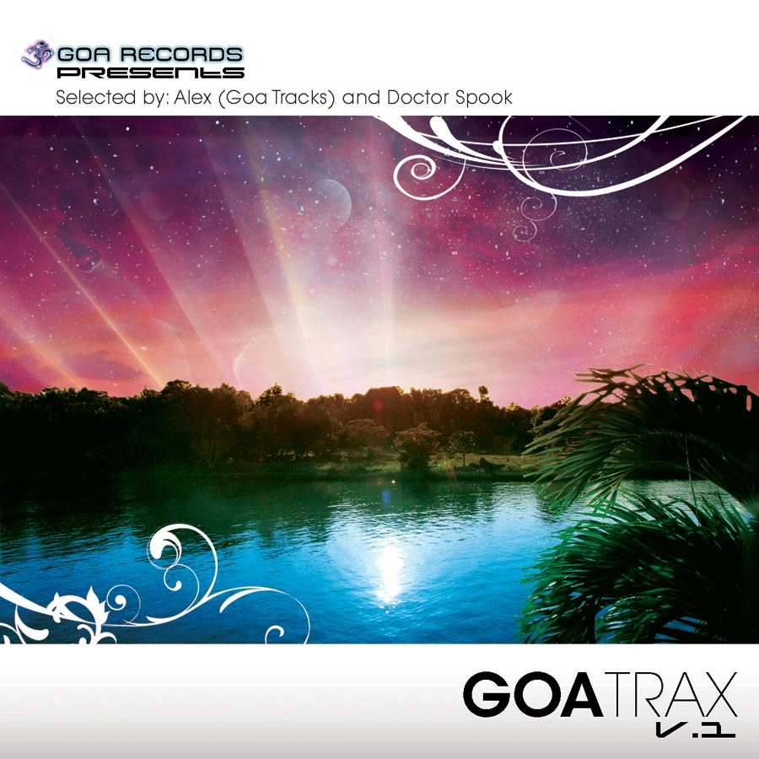 |  | RELEASE NOTES: Goa Trax v.1  Goa Trax v.1 features top psytrance and goa producers from across the world. Alex (goa tracks.com) and Spook (Goa-records) have devised the perfect selection of styles and diversity of backgrounds by choosing the best of different artists from around the globe. Memorable samples, heartfelt melodic hooks, full power raging bass lines, original compositions and fresh new musicians who have been practicing their styles on their local dance floors across the planet all combine to create the perfect refreshing dose of life. This totally packed CD presents 10 truly memorable and moving tracks that will be making you yell out for more. This cross section of the planets winning masters and new wizards of Goa Trance and Progressive Psychedelic Fullon as well as two special psy-chill producers offers a real world glimpse into the magic and mystery that is felt each weekend at secret parties around the planet held on beaches, forests, mountain tops, deserts and indoors at warehouses, yoga/dance studios, and living rooms. Now you can have a piece of these underground phenomena and relive the excitement that this experience conveys. Welcome to the Goa Trance Experience.  Artist Profile:  Alex from France has been promoting and supporting the psytrance and goa movement in France since its inception. Since then he founded one of the more visible independent music download shops in France and offers unique and special music not found on other sites. With this in mind he chose many of these hits that have reached legendary status on his site and included them in this hit compilation! =)  DJ/VJ Doctor Spook (San Francisco, Goa Records) Also known as Nathan Vogel, Spook is an award winning 3D animator and music video director. He began creating psychedelic visuals in 1992, receiving critical acclaim for all of his projects. Nathan has worked with major music labels such as Arista, Geffen/Universal, Sony, Om and now with all of the most prominent Psy-trance labels with ground breaking new releases. Spooks passion for electronic music drove him to start making music in 1990. He began DJing Psy-trance at the Burning Man festival in 1998.  Label Profile:  Goa Records is a sub-label of Geomagnetic Records founded in 2006 based in California/USA. Focused on finding the very best of the worlds leading psy-trance and goa-trance hits and compiling these into a highly commercialized package suitable for mainstream distribution outlets. Expect a steady stream of high quality, cutting edge releases from this already amazingly popular new label.  GoaTracks.com was founded in 2008 and provides the world with unique and original selections of Goa Trance and Downtempo world grooves.
Title: | Goa-Trax v.1
Artist: | v/a by Alex (Goatracks) & Spook
Label: | Goa Records / Goa Tracks
Catalogue: | GOAREC007
Format: | 6-Panel Jewel Case Audio CD
Barcode: | 881034279064
Release: | Mar 2009
TRACK LIST

01 Secret Vibes - Luna Fairy World
02 Cabal - Mindless
03 Jaws Underground - Day Dreamer
04 Micro Scan - Shadow Magnet (rmx)
05 Virtual Light - Nuclear Sun (Reactive Rmx)
06 Atyss - Chemical Drift
07 Crying Freemen - Condemned
08 Virtual Light - Castelvania (Te-Tuna Rmx)
09 DSP - Die Another Day
10 Skyloops - Computers

CREDITS:
Artwork by: Doctor Spook
Mastered by Maurcio @ Ovnimoon Studio
Compiled By: Servellen, Prahlad and Doctor Spook
Distribution by Saiko Sounds, Psyshop, Geomagnetic
(p) and © Goa Tracks, Goa Records, Geomagnetic.tv
info@geomagnetic.tv More info online.


