GOA Moon vol2.2 goarec009 - V/A 2 Part Set Compiled by Ovnimoon– GOA RECORDS

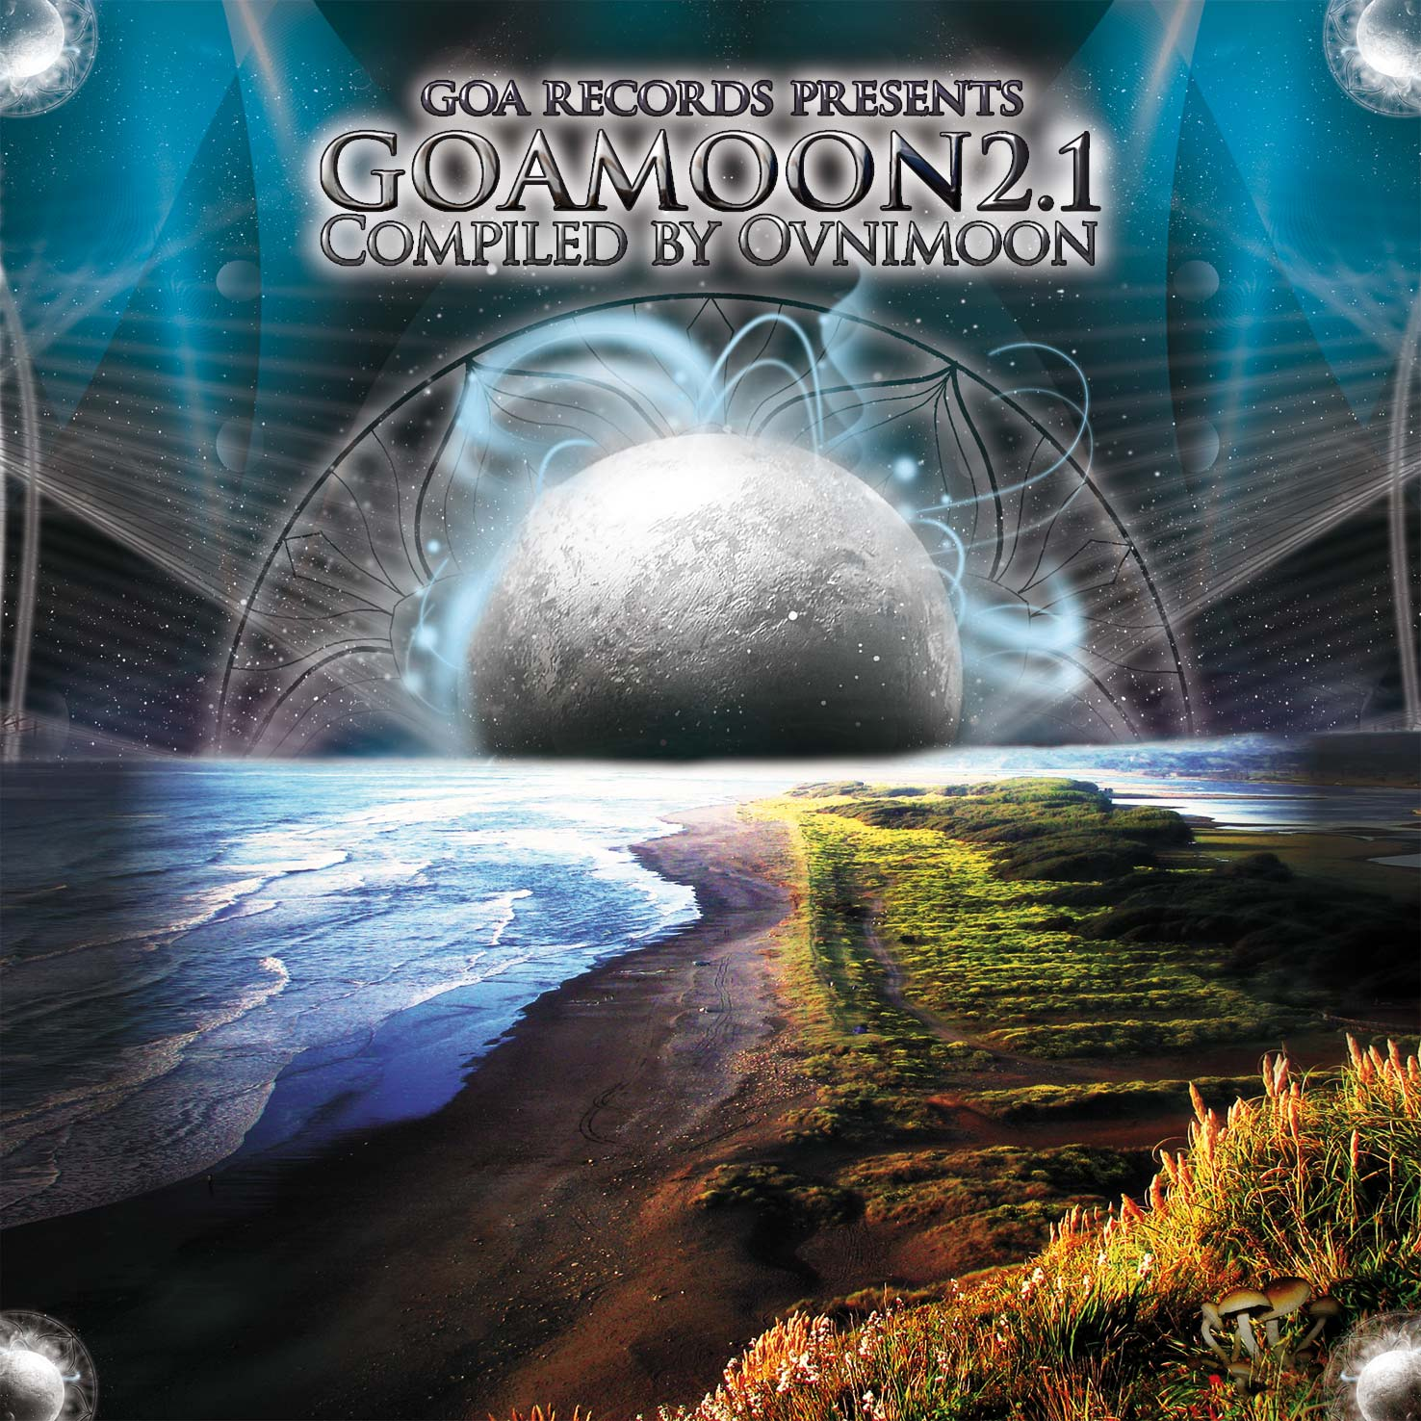 |  | RELEASE NOTES: Goa Moon Vol. 2.2  GOA - Moon Vol. 2.2 presents an amazing return that is full of color and life and energy. Ovnimoon compiles up a top shelf release for dancers, DJs, and collectors alike. Memorable samples, heartfelt melodic hooks, full power raging bass lines, original compositions and fresh new musicians who have been practicing their styles on their local dance floors across the planet all combine to create the perfect refreshing dose of life. Ovnimoon presents 10 unforgettable tracks on each part of this epic 2 part follow up to the hit first compilation that will be making you scream for more. This cross section of the planets best masters and new wizards Goa Trance and Progressive Psychedelic Fullon producers offers a real world glimpse into the magic and mystery that is felt each weekend at secret parties around the planet held on beaches, forests, mountain tops, deserts and indoors at warehouses, yoga/dance studios, and living rooms. Now you can have a piece of these underground phenomena and relive the excitement that this experience conveys. Welcome to the Goa Trance Experience. Ovnimoon (Chile, S. America) has released three amazing albums and numerous great singles on many different label's compilations. His experience and style as both a DJ and a professional trance/downtempo producer combine to allow him to cultivate a sound beyond the standard Dance floor fodder most DJs look for. Now you can play tracks never before available chosen by this veteran Goa-trance wizard from Chile.  Artist Profile:  Ovnimoon (Chile, S. America) has released three amazing albums and numerous great singles on many different label's compilations. His experience and style as both a DJ and a professional trance/downtempo producer combine to allow him to cultivate a sound beyond the standard Dance floor fodder most DJs look for. Now you can play tracks never before available chosen by this veteran Goa-trance wizard from Chile.  Label Profile:   Goa Records is a new label founded in 2006 based in California/USA. Focused on finding the very best of the worlds leading psy-trance and goa-trance hits and compiling these into a highly commercialized package suitable for mainstream distribution outlets. Expect a steady stream of high quality, cutting edge releases from this already amazingly popular new label.
Title: | Goa Moon Vol. 2.1
Artist: | V/a by Ovnimoon
Label: | Goa Records
Catalogue: | GOAREC009
Format: | 4-Panel Digipak Audio
Barcode: | 881034279163
Release: | August 2009
TRACK LIST

01- E-Mantra - Liquid Frequencies (2008)
02- Terra vs Protoactive - Full Moon
03- Micro Scan - Concentric Ripples
04- Virtual Light vs Wizack Twizack - Robot Revolution
05- Enertopia - Shadow World (Loki Rmx.)
06- Wizack Twizack - Pleonasm
07- Dragon - Morning Storm
08- Zybex - Fantasma
09- Imix - Disco Dis Way Disco Dat Way
10- Kinesis - The Prophecy

CREDITS:
Artwork by: Doctor Spook
Compiled By: Ovnimoon and Doctor Spook
Distribution by Saiko Sounds
(p) and © Geomagnetic.tv
info@geomagnetic.tv More info online.
http://geomagnetic.tv/news/goarec009



