~ Groove Criminals Records ~

V/A Invisible Connections

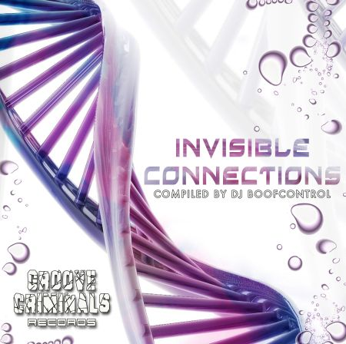 |  | RELEASE NOTES  A fresh blend enters the Psyscene with its amazing compilation “Invisible Connections”. Groove Criminals debut release forces to dance, to dream and to spin up at any party where it is played.  The average BPM range on this CD is 145 but the flow trough the whole CD is very pleasant and some tracks don’t feel like 145 at all. On this CD you will hear clear and clean Psytrance for any moment of a party, that makes this CD a must for any DJ who is looking for different “feelings” within the Psytrance genre. The CD was mastered by Tim Schuldt at 4CN Studios in Germany where other acts and labels are going for mastering purposes.  Label Profile:  Groove Criminals is a new trance record label from Austria and they are bringing out their first compilation, named “Invisible Connections”.  DJ Boof Control was responsible for the selection of the tracks featured on this CD and he managed to have four new upcoming artists: Kajola (Austria), Paradox (Austria), Snikers (Portugal) and Boof Control himself from Israel playing on this CD with some established international artists like Freakulizer, Broken Toy, Aphid Moon, Ibojima and Groovin Mad Dogs (the new morning trance, side project of Dark Soho).
Title: | Invisible Connections
Artist: | Various Artist
Label: | Groove Criminals Records
Catalogue: | GCRCD001
Format: | 4-Panel Digipak Audio CD
Barcode: | 9366977745520
Release: | January 2007
TRACKLIST

01. Freakulizer – Use Our Mind
02. Kajola – Logic
03. Broken Toy – Namibian Sky
04. Paradox – Up To The Night
05. Aphid Moon – Another Planet
06. Snikers – 1997
07. Ibojima – Mind Control
08. Boofcontrol – Atem The Terra Gaia
09. Grooving Mad Dogs (aka Dark Soho)-Marsh

CREDITS

Mastered by Tim Schuldt @ 4CN Studios
Artwork by Paradox
Distribution by Crystal Code Distribution
www.crystal-code.com www.geomagnetic.tv
(p) and © Geomagnetic.tv

