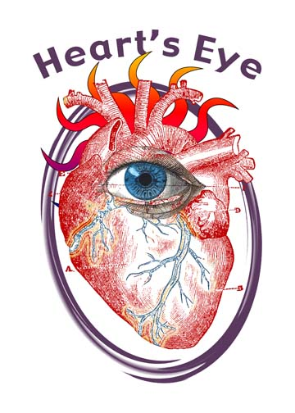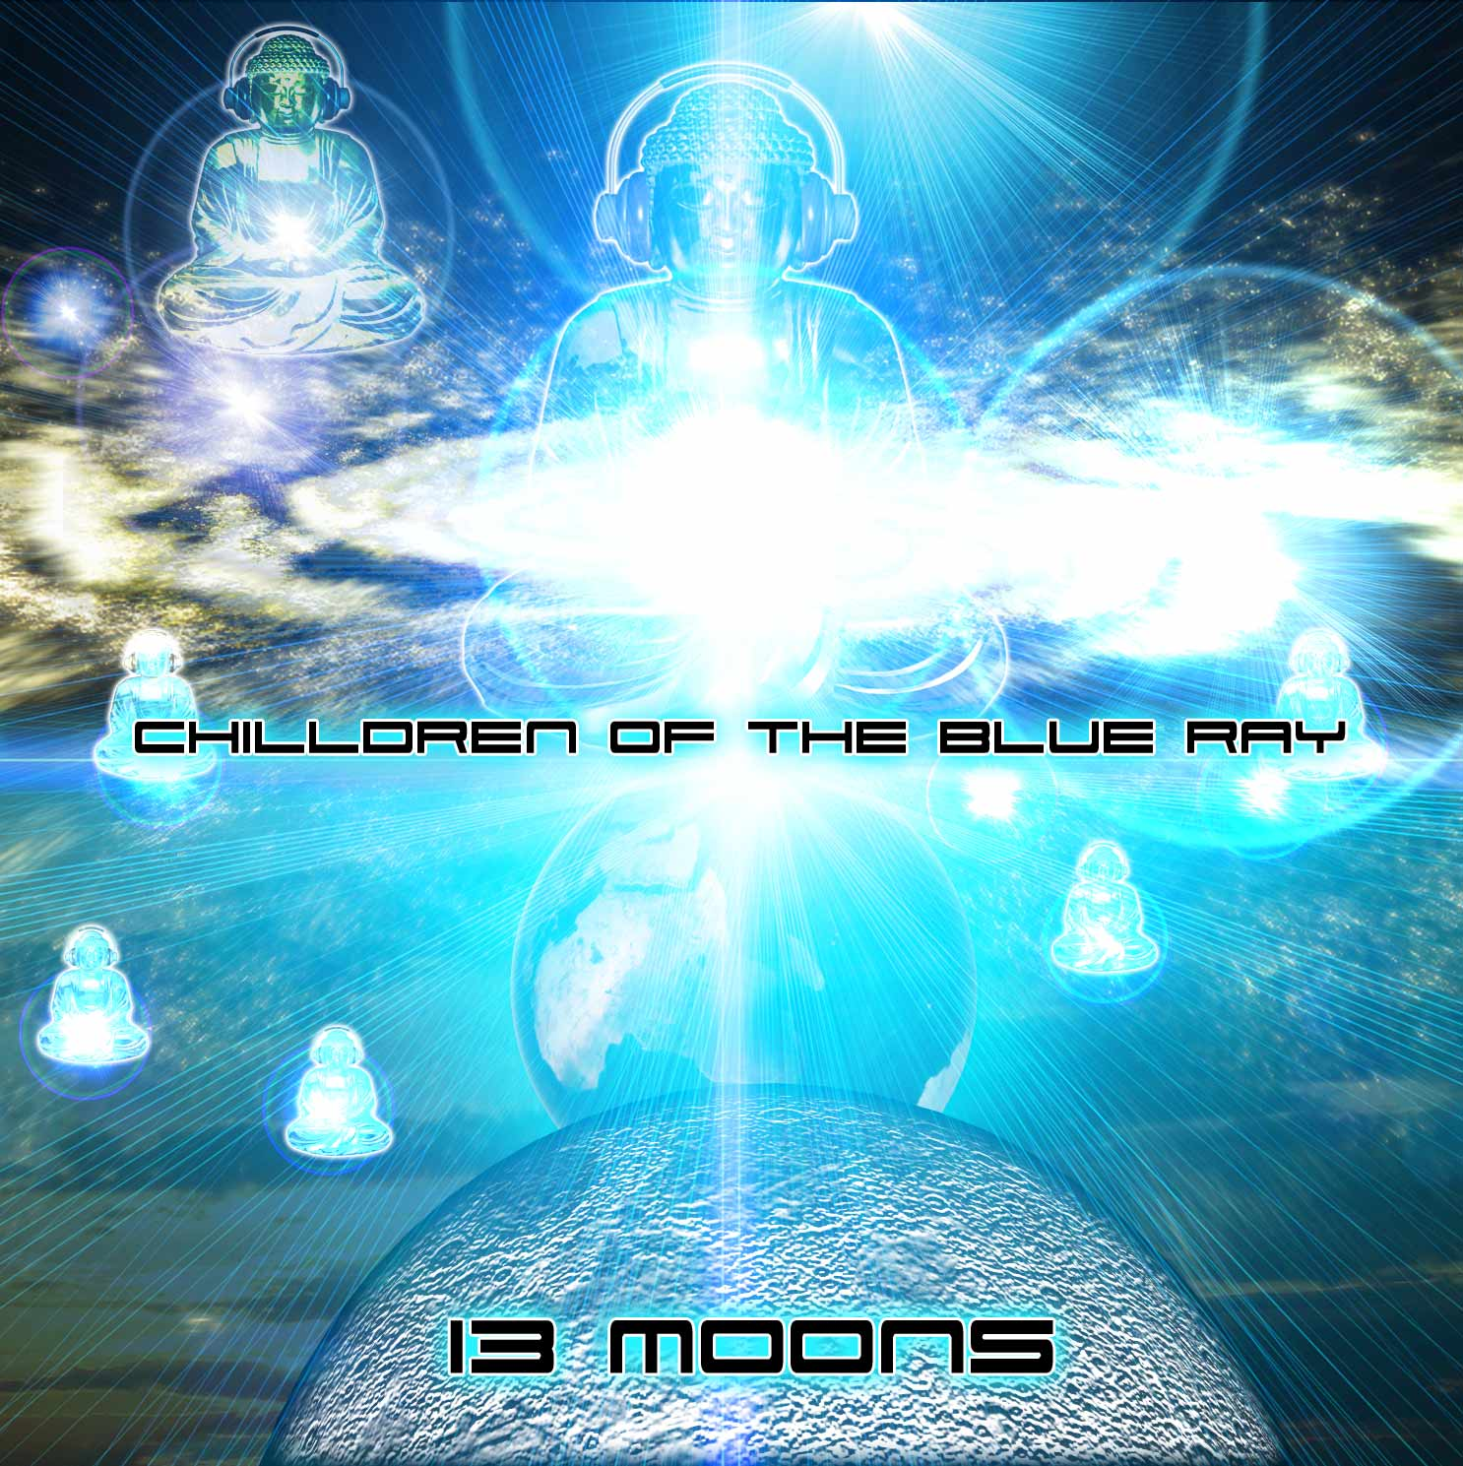
Hearts Eye Records
San Francisco
CA, 94133, USA

Album: Chilldren Of The Blue Ray v1. – 13 Moons

Artist: Various
UPC #: 881034279118
Catalog: Hercd002
Contact: info@saikosounds.com

Tracklisting:

01-PhasePhour-The Land 3:41
02-Lauge-Winter Look 3:57
03-Cybervixen - Krystal Water 6:16
04-Helios-Dreamtime 7:45
05-Imix - Bottom Of The Dirt (Chill Mix) 8:16
06-Outersect-Light Universe 6:55
07-Twisted Reaction vs Hero For a Day-One Love 5:06
08-Mr Rogers-DMT Factor 6:58
09-VirtualLight-RadeonRadio 5:44
10-Morphonix vs Helios-Incanterpolation 7:51
11-IrinaMikhailova and KenjiWilliams-DeepStep 5:26
12-01-N-VishuddhiChakra 9:39
13-Jirah aka TimMcCall-Psyrene 8:35

About:
This CD is a showcase of the leading psychedelic electronic music artists of this time featuring rare and hard to find tracks from across the spectrum of downtempo, breaks, tech house, chill out, trip hop, Dubstep, Ambient and otherwise relaxing and meditative styles fused together with a modern sounding backdrop of at times danceable yet always moving and grooving laced with melodies and rich soundscapes. This audio journey tells a story of self discovery through seaking inner peace and bliss. A tale of our own past and future. Did you ever wonder why the word Month is spelled that way? Its Based on the word Moon! Yes… the calendar was at one time based on the moon and its 13 annual phases of the full moon. The Roman Catholic Church imposed a new calendar to prevent the people they conquered from celebrating their traditional moon phase and seasonal quarterion cycles that predated their rigorous and megalomaniacle rulership based on outdated and illogical pretenses. The Children of the Blue Ray are the prophesied generation of souls who will incarnate with the mission of exposing the broken, unfair and outdated policies that have been inflicted on our planet in a sorry attempt at halting our collective planetary evolution. This CD is a call to action to this generation of Blue Ray Chilldren who are ready to ACT!

Label: Hearts Eye Records was founded in 2006 by Rob Rayle, long time figure head and founder of several pivotal electronic music collectives in the San Francisco Bay Area. His professional music career has taken off and enabled the label to prosper as a platform for international downtempo and ambient artists.

