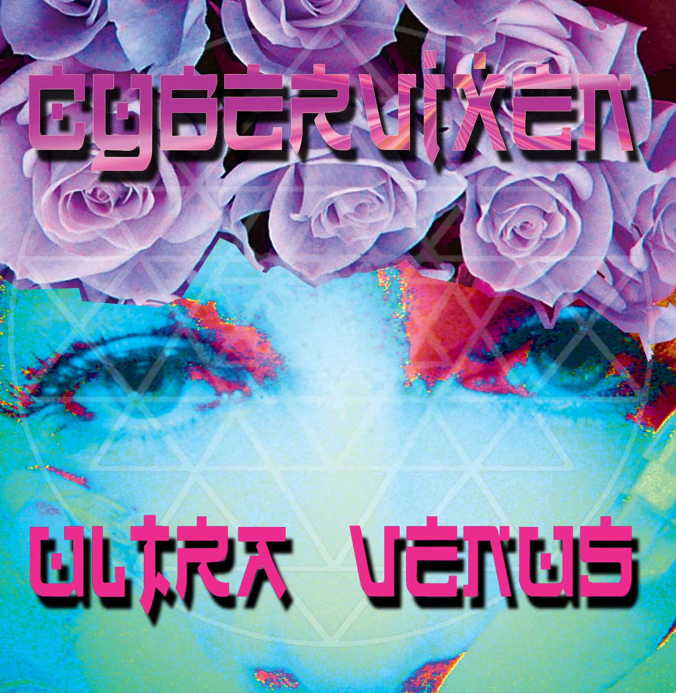
Hearts Eye Records
San Francisco
CA, 94133, USA

Album: Cybervixen – Ultra Venus

Artist: Various
UPC #: 881034279033
Catalog: Hercd003
Contact: info@saikosounds.com

Tracklisting:

1. E.n.e.r.g.y. | 8:07
2. Into the unknown | 8:08
3. Telepathine | 8:41
4. Snowflake | 7:48
5. Durga and the cyber starr gods | 8:40
6. The alignment | 7:27
7. Luved up and fluffed up | 8:23
8. Aquamarine | 8:34
9. Tetrahedron | 7:01

About:
The luscious new album "Ultra Venus" from Cybervixen is pure love...! Ultra Venus is the follow-up to her globally-acclaimed and classic "Kundal My Lini" album. This music is for you to create to, for when you make love and dream, and lose yourself in ecstatic bliss and dance… A mixture of fresh, sexy, shimmering vocals drives this music - and Cybervixen pulls out all the stops, riding the rhythm on the electronic dance musical wave.
In the real world, Cybervixen is vocalist Joie Favier - and has recorded with multi-platinum producer Trevor Horn (Seal, Grace Jones, Art of Noise) as a solo artist signed to his label ZTT. She has recorded at world reknowned studios such as Abbey Road and Pink Floyd's Brittania Row. Recent live performances include Earthdance Festival, Anon Salon's "Sea Of Dreams", Burning Man Festival, SF Love Parade and the Digital Be-In. She's a DJ and a songwriter who is passionate about what she sings - and she enlisted keyboard wizard and producer Alex Newman for his renowned ability as a rhythm smith, and to make the music "breathe".
Newman has produced numerous electronic dance music albums - including Medicine Drum's third album "Original Face", described by Billboard Magazine as "A major thrill". He has toured internationally with Medicine Drum as a DJ and keyboardist. He also composed the "Prayer for Peace", which is played annually at over 100 international locations simultaneously by DJs at Earthdance International, the world's largest synchronized music and dance festival.
These two musicians are telepathically linked and create something original and cutting edge whenever they go into the studio together... listen to this album now!
www.cybervixen.tv | www.geomagnetic.tv/artists/Cybervixen.htm | www.myspace.com/cybervixen
Label: Hearts Eye Records was founded in 2006 by Rob Rayle, long time figure head and founder of several pivotal electronic music collectives in the San Francisco Bay Area. His professional music career has taken off and enabled the label to prosper as a platform for international downtempo and ambient artists.

