TETRIUM – KEY POINT (2nd Artist Album)
Limit Space Rec. Cat.#: LSR001
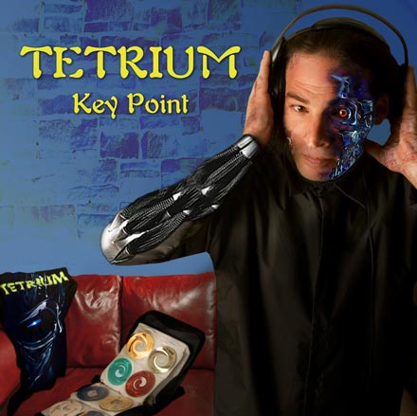 |  |   RELEASE NOTES  After the big success of the debut album from Tetrium 'Speed Of Light' that was released in Phonokol Records in the end of 2004, Limit Space Records are proud to present the second and long awaited Tetrium album .'Key Point'. Gadi Aviv a.k.a Tetrium is one of the Israeli trance pioneers, Tetrium has released numerous tracks on various compilations in labels around the world ,Such as : Phonokol ,Yellow Sunshine Explosion , Underground Sound Of Tel Aviv ,And more... 'Key Point' contain 9 exclusive unreleased tracks. The style can be describe as groovy full on trance with psychedelic touch and sweet melodies, Powerful energies that will smash the dance floor. As expected from an artist such as Tetrium this is a solid release to expect for...  Label Profile:  Limit Space Records is leading the way for the sound coming from Israel. Founded in 2006 by Gadi Aviv aka Tetrium, his mission is to give new artists as well as the brightest of the current stars a place to release their best productions. Get ready for lots more killer tunes and dance floor hits from this label!  
Title: | KEY POINT
Artist: | TETRIUM
Label: | LIMIT SPACE RECORDS
Catalogue: | LSR001
Format: | 4-Panel Digipak
Barcode: | 9366977745513
Release: | January 2007
TRACK LIST
1. AnythingIsPossible
2. HighSpeed
3. SmileToTheFuture
4. LifeIsAMission
5. ElectroSound
6. MoonScream
7. Tuister
8. MechanicBox
9. GetUp

CREDITS

Distribution: Geomagnetic/Crystal Code Distribution
(p) and © Limit Space Records
Website : www.limitspace-rec.com Mobile : +972 057 3290300
www.geomagnetic.tv
info@geomagnetic.tv

