“Complex Cosmic Creation” – Compiled by Dj Paradigm & Dj Shawnodese (Mind Funk Music)

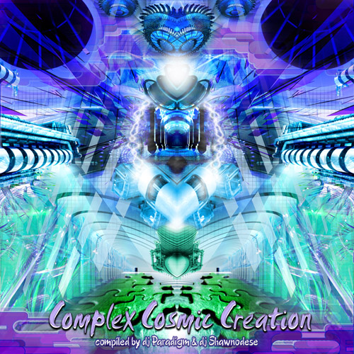 |  | RELEASE NOTES  Label Profile:  After heavy restyling Mind Funk Music has manifested itself out of the remains of Mind Funk Parties & Mind Funk Records. The label is nowadays operating from it’s base in Caracas (Venezuela) after having moved out of Amsterdam (Holland) in 2005. Our goal is to deliver you the best psytrance worldwide according to our globally tested standards of what is truly psychedelic music. It's aim and holy misssion is to outstand the commercial mass-productions that dominate the psytrance market nowadays. The label is being managed by Dj Shawnodese and his beloved wife Djane Ada. The rest of the Mind Funk team exists of very carefully selected dj's, producers, designers and promoters worldwide that all work together as a professional team. They are not all just collegues or partners in business, but go beyond these superficial kind of relationships and are all good friends in real life, which garantuees the succes of the team. Because of this we dare say that Mind Funk Music is ready to create some major impact in the worldwide psytrance scene soon. We're @ your service where- and whenever you need us, just ring the bells !  Artist Profile:  This compilation was made by the dynamic duo Dj Paradigm & Dj Shawnodese, both friends & collegues for quite a few years, that have been colaborating hard to get this astonishing powerful and hi-tech release out on Mind Funk Music. Both of 'm are without a doubt oustanding dj's in their league and forces to be reckoned with on the continents they're active on. Paradigm hails from San Francisco – California, a continent known for it’s strong psychedelic legacy, which is where he's known as one of the leading characters in the local scene. He’s also on the verge of a massive national breakthrough in the rest of the North-America (U.S.A. & Canada) as well as Mexico that is also starting to discover his talent. Recently also Geomagnetic.tv signed him up as their label-dj and having Paradigm represent their team, so this is a dj to be on the look-out for ! Shawnodese is originally born in Holland and preaching the psychedelic message nowadays in Latin-America, together with his beloved wife and label-partner Djane Ada. Shawnodese does not need much further introduction, he has been playing worldwide in over 15 countries on almost every continent on major festivals like Return to the Source, Antaris Project, Full Moon Festival and Ozora to name a few in a long list. Next to managing Mind Funk Music he’s also recently been signed for the Mechanik & Acidance Records teams as a label-dj and assisting bookings-agent. Both Mind Funk dj's, Paradigm & Shawnodese, garantuee you almost 80 minutes of absolute mind-blowing psytrance pleasure to hit and please your senses to the very maximum on this new storming compilation: "Complex Cosmic Creation". We @ Mind Funk are proud to present such a masterpiece collection to you as our audience and truly hope you have just as much fun & pleasure in listening to it as we had collecting these tunes for all of you out there…enjoy !
Title: | “Complex Cosmic Creation”
Artist: | Dj Paradigm & Dj Shawnodese
Label: | Mind Funk Music
Catalogue: | MFM 002
Format: | 4-Panel Digipak
Barcode: | 0902200623051967
Release: | May/June 2006
TRACK LIST
01 - Hux Flux - Post 100
02 - Chromatone - Cosmicrophone
03 - Neuromotor - Tribal Shark
04 - Concept - Get High
05 - Vibe Tribe – Damage
06 - Orca - The Magic Medicine
07 - Sick Addiction - Toy Chest
08 - Killer Buds vs. Energetic - Cosmic Disorder
09 - Bio Genesis - Beta Virus
10 - Slug – Biotechnology

CREDITS
Mastered by: Chromatone
Distribution by: Acidance
& Geomagnetic.tv Distribution
Artwork by: Mr. Peculiar & Myla
Conceptual Design by: Dj Shawnodese
(p) and © Mind Funk Music
http://www.mind-funk-music.com
Info@mind-funk-music.com or Shawnodese@mind-funk-music.com

