
Muti Music Inc
17 Parsons st
San Francisco
CA, 94118, USA
Contact: Dov@mutimusic.com
Tel # 510 499 1568

Artist: Timonkey
Title: Cerulea
Cat # MutiCD005
UPC Barcode #: 843041036887
File Under: Trip-Hop/ Downtempo/ Minimal / Glitch / Chillout / Leftfield / Dub / House

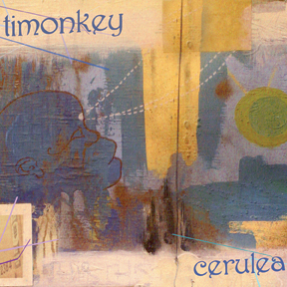
Tracklisting:
1. Always 5:39
2. Telephasic 2:56
3. Condensation 4:37
4. Back To The One 5:01
(feat. Joss-i On Tabla)
5. Lights In The Sky 3:05
6. The Ripest Fruit 4:16
(feat. Blink on Turntable)
7. Module Two 4:45
8. Thought Bubbles 3:28
(feat. Somesh on Viola)
9. Spacious 3:49
10. Azure 4:52
11. Protophonic 4:38
12. Ucopia 4:19
13. Five Kingdoms 4:20

Timonkey has established himself as an artist to watch with his second album 'Cerulea'. Moving through genres and influences and fluidly as a well oiled carp, he crafts one of the most pleasurable listening experiences you can hope to encounter in electronic music.
Equally at home hanging from a tree branch or bouncing off concrete, Santa Cruz's Timonkey (Tim Donlou) fuses organic and synthetic elements together in order to bridge the worlds of nature and technology. He says, "Branching patterns, mineral lattices, geological timescapes - the living earth is as much an influence on my music as King Tubby, Bernie Worrell, or Steve Reich ever were."
From its roots in dub, funk and ambient music, Timonkey's sound has been evolving further into the synthetic realms of midtempo glitch. He crafts his tracks using a combination of found sounds, analog synths, live instruments, and software wizardry, all from under the shade of the ancient redwoods. Influenced by years of collaboration with the 13 Moontribe, Raindance, and Nexus crews, he brings a unique flavor to the West Coast underground.

