
Muti Music is very happy to announce the combined album release :


‘Whomp Gland’ - ‘Pineal Dub’ CD

Tracklisting:
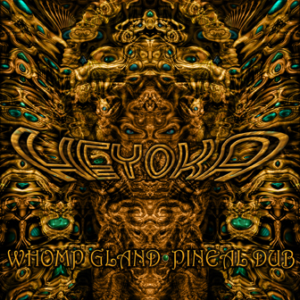
1. Bubble 5:57
2. Shmlizl 4:15
3. Bass Case 6:00
4. Diesel 6:13
5. Big Bud Barney 4:34
6. Airy Dub 5:36
7. Etheric Dub 5:18
8. Lazy Bass 6:58
9. Melting 5:00
10. Squishy Dub 5:33
11. Kombulade 5:52
(w/ Tina Malia & Poloka Lele)
12. Moth Dub 5:49
13. Bass Spalls 4:37
14. Purgatory Dub 5:02

File Under: Downtempo, Dub, Instrumental Hip Hop, Grime, Dubstep

Artist Info:
‘Whomp Gland - Pineal Dub’ extend Heyoka’s range from mellow dubs and glitchy bass tracks to a newer dubbed out version of instrumental Hip Hop. The popularity of his first two digitally released EP’s spurred us on to release his latest two on this new CD.
Heyoka is fast becoming one of San Francisco’s hottest new producer / performers on the scene. His early influences in Downtempo, Dub and IDM combined with more recent mid-tempo dancefloor genres from the likes of Bassnectar, Glitch Mob and An-ten-nae have helped create a very unique sound that combines relentless basslines, hip hop and dub rhythms with a lot of musicality and melody.
The response to his emergence so far has been overwhelming with Heyoka opening performances for Tipper, Benga & Skream amongst others.


Title: Whomp Gland - Pineal Dub
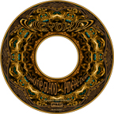
Format: CD Album
Cat # MutiCD007
UPC Barcode #: 844185007634
Release Date: December 22nd 2008
Cover image by Victor Olenev
P & C Muti Music 2008

Muti Music - 17 Parsons st, San Francisco, CA, 94118, USA
Contact: label@mutimusic.com / Tel # 510 499 1568

