DIGITAL SHAMAN–Compiled by Nikon
Psybertribe Records

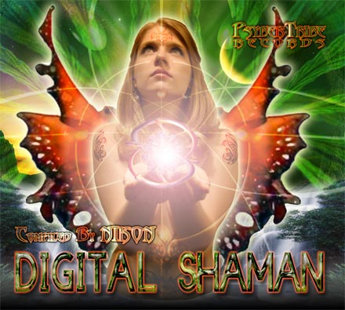 |  | RELEASE NOTES  PsyberTribe Records is proud to present it’s first release, Digital shaman. Featuring 10 breathtaking previously unreleased experiMENTAL audial soundscapes, created by the top sound prophets from the Night Floor dance Experience. compiled by San Francisco Label owner and Dj: Nikon  Label Profile:  PsyberTribe is a tribe of energy creating spaces and ritual dance ceremonies sacred to the participants and people joining. We are Promoting the continued growth of our senses, our surroundings, creativity and dance exploration with one another and ourselves in a majikal and open way for all to enjoy, all are equal, all are welcome, no parties, no clubs, Just dance and visionary communal creation. "Let the world change you and you can change the world.” This tribe caters to dance and creative exploration through audial soundscapes and atmosphere's currently and most popularly recognized as "THE TRANCE DANCE EXPERIENCE". Not for the faint hearted or close minded. Let go of your comfort's and surrender to the unknown.  The Record label is non-profit meaning that the funding from this project goes back into the artists and the next compilation/album. With the consent of all producers involved, the funds will occasionally go to bringing out one of these artists to our hometown. Eventually all:) Much love to you all, WELCOME TO PSYBERTRIBE.....EXPERIENCE!!!!!!!!!!!  Artist Profile:  Residing in San Francisco with his beautiful girlfriend Brianna and two awesome roomates, Tarah and Lori, Nik Pastor continues to push the envelope of PsyberTribe Records and Future Dance Culture on a worldwide scale. A Verteran Dj of 8 years now with 4 years in the studio producing under "PsyberDrum" and the Side Project "Pinky and the Brain", Nik holds no sound barriers. His style is Relentless, uncompromising, Aggressive, ExperiMENTAL, and most of all, Creative. His DJ Mixing talents have landed him playing alongside many local and international talents. A mainstay for this psychedelic underworld, Nik will continue to release forward thinking Artwork, music Ideas, and atmospheres, for as long as he is granted time on this earth, in his skin.
Title: | Digital Shaman
Artist: | Nikon – Various Artist
Label: | PsyberTribe Records
Catalogue: | PTRCD001
Format: | 4-Panel Digipak
Barcode: | 9366977745063
Release: | Feb 10 2006
TRACK LIST
1.Bodhisattva 13:20-Crystal Database(RMX)
2.Phobium-Hatz Is on
3.Vegetal-Molotov Politics
4.Jellyheadz-John Wayne(Methadone RMX)
5.The Galactic Brain-Unconscious Whispering
6.Baphomet Engine-Mainhead
7.Gidra-Digital Shaman
8.Kryptum-Mutpyrk
9.Crying Orc-My kippi shoes
10.Zoolog-Axis of evil Muffs(RMX)

CREDITS
Mastered by Chromatone
Distribution by Saiko Sounds
And Geomagnetic.tv Distribution
3D Art and effects by Doctor Spook
Conceptual Design by Nik Pastor
(p) and © PsyberTribe Records
http:/www.psybertribe.org
info@psybertribe.org

